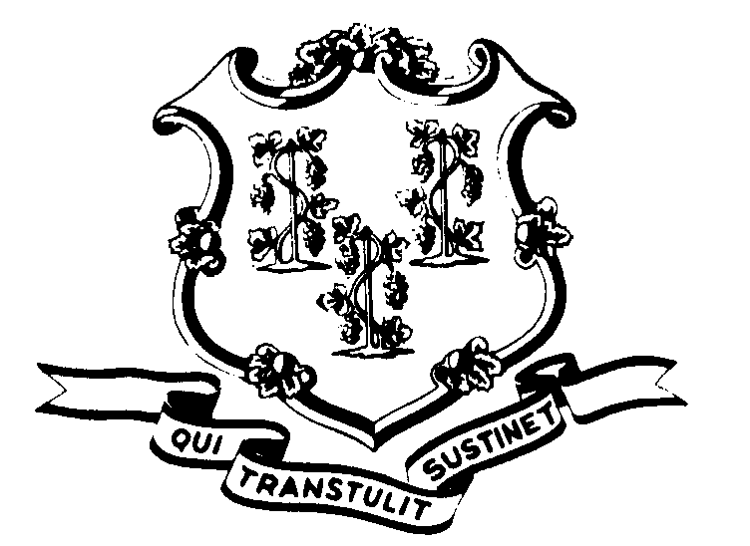STATE OF CONNECTICUT

OFFICE OF POLICY AND MANAGEMENT

Office of Labor Relations

September 12, 2001

General Notice 2001-13

TO: Labor Relations Designees

SUBJECT: Early Release – September 11, 2001

On Tuesday, September 11, 2001, Governor John G. Rowland released nonessential state employees early because of the events on that day.

Consistent with past practice, contractual and statutory provisions, you are reminded of the following:

- Nonessential employees who were released early will record the time they did not work by the symbol “WG”. Essential employees who worked will be paid in accordance with contractual and statutory provisions. Essential employees are not eligible for compensatory time off.
- Employees absent because of illness or scheduled to take vacation leave, personal leave or other earned time shall have the appropriate leave balance charged and shall not be eligible for “WG” time. Employees on leave of absence without pay (including voluntary leave) or other scheduled day off, such as a pass day or “flex” day, shall not be eligible for “WG” time.
Labor Relations Designees with questions should be directed to the Office of Labor Relations at 418-6447. All others should contact their Central Personnel Office.

Linda J. Yelmini
Linda J. Yelmini
Director of Labor Relations

