STATE OF CONNECTICUT
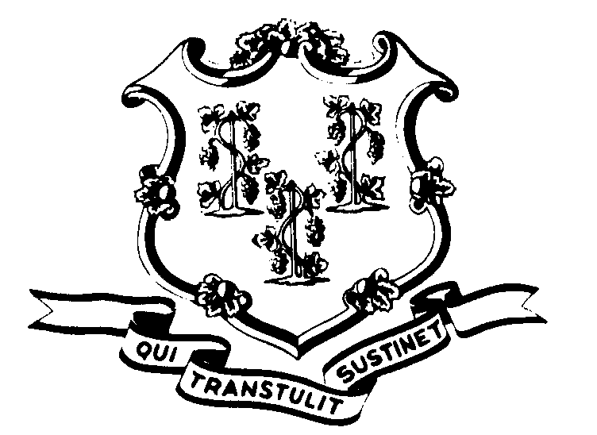

OFFICE OF POLICY AND MANAGEMENT

Office of Labor Relations

November 26, 2001

General Notice No. 2001-16

TO: Agency Heads and Labor Relations Designees

SUBJECT: Arbitration Award -- Retroactive Payments for Auto Usage, Meal Rates, Safety Shoes and Holidays for Members of the Administrative and Residual (P-5) Bargaining Unit

Pursuant to an Award issued by Arbitrator Jeffery Selchick on October 22, 2001 regarding three A&R grievances, the State is required to reimburse employees retroactively as follows:

- The State shall reimburse affected employees retroactive to July 1, 1999 at the rate of $4.50 per day for each day of required auto usage consistent with Article 25, Section 5(b) provided that such employees have not already been so reimbursed.

- The State shall reimburse affected employees retroactive to July 1, 1999 at the following meal rates consistent with Article 25, Section 13(a) provided that such employees have not already been so reimbursed:

Breakfast $ 8.00
Lunch $10.00
Dinner $20.00

- Employees, who on or after 7/1/99 were required on a daily basis to wear safety shoes and who were reimbursed in the amount of $60.00 for such shoes, will receive $10.00, representing the amount of increase retroactive to July 1, 1999 in the safety shoe allowance under Article 24, Section 9.

- Employees who worked on a holiday, and who were otherwise eligible, but were not compensated in accordance with Article 17 of the Contract, shall be compensated accordingly retroactive to 7/1/99.

Employees with questions about this Award should contact their Agency Human Resources Offices. Questions from Agency Personnel Officers should be addressed to Christine Cieplinski at 418-6321 or Fae Brown-Brewton at 418-6217 of the Office of Labor Relations.

Linda J. Yelmini

Linda J. Yelmini
Director of Labor Relations

