STATE OF CONNECTICUT
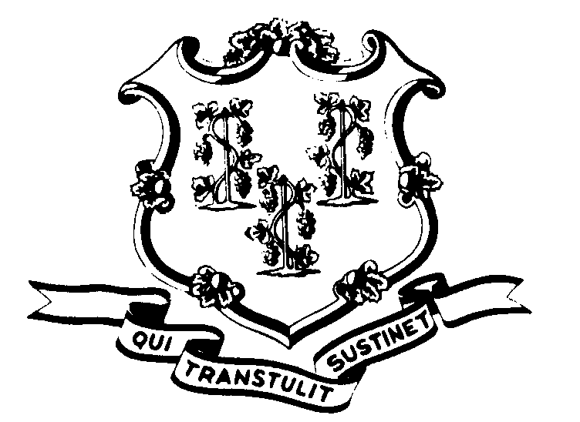

OFFICE OF POLICY AND MANAGEMENT

Office of Labor Relations

June 19, 2002

General Notice 2002-10a - Supplemental

TO: Labor Relations Designees

SUBJECT: A&R Seniority List - Question

An excellent question was posed to me yesterday, regarding whether or not service prior to 7/1/77 FOR LAYOFF PURPOSES ONLY counts in A&R (P-5) and Protective Services (NP-5). The answer is no it does not.

Therefore, in developing bargaining unit service, do not include service prior to 7/1/77. This is because the bargaining unit did not exist before that date. It is especially important that all agencies do this the same in A&R due to statewide bumping issues. I have made the appropriate changes to the A&R service information, as well as the changes suggested at the Agency Personnel Managers meeting and have attached the same hereto.
Agency Labor Relations Designees with questions may contact me at 418-6446. All other questions should be directed to the agency personnel office.

Linda J. Yelmini

Linda J. Yelmini
Director of Labor Relations

