STATE OF CONNECTICUT
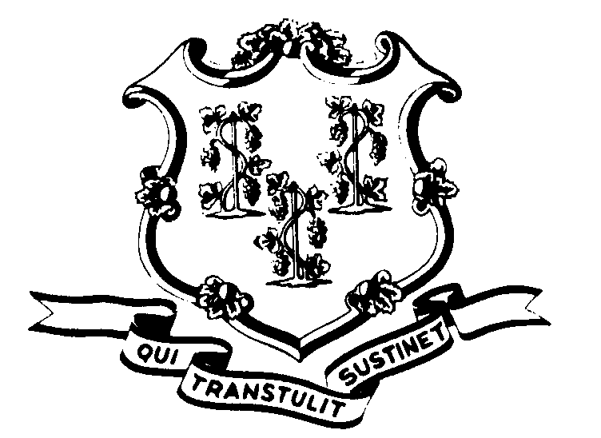

OFFICE OF POLICY AND MANAGEMENT

Office of Labor Relations

July 25, 2002

General Notice 2002-14

TO: Labor Relations Designees

SUBJECT: A&R Seniority List

Attached is the A&R Seniority list by Classification as of June 30, 2002. It represents all of the corrections that were made in accordance with OLR General Notice 2002-10. A copy of the list is also being sent to A&R. Please make any additional corrections you deem appropriate that may be identified by A&R and/or individual employees.
Agency Labor Relations Designees with questions may contact the Office of Labor Relations at 418-6447. All other questions should be directed to the agency personnel office.

Linda J. Yelmini

Linda J. Yelmini
Director of Labor Relations

