STATE OF CONNECTICUT
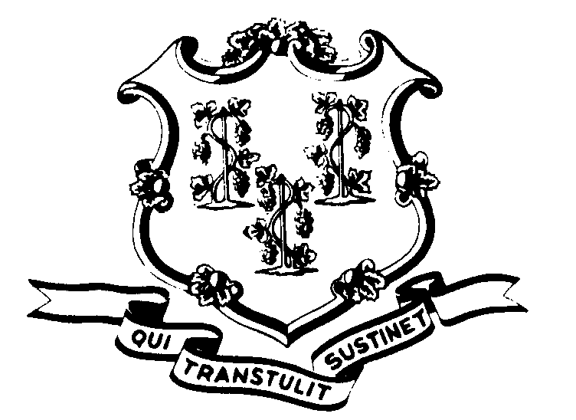

OFFICE OF POLICY AND MANAGEMENT

Office of Labor Relations

November 15, 2002

GENERAL NOTICE NO. 2002-23

TO: Labor Relations Designees

FROM: Office of Labor Relations

SUBJECT: Mandatory Overtime – District 1199

The State and the Union (New England Health Care Employees Union, District 1199) have recently received an Arbitration Award concerning the above subject.
Under the contract, Mandatory Overtime (Article 13, Section 13) may be utilized only under emergency situations. Emergency is defined as a weather emergency or other event where the Governor closes State offices, a lockdown in a correctional institution, or when the number of actual staff reporting to work is below minimum safe levels or legal requirements.
The contract also addressed the amount the employees should be paid when they are mandated. The compensation rate is double the regular hourly rate.
The arbitration addressed the rate of pay for part-time employees who are mandated. The award specified that the double time rate does not apply for mandatory hours that do not exceed forty (40) hours of work time per week.
Additionally, the Arbitrator stated “the standard of measure for purposes of Article 13, Section 13(A) is not an employee’s full-time or part-time status, but rather, whether he/she has been mandated to work over forty hours in an emergency”.
As a result of this award, agencies are required to:
- Review records to determine when the double time rate has been paid or not paid;
- Recognize that employees who have been paid double time while working less than forty (40) hours have been overpaid and follow the overpayment procedure of the contract;
- Recognize that employees who have not been paid double time for hours worked over forty (40) when mandated have been underpaid. This is applicable whether a full-time or a part-time employee. Such employees are to be properly compensated.
- The retroactive date for paying those entitled to double for mandated over forty (40) hours of work shall be July 14, 2001.

Labor Relations Designees with questions regarding this should contact Robert Curtis at 418-6241. All others please direct your inquiries to your agency Personnel Office.

Linda J. Yelmini
Linda J. Yelmini
Director of Labor Relations

