STATE OF CONNECTICUT
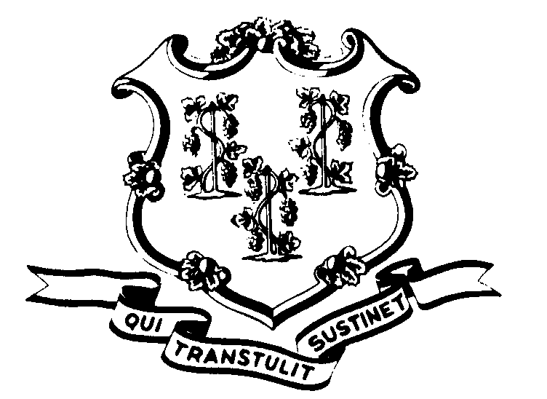

OFFICE OF POLICY AND MANAGEMENT

Office of Labor Relations

February 23, 2003

General Notice 2003-06

TO: Labor Relations Designees

SUBJECT: Alternative Work Schedules
Pilot Projects
A&R – Article 16A
We have received an arbitration award on the above subject matter. Under the Award, Arbitrator Selchick found that if an Agency offers an AWS option to only a limited group of employees on a pilot project basis, those employees not part of the pilot must be offered the option on the AWS menu of options outright UNLESS:

- The employees are otherwise exempt because they are subject to another pilot project; OR
- The employees are exempt pursuant to a written justification to OLR based upon provable business necessity as referenced in Article 16A, Section One (a).

Agencies should note that Article 16A, Section 2(a) provides that the number of employees identified for a pilot project should be determined in consultation with the Union. Arbitrator Selchick interpreted this “consultation” to “naturally include the identified class of employees to be covered by the pilot project and other essential details including but not limited to the duration of the pilot and the location(s) where the pilot will be utilized” as well as “[c]riteria for evaluation of the pilot project.”

Arbitrator Selchick ordered that Agencies must comply with the award by March 13, 2003.

Labor Relations Designees with questions concerning this request should contact Christine Cieplinski (418-6321) or Robert Curtis (418-6241). All others should contact their Central Personnel Office.

Linda J. Yelmini
Linda J. Yelmini
Director of Labor Relations

