STATE OF CONNECTICUT
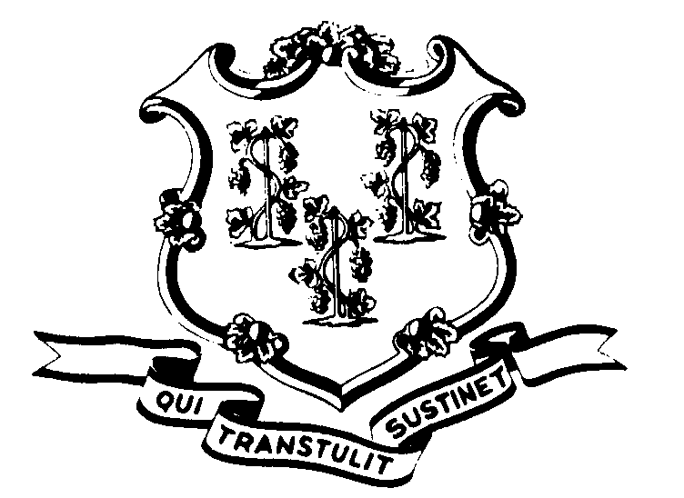

OFFICE OF POLICY AND MANAGEMENT

Office of Labor Relations

April 9, 2003

General Notice No. 2003-15
TO: Labor Relations Designees

SUBJECT: Reemployment of Retired Employees

You are reminded that under the provisions of CGS §5-164a(c), as modified by the Pension Award, retired members of the State Employees Retirement System who are reemployed by the State can work no more than 120 days (960 hours) in a calendar year without impairing their pension rights. In the event they work more than 120 days, such members must reimburse the retirement fund for all retirement income payments received during the period of reemployment.

In order to monitor compliance with the provision, as well as make appropriate deductions from the income such individuals receive, you are reminded that it is essential to place such employees on the regular payroll in temporary positions established for no more than 120 days in a calendar year. Of course, OPM approval is required to establish temporary positions and such approval will be given only in special circumstances. The constituent units of higher education and other agencies, not subject to OPM review and approval of their position actions, are advised that they must also comply with the 120-day requirement.

Reemployed retirees should not be placed on personal services contracts. Such contracts will not be approved by OPM.
Labor relations designees with questions regarding this should contact OLR at 418-6447. All others please direct your inquiries to your agency personnel office.

Linda J. Yelmini

Linda J. Yelmini
Director of Labor Relations

