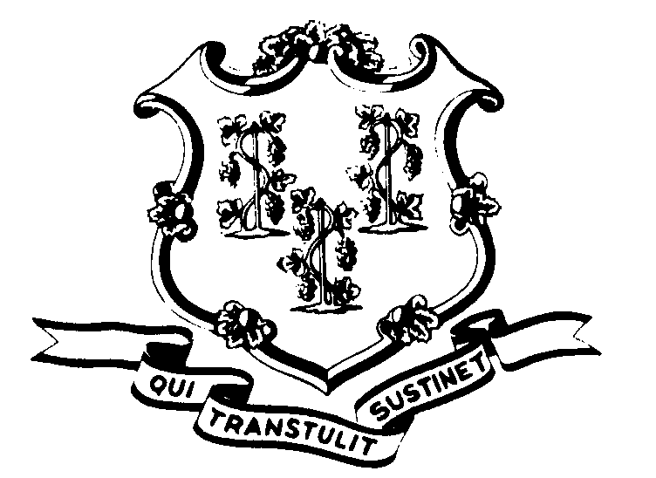STATE OF CONNECTICUT

OFFICE OF POLICY AND MANAGEMENT

Office of Labor Relations

April 6, 2004

General Notice No. 2004-09

TO: Agency Heads and Labor Relations Designees

SUBJECT: Administrative and Residual Union - Letter from Michael Winkler dated 4/01/04

Michael Winkler, President of the Administrative and Residual Union has sent another letter to Agency Heads and Labor Relations designees requesting information under CGS §1-200 (Freedom of Information Act).
Kindly acknowledge the request within the statutory four (4) day time period. Please begin compiling the requested documents, if any. Contact Victoria Chavey, Esq., Day, Berry & Howard, City Place I, Hartford, CT 06103, (860) 275-0100 so that she can coordinate the production of responsive documents.
If your agency does not have any of the requested information, you should respond to Mr. Winkler accordingly. If possible, please do that within the four (4) day period to eliminate the necessity of sending an acknowledgement.
Please send copies of any responses to Mr. Winkler to both Ms. Chavey and myself. Thank you.
Employees with questions should contact their Agency Personnel Office. Questions from Agency Personnel Officers may be addressed to me at 418-6446.

Linda J. Yelmini

Linda J. Yelmini
Director of Labor Relations

