STATE OF CONNECTICUT
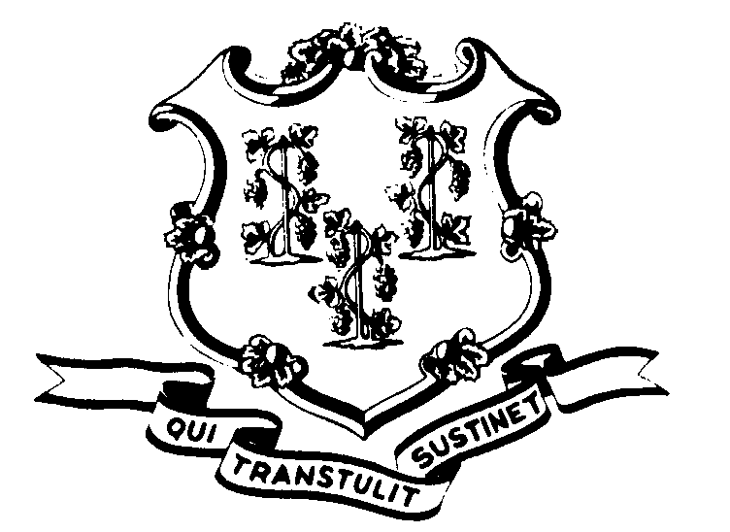

OFFICE OF POLICY AND MANAGEMENT

Office of Labor Relations

May 18, 2004

General Notice 2004-11

TO: Labor Relations Designees

SUBJECT: Notice of Layoff for Employees Given AT RISK Notices in P-4

____________________________________________________________________

P-4 AWARD
Based upon the arbitration award issued by Arbitrator Selchick in a case arising under the P-5 Contract, Arbitrator Holden recently ruled that the “at risk” notices that were sent to employees in the P-4 bargaining unit were insufficient notice of actual layoff under Article 13, Section 3 of the P-4 Agreement. The Union clarified its position during the hearing protesting the notices given to employees who were bumped out of their former positions and left without a job, as opposed to its original position, that all persons bumped were entitled to four weeks notice.
According to Arbitrator Holden, while some of the notices provided an actual date certain for layoff, many of these notices were insufficient because they did not provide such a date. Some employees received only one (1) full day notices of the actual layoff and discontinuation of employment while others received four weeks notice of the actual layoff. Since there was confusion among the agencies about the matter, Arbitrator Holden, like Arbitrator Selchick determined that the at risk notices were inadequate notice of actual layoff.
The Arbitrator ruled that employees who received at risk notices are entitled to 4 weeks notice of actual layoff. The Union provided the attached list of employees it maintained were inadequately noticed, including the corresponding departments. It is OLR’s understanding that in most instances, the P-4 bargaining unit members who received initial at risk notices also received subsequent notices confirming the effective date of the layoff. Accordingly, in these situations, the 4 weeks will be calculated from the date of the confirmation letter.
The following page is the list of P-4 bargaining unit members identified by the Union indicating the number of days pay the Union believes is owed to those impacted employees. Please carefully review the list and compare it with your records. If there is no dispute with the Union’s calculations, please compensate the employees accordingly. If there is a disagreement, please notify Fae Brown-Brewton at the Office of Labor Relations by calling 860-418-6217 or by e-mail at Sandra.brown-brewton@po.state.ct.us.

Linda J. Yelmini
Linda J. Yelmini
Director of Labor Relations

