STATE OF CONNECTICUT
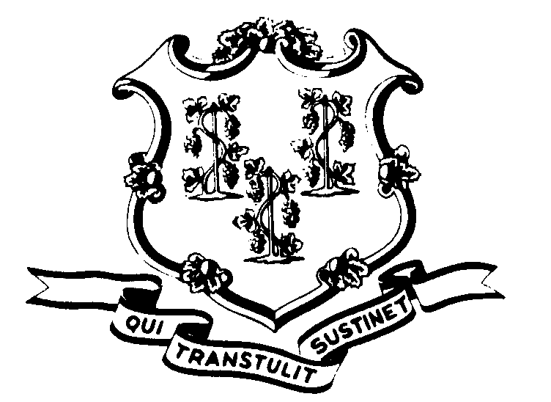

OFFICE OF POLICY AND MANAGEMENT

Office of Labor Relations

November 19, 2004

General Notice No. 2004-22

TO: Labor Relations Designees

SUBJECT: Notice to Departments Employing NP-6 & P-1 Bargaining Unit
Members

As you probably know, we recently commenced negotiations with District 1199 for a successor collective bargaining agreement. The Union has made a substantial information request. While we have been able to gather some of the information requested with the assistance of DAS and OPM Personnel, we need your assistance to compile some of the information available only from the State Agencies. This includes the request for the following:
The names, work locations, and classifications of all provisional workers in the NP-6 and P-1 Bargaining Units.
The number of education and/or conference days allowed per worker by agency.
The number of hours and amount spent in each FYE 2003 and 2004 on
pool/outside agency nurses, again by agency or by department.

Please gather this information as soon as possible and forward it to Fae Brown-Brewton via email at Sandra.Brown-Brewton@po.state.ct.us or via fax at 418-6491.

Your prompt attention to this matter is appreciated.

If you should have any questions, please do not hesitate to contact Fae Brown-Brewton at 418-6217. Employees with questions should contact their Agency Personnel Office.

Linda J. Yelmini

Linda J. Yelmini
Director of Labor Relations

