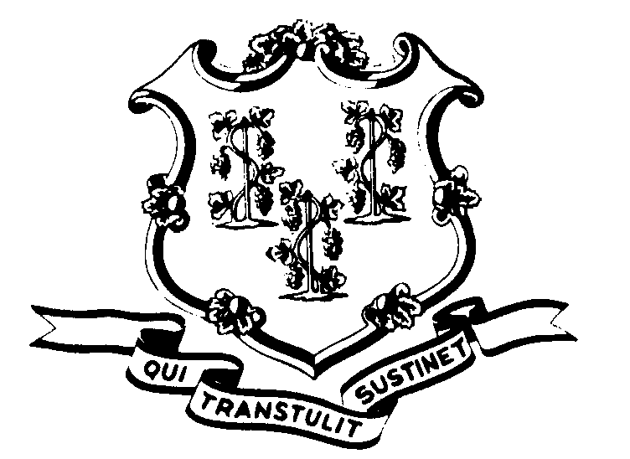STATE OF CONNECTICUT

OFFICE OF POLICY AND MANAGEMENT

Office of Labor Relations

April 17, 2006

General Notice No 2006-06

To: Labor Relations Designees

SUBJECT: NP-2 Contract Informational Meetings

The NP-2 Interest Arbitration Award is expected on or about April 21, 2006 and will contain changes to the contract. The Union will be conducting informational meetings with NP-2 members to explain the changes and answer any questions they may have. These meetings are to be conducted during the regular work day and NP-2 employees are to be released, on State time, to attend.

Agencies will be contacted by Union representatives to coordinate the time and location of the meetings. In order to maximize efficiency, Agencies with centrally located appropriate meeting areas are requested to allow employees from other Agencies to attend meetings at their facilities and Agencies are requested to release their employees to do so.

If you have any questions, contact Paul Bodenhofer at (860) 418-6215.

Robert L. Curtis
Robert L. Curtis
Director of Labor Relations

