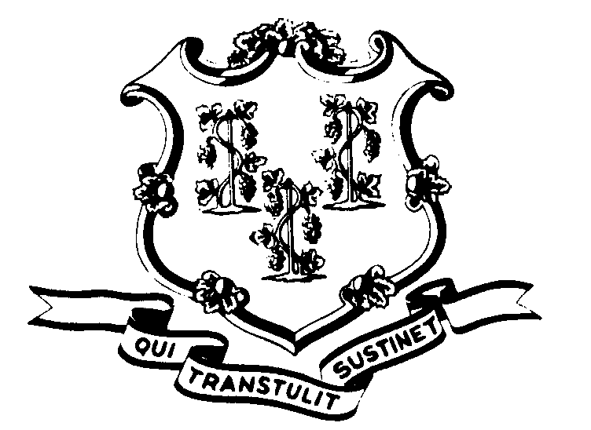STATE OF CONNECTICUT

OFFICE OF POLICY AND MANAGEMENT

Office of Labor Relations

April 6, 2009

General Notice 2009-6

TO: Labor Relations Designees

SUBJECT: Tentative SEBAC Agreement

The following statement was released by the Governor’s office and SEBAC today:
“Governor Rell and State Employees Union Leaders today announced that they had worked out the framework for an agreement intended to help reduce costs and protect public services in the current fiscal year and the upcoming biennium. When finalized, the agreement will provide for labor cost savings of over $637 million in the upcoming biennium, in addition to savings in the current fiscal year. The framework also provides job security for permanent employees during the upcoming biennium, as well as the flexibility needed to make organizational changes. Details of the agreement are still being discussed, including translating its job security provisions to the particular circumstances of the Judicial Branch and higher education institutions.
In order to respect the democratic processes of the unions involved, Governor Rell and union leaders have agreed not to provide details to the press until they can be presented to union delegates and members. This process is expected to take several days. However, the Governor and union spokesperson have confirmed that the proposed agreement includes a Retirement Incentive Program, in addition to changes in health insurance and wages.
While the parties expressed optimism that a positive result would be reached, they cautioned that more work remains to be done, and that any agreement ultimately must be presented to union membership for ratification, and to the General Assembly for approval.”
It is anticipated that there will be meetings with union leadership over the next several days to attempt to resolve individual bargaining unit issues. SEBAC has scheduled a meeting on April 15, 2009 to take a vote on the Agreement. The agreement will then go out for voting by the union membership. No union release has been authorized for any of these purposes.

Agency Labor Relations Designees with questions may contact the Office of Labor Relations at 418-6447.

Linda J. Yelmini
Linda J. Yelmini
Director of Labor Relations

