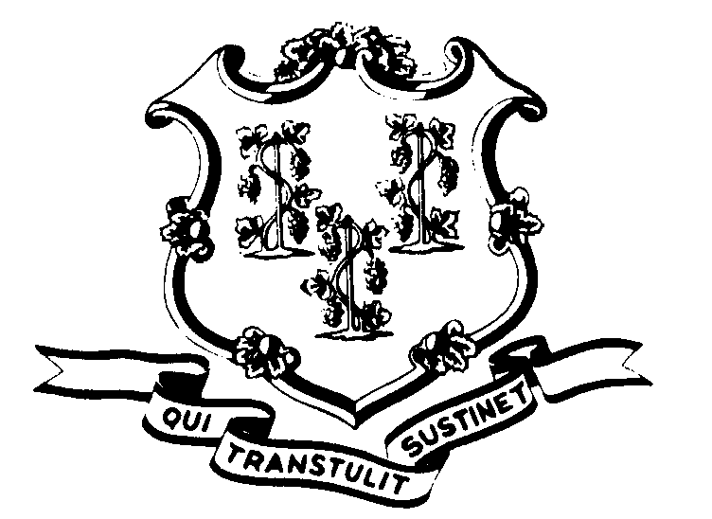STATE OF CONNECTICUT

OFFICE OF POLICY AND MANAGEMENT

Office of Labor Relations

January 27, 2011

General Notice 2011-03

TO: Labor Relations Designees

SUBJECT: January 27th Snow Storm

On Thursday, January 27, 2011 Governor Dannel P. Malloy indicated that nonessential state employees did not have to report to work until noon because of the hazardous driving conditions.

Consistent with past practice, contractual and statutory provisions, you are reminded of the following:

- Nonessential employees scheduled to work on that day will record the time from the beginning of their scheduled workday until 12:00 noon as “LWGOV”. Essential employees who did report to work will be paid in accordance with contractual and statutory provisions. Essential employees are not eligible for compensatory time off unless specifically provided in their collective bargaining agreement.
- Employees who were not scheduled to work on January 27th or who did not come in at noon (even though they were otherwise scheduled to work) are not covered by the Governor’s action. Employees absent because of illness or scheduled to take vacation leave, personal leave or other earned time shall have the appropriate leave balance charged and shall not be eligible for “LWGOV” time. Employees on leave of absence without pay (including voluntary leave) or other scheduled day off, such as a pass day or “flex” day, shall not be eligible for “LWGOV” time.
- Governor Malloy’s request did not impact state employees who work on the second or third shift as those operations were not delayed.
Labor Relations Designees with questions should be directed to the Office of Labor Relations at 418-6447. All others should contact their Central Personnel Office.

Linda J. Yelmini
Linda J. Yelmini
Director of Labor Relations

