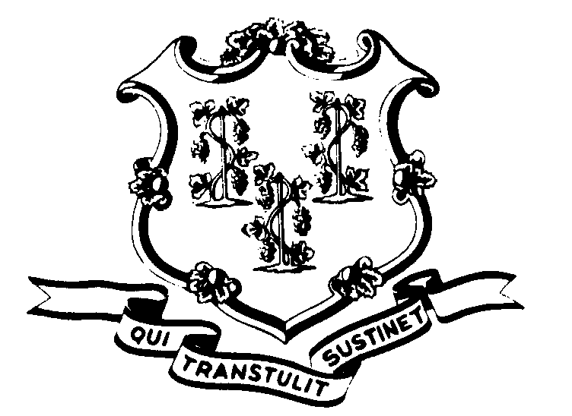STATE OF CONNECTICUT

OFFICE OF POLICY AND MANAGEMENT

Office of Labor Relations

August 30, 2011

General Notice 2011-22

TO: Labor Relations Designees

SUBJECT: August 29th delayed arrival time

As a result of Hurricane Irene, Governor Dannel P. Malloy indicated that nonessential state employees should report to report to work at 10:00 a.m. on Monday August 29, 2011.

Consistent with past practice, and contractual and statutory provisions, you are reminded of the following:

- Nonessential employees scheduled to work on that day will record the time from the beginning of their scheduled workday until 10:00 a.m. as “LWGOV”. Essential employees who did report to work will be paid in accordance with contractual and statutory provisions. Essential employees are not eligible for compensatory time off unless specifically provided in their collective bargaining agreement.
- Employees who were not scheduled to work on August 29, 2011 or who did not come in at 10:00 a.m. (even though they were otherwise scheduled to work) are not covered by the Governor’s action. Employees absent because of illness or scheduled to take vacation leave, personal leave or other earned time shall have the appropriate leave balance charged and shall not be eligible for “LWGOV” time. Employees on a leave of absence without pay (including voluntary leave) or other scheduled day off, such as a pass day or “flex” day, shall not be eligible for “LWGOV” time.
- Governor Malloy’s request did not impact state employees who work on the second or third shift as those operations were not delayed.
- As the aftermath of Hurricane Irene continues to impact various locations throughout the State, until power is restored in specific work locations, nonessential employees shall be permitted to use the “LWGOV” code for time that they are not permitted to report for duty. Employees should continue to contact their worksite or office to determine if the situation has been remedied.

Labor Relations Designees with questions should be directed to the Office of Labor Relations at 418-6447. All others should contact their Central Personnel Office.

Linda J. Yelmini
Linda J. Yelmini
Director of Labor Relations

