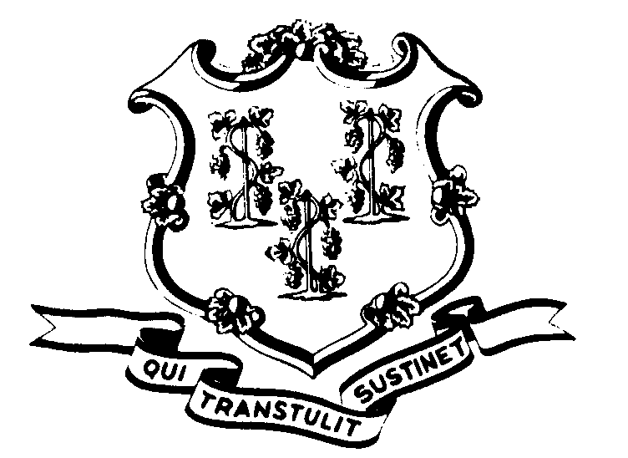STATE OF CONNECTICUT

OFFICE OF POLICY AND MANAGEMENT

Office of Labor Relations

February 3, 2015

General Notice 2015-02

TO: Labor Relations Designees

SUBJECT: January 26th, 27th and February 2nd Winter Weather Events

JANUARY 26 2015 EARLY RELEASE

On Monday, January 26, 2015, due to the impending snow storm, Governor Dannel P. Malloy authorized first shift non-essential state employees to be released by 3:30 pm. In Hartford, a staggered release time was granted at either 3:00 or 3:30 p.m. Second and third shift non-essential employees were not to report to work for Monday, January 26, 2015.

- Non-essential employees working on January 26, 2015 who were released early should code “LWGOV” for the hours following departure from work through the end of the employees scheduled work day. Non-essential employees scheduled to work on the second or third shift on January 26, 2015 shall code their time as “LWGOV” for their scheduled work hours.
- Employees who were not scheduled to work January 26, 2015 or who did not come to work or departed prior to 3:00/3:30 p.m. are not covered by the Governor’s directive.
- Essential employees will be paid in accordance with contractual and statutory provisions and are not eligible for compensatory time off unless specifically provided in their collective bargaining agreement.
- Employees absent because of illness, scheduled vacation, personal leave, or other earned time shall have the appropriate leave balance charged and are not eligible for “LWGOV” time. Employees on a leave of absence with or without pay (including voluntary leave), scheduled day off or pass day shall not be eligible for “LWGOV” time.

ALL THREE SHIFTS NOT TO REPORT ON JANUARY 27, 2015

In response to winter storm conditions throughout the State, Governor Malloy initially ordered first and second shift, non-essential State employees not to report to work on Tuesday, January 27, 2015 and later advised third shift non-essential employees not to report as well.

Due to the very unusual circumstances of the storm, including the travel ban necessitating the closing of state offices to non-essential state employees on all shifts, it has been determined that time and attendance should be treated as follows:

- Non-essential employees scheduled to work on the three shifts beginning with the first shift on January 27, 2015 and ending with the third shift should record their regularly schedule time as “LWGOV”.
- Essential employees who reported to work will be paid in accordance with contractual and statutory provisions. Essential employees are not eligible for compensatory time off or other enhancements unless specifically provided in their collective bargaining agreement.
- Non-essential employees who were not scheduled to work on January 27, 2015 due to pre-planned paid sick or vacation leave may also be allowed to record their time as “LWGOV” as provided by the specific terms of their collective bargaining agreement. This only applies to collective bargaining agreements that provide that employees will not be charged vacation and/or sick leave when “A full day off is granted by act of the Governor…” Absent specific contract language, employees who were not scheduled to work on January 27, 2015 due to prescheduled time off, shall have the day charged to the appropriate leave balance.
- Employees on a leave of absence with or without pay (including voluntary leave) or other scheduled day off, such as a pass day or “flex” day, shall not be eligible for “LWGOV” time.

DELAYED OPENING FOR FEBRUARY 2, 2015

Due to the winter storm and the related travel conditions, Governor Malloy ordered a delayed opening of state offices and directed that non-essential state employees report to work at 10:00 a.m. on Monday, February 2, 2015.

- Non-essential employees who reported to work on February 2nd may record the time from the beginning of their scheduled workday until 10:00 a.m. as “LWGOV”. Non-essential employees arriving after 10:00 a.m. may request to use their accrued vacation or personal leave time to cover the excess time beyond 10:00 a.m. Anyone who did not report to work is not eligible for “LWGOV” time.
- Employees who were not scheduled to work on February 2nd are not covered by the Governor’s declaration. Employees absent because of illness or scheduled to take vacation leave, personal leave or other earned time shall have the appropriate leave balance charged and shall not be eligible for “LWGOV” time. Employees on leave of absence with or without pay (including voluntary leave) or other scheduled day off, such as a pass day or “flex” day, shall not be eligible for “LWGOV” time.
- Essential employees are not eligible for compensatory time off unless specifically provided in their collective bargaining agreement.
- Governor Malloy’s instruction did not impact state employees who work on the second or third shifts as those operations were not delayed.

Employee questions about this notice should be addressed to the Agency’s Human Resources office. Agency Labor Relations Designees with questions may contact the Office of Labor Relations at 418-6447.

S. Fae Brown-Brewton
S. Fae Brown-Brewton
Assistant Director of Labor Relations

