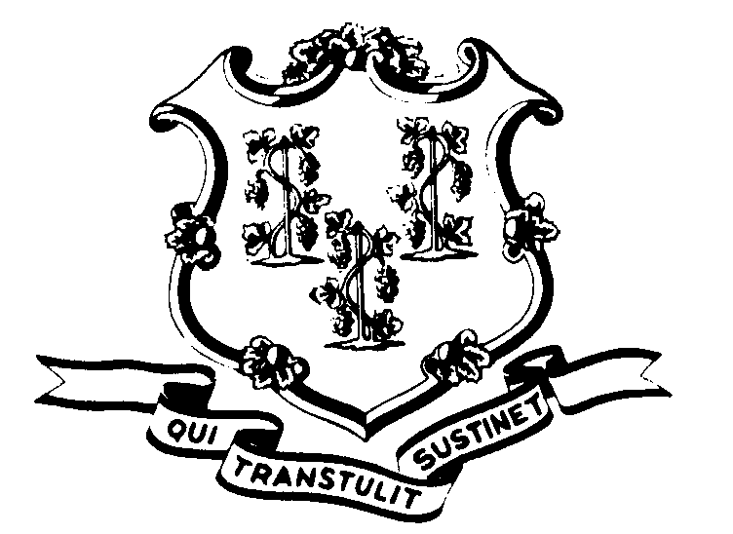STATE OF CONNECTICUT

OFFICE OF POLICY AND MANAGEMENT

Office of Labor Relations

November 15, 2016

GENERAL NOTICE NO. 2016-06

TO: Labor Relations Designees

SUBJECT: Contract Extension Agreements

Attached are copies of the fully-executed extension agreements for the collective bargaining agreements that expired June 30, 2016. We do not have an agreement with the Corrections Supervisors (NP-8) bargaining unit. Should we enter into an extension agreement with that unit, we will provide a copy to you at that time.

Labor Relations Designees with questions may contact Fae Brown Brewton at (860) 418-6217. All others should contact their Central Personnel Office.

______________________
Lisa Grasso Egan
Undersecretary for Labor Relations

Phone: (860) 418-6447 Fax: (860) 418-6491
450 Capitol Avenue-MS# 53OLR, Hartford, Connecticut 06106

