STATE OF CONNECTICUT
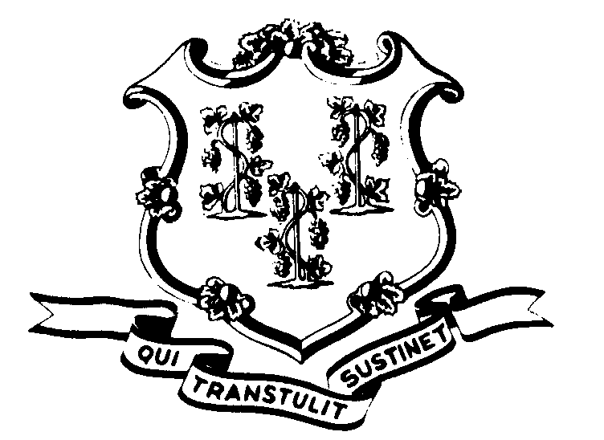

OFFICE OF POLICY AND MANAGEMENT

Office of Labor Relations

August 11, 1999

General Notice No. 99-07

TO: Labor Relations Designees

SUBJECT: A&R Seventh Step Bonus - Employees at maximum who retired between July 1, 1997 and October 1, 1997
As part of the A&R negotiations for the 1995 - 1999 A&R contract, the Union agreed to delay the Annual Increment for three months from July 1, 1995 through January, 1999. For each year of the Agreement, employees who were at maximum were to receive a lump sum payment in lieu of an annual increment. The lump sum payment was likewise delayed for three months in each year.
The State did not pay a lump sum payment to those employees who retired between July 1, 1997 and October 1, 1997. This was based upon the fact that the employees left state employment before the October 1, 1997 payment became due. The A&R Union grieved the nonpayment.
We recently received an Arbitration Award which granted a Seventh Step Bonus payment to A&R employees who were at maximum and who retired between July 1, 1997 and October 1, 1997. The amounts are dependent upon the employee's salary grade. Payment must be made in accordance with the following schedule:
Salary Grade | Bonus | Salary Grade | Bonus | Salary Grade | Bonus | Salary Grade | Bonus
11 | $656 | 18 | $905 | 25 | $1238 | 32 | $1619
12 | 677 | 19 | 945 | 26 | 1294 | 33 | 1680
13 | 733 | 20 | 987 | 27 | 1354 | 34 | 1743
14 | 764 | 21 | 1031 | 28 | 1416 | 35 | 1809
15 | 796 | 22 | 1084 | 29 | 1452 | 36 | 1878
16 | 831 | 23 | 1132 | 30 | 1506 | 37 | 1950
17 | 867 | 24 | 1184 | 31 | 1562

Employees with questions about this policy and procedure should contact their Agency Human Resources Office. Questions from Agency Personnel Officers may be addressed to Fae Brown-Brewton of the Office of Labor Relations at 418-6217.

Linda J. Yelmini
Linda J. Yelmini
Director of Labor Relations

