STATE OF CONNECTICUT
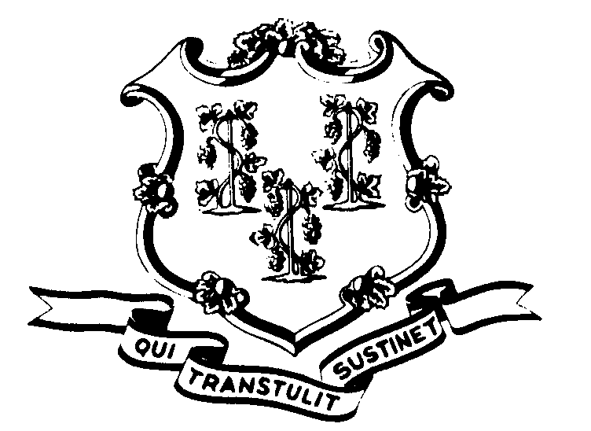

OFFICE OF POLICY AND MANAGEMENT

Office of Labor Relations

August 19, 1999

General Notice No. 99-08

TO: Labor Relations Designees

SUBJECT: Employee Personnel Files and Information
A number of questions have been posed concerning the above. Effective immediately, when an employee transfers from one agency to another, the individual's entire personnel file shall be sent to the new agency. In this way, all of an employee's records will be in one place. The transferring agency should get a signed receipt from the new agency.
There is no need to send the files of employees who transferred prior to today. However, if an employing agency requests the file, the former agency should forward it and receive the appropriate receipt.
Additionally, you should remember that the State is one employer. There is no prohibition against sharing employment information between agencies. This is especially important to remember in reemployment situations. For example,
An employee applies for reemployment with Agency X and lists that they have been employed by Agency Y in the past. Upon request by Agency X, Agency Y should share any employment related information with Agency X. If Agency X hires the employee, the personnel file from Agency Y should be transferred to Agency X.
In the above example, pursuant to Connecticut General Statutes §4-193, a record must be kept of any disclosure of “personal data”.
Employees with questions about this General Notice should contact their Agency Human Resources Office. Questions from Agency Personnel Officers may be addressed to the Office of Labor Relations at 418-6447.

Linda J. Yelmini
Linda J. Yelmini
Director of Labor Relations

