STATE OF CONNECTICUT
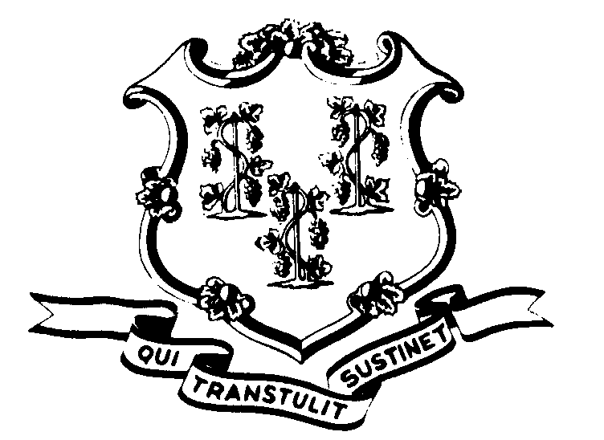

OFFICE OF POLICY AND MANAGEMENT

Office of Labor Relations

September 14, 1999

General Notice No. 99-09

TO: Agency Heads and Labor Relations Designees

SUBJECT: Violence in the Workplace Policy and Procedures Manual for Human Resource Professionals
As described in OLR General Notice No. 99-05, the State has developed a policy and procedures manual for Human Resource professionals regarding violence in the workplace. It should be utilized together with the information provided in OLR General Notice No. 99-05.
Additionally, a training program will be implemented by the Department of Administrative Services (DAS) so that Agency Human Resources staff will be informed of the various aspects of this important subject. The manual will be utilized in the training. The training will offer more in depth information with emphasis on prevention of workplace violence. Information on training sessions will be distributed by DAS.
Copies of the manual can be downloaded from the Office of Policy and Management website at the following address: http://www.opm.state.ct.us/olr/wpv/wpv.htm. If you do not have Internet access, please contact our office.
Employees with questions about this policy and procedure should contact their Agency Human Resources Office. Questions regarding the building security and safety aspects of the manual should be addressed to Ray Philbrick, Department of Public Works at 713-5811. Questions from Agency Personnel Officers regarding the labor relations’ aspects of the manual should be addressed to the Office of Labor Relations at 418-6447.
Linda J. Yelmini

Linda J. Yelmini
Director of Labor Relations

