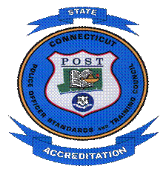
Police Officers Standards and Training Council
State Accreditation Program

STANDARDS REVISION FORM

Please provide standard number, and place an X in the appropriate box.

Standards Manual Edition Version: ______________Standard Number: __________________

New Standard |  | Revision |  | Deletion

Proposal (State the standard exactly as you believe it should appear in the manual).

Rationale for revision.

Proposed by:
Name_________________________________________Date____________________________
Agency_______________________________________________________________________
Address_______________________________________________________________________
City, State, ZIP_________________________________________________________________
Phone_______________________________________________________________

All proposed changes will be reviewed by State Accreditation subcommittee of the POST Council.

Approved__________ Disapproved____________ Approved with changes___________

