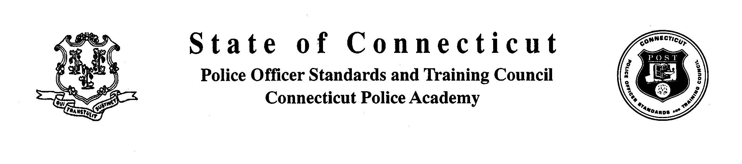

Police Officers Standards and Training Council
Certification Division

Date |  |  |  |  | Name
Agency |  |  |  |  | Area Requesting
Dates Available:
As required by the Police Officer Standards and Training Council, you will need to attend a 4- Hour practicum with a Basic Training POSTCS’ instructor. Please contact 203-427-2610 to schedule a practicum in the area you are applying for. Once the practicum is completed please have the POSTC instructor sign below confirming you have complete the requirement. Please forward to the Certification Division with your request for certification in this area. Please be sure lesson plans are included and application is filled out completely and signed by your Chief of Police.

POSTC Instructor |  |  |  |  |  | Applicant

