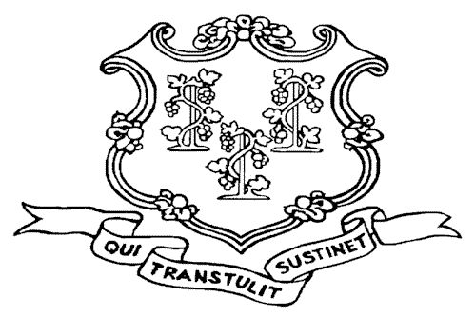
POLICE OFFICER STANDARDS AND TRAINING COUNCIL
285 PRESTON AVENUE
MERIDEN, CT 06450
CERTIFICATION DIVISION
203-427-2606

Police Officer Recertification Form

Department Date

The following officers have completed all training as required by the Police Officer Standards and Training Council Regulations 7-294e-14. All training files are available for inspection at any time.

Name | Certification# | Name | Certification #

I have read and signed this form and attest that the information provided herein is true and accurate to the best of my knowledge. I understand that intentionally making a false written statement that I do not believe to be true with the intent to mislead a public servant in the performance of their official functions on a form bearing this notice is punishable by law. False Statement in the 2nd degree, under Connecticut General Statute § 53a-157b, is a class A Misdemeanor. If I am a certified Police Officer in the State of Connecticut falsification will also result in my decertification as an officer.

Officer’s/Preparer’s Signature Print Name and Rank

