Catherine Fellows performing Harmonic Vibration with
Sol LeWitt's Concentric Circles at CCSU
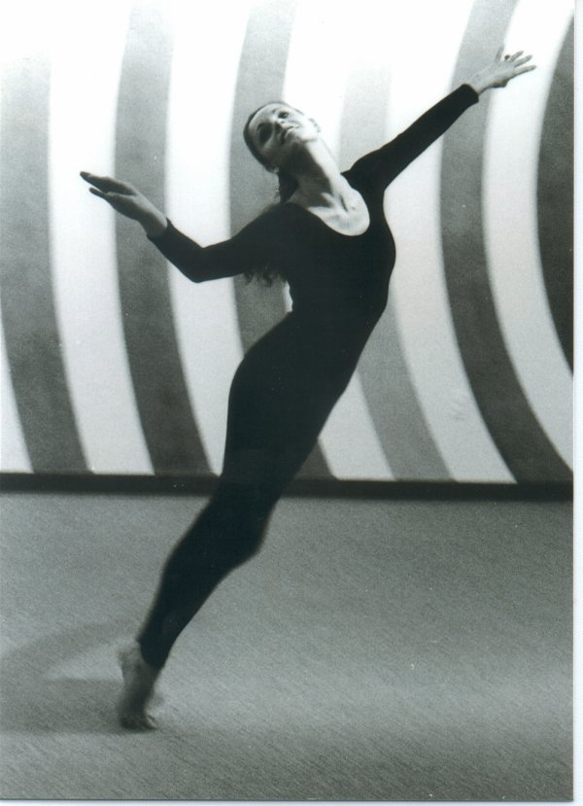
Catherine Fellows performing Harmonic Vibration with
Sol LeWitt's Concentric Circles at CCSU

CATHERINE J. FELLOWS, Professor, received her Master's degree in Dance Education from Boston University and her 6th year and B.S.ED from Central Connecticut State University. She has lectured, taught and performed for various regional, national and international dance companies and organizations. For the past 30 years Catherine has taught in the departments of Physical Education and Human Performance and Theatre at Central Connecticut State University. She is the director of the CCSU Dance Program and faculty advisor to the student dance organization, Dancentral. During the 2000-2001 academic year Professor Fellows received University recognition by being named to the Excellence in Teaching Honor Roll.

"The common goal that I strive for as an educator is to give all students the time, space and guidance to experience their maximum potential, whether executing a simple movement phrase, delivering a monologue, or performing a complete dance composition." Catherine J. Fellows

Colleagues and students attest to the significant level of her teaching ability:

"She encourages students to embrace their humanity and
to connect their core energy allowing truth in moving.”

"Professor Fellows is a disciplined and tireless worker who gives individual attention to her dancers. She is firm, but patient, and sets high standards for her students. The students respect her dedication and insistence on excellence, and they rise to the call......Catherine instills in her students an appreciation of hard work, discipline, and the satisfaction of a job well done."

Contact information: 860-832-2167
Email: fellowsc@ccsu.edu


CCSU

Central Connecticut State University

Start with a Dream…

Dance Program

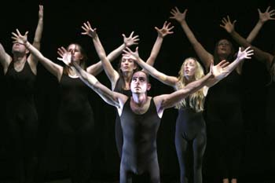

The Department of Theatre offers a Bachelor of Fine Arts (BFA) degree in Dance, as well as a Minor in Dance. The Department of Physical Education and Human Performance offers a cross-endorsement in dance education (B.S.Ed.).

The dance program is based in dance education supporting Connecticut’s formal pathway to dance teacher certification. Performance opportunities, internships with professional companies and community outreach programs are available to all students.

CCSU’s dance program is committed to teaching dance education as our primary focus. Students have the opportunity to perform their own works, faculty choreography and pieces by visiting guest artists in studio performances and main stage productions.

The dance program embraces personal development and wellness, technical dance training, growth in knowledge and skills, and exploration and application of creativity.

Dance Program Director/Adviser: Catherine J. Fellows,
Professor, CCSU
Adjunct Dance Faculty: Julia Frederick, Ballet; Judie Clark, Modern; Jill Henderson, Dance Methods; Susan Matheke, Dance History.
Guest Artists: Joseph Albano, E. Clayton Cornelius, Josh Hilberman, Jennifer Muller, Jennifer Newman, Paul Taylor/Taylor 2

Central Connecticut State University
Department of Physical Education and Human Performance
Department of Theatre
1615 Stanley Street • New Britain, CT 06050
Dance Program Office (860) 832 2167 http://www.ccsu.edu/Arts@CCSU.htm

… Finish with a Future!

DANCENTRAL
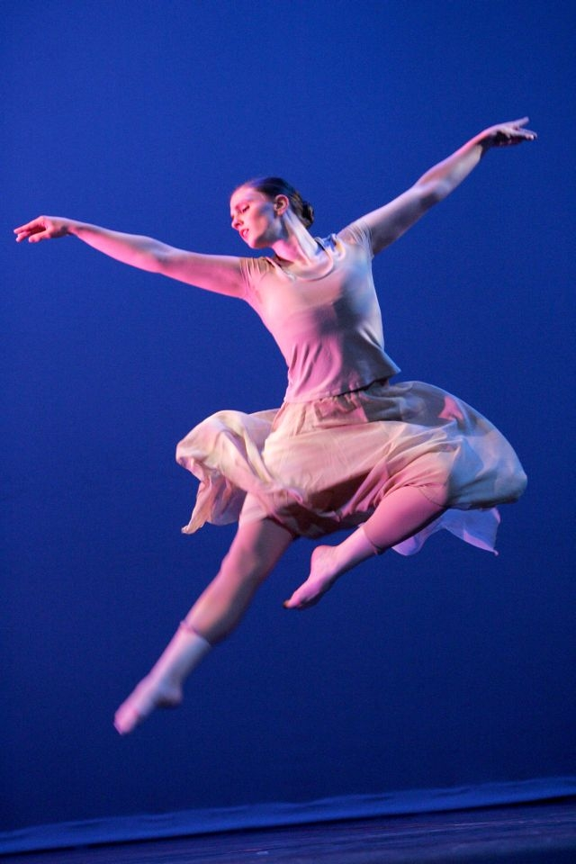

CCSU Dance Concert 2005
Dancentral is the student performing dance ensemble at Central Connecticut State University. The company offers several dance performances each year, and hosts regional and internationally acclaimed guest artists. Dancentral also presents a variety of dance in education programs for area public schools. Dancentral has toured over 40 Connecticut schools giving lecture demonstrations and workshops promoting dance in education. Dancentral has brought internationally renowned companies to the New Britain/Greater Hartford communities.

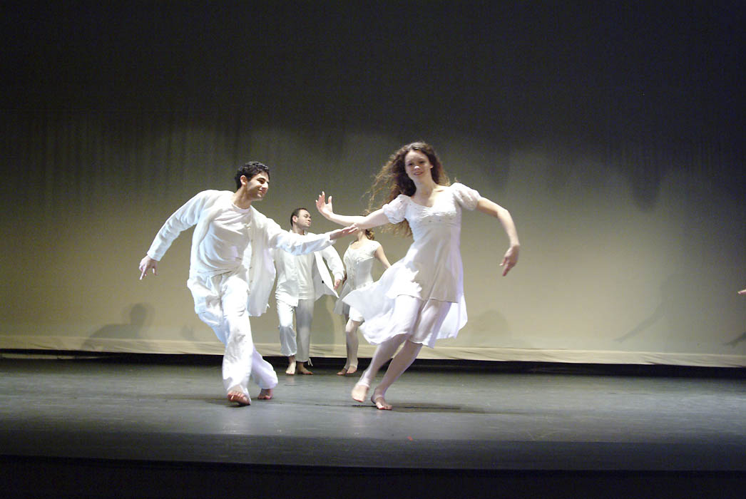

Dancentral's Spirit in Motion 2004

Community Outreach
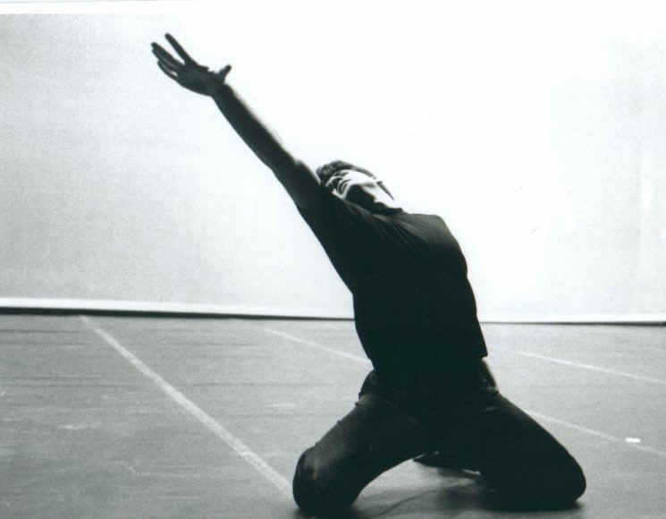
CCSU’s Dance Program serves the public in several ways by offering: community outreach programs, student participation and dance in education programs.

Outreach is accomplished by placing guest artists in area public schools and by inviting students and the dance community to CCSU campus for master classes and workshops. We are also building dance awareness throughout the area by sponsoring performances that reach out to the community at large.

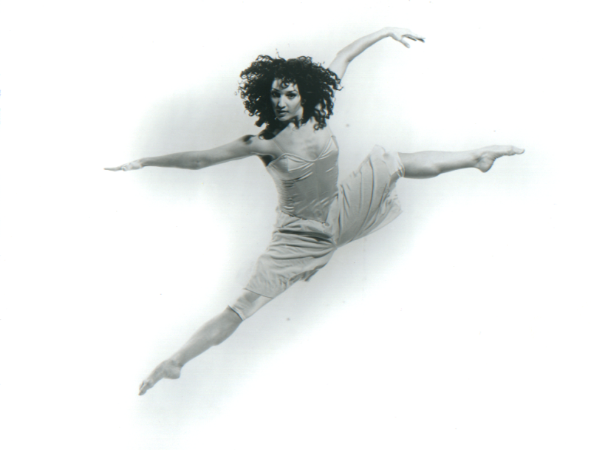

Artist in Residency Program
Central Connecticut State University is proud to host an active and acclaimed Artist in Residency Program through the Dance Program. Over the years CCSU has brought to campus well-known artists such as Jennifer Muller/The Works, National Dance Theatre Company of Jamaica, Merce Cunningham, Martha Graham’s Ensemble Company, Hubbard Street Chicago and the Albano Ballet. and many other internationally known artists and professional companies.

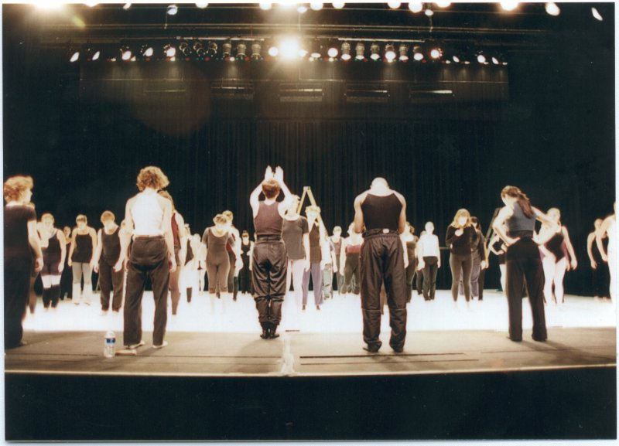

Jennifer Muller conducting a Master Class at CCSU

Dance Teacher Certification
The field of dance education is taking an exciting step forward in Connecticut's public schools. The Connecticut State Department of Education has developed guidelines for teacher certification in dance. Certification is the license to teach in the public schools.

In collaboration with Naugutuck Valley Community College, the CCSU dance program now offers a formal pathway leading to cross-endorsement certification in dance, and has developed a program that will enable students to earn dance certification when the State begins offering that licensure as currently planned.

Central Connecticut State University’s Dance Program proudly supports Connecticut’s statewide dance certification initiative. CCSU’s Department of Physical Education and Human Performance offers a cross-endorsement in dance education.

