Pacing: 3 weeks (plus 1 week for reteaching/enrichment)
Mathematical Practices
Mathematical Practices #1 and #3 describe a classroom environment that encourages thinking mathematically and are critical for quality teaching and learning.

Practices in bold are to be emphasized in the unit.
1. Make sense of problems and persevere in solving them.
2. Reason abstractly and quantitatively.
3. Construct viable arguments and critique the reasoning of others.
4. Model with mathematics.
5. Use appropriate tools strategically.
6. Attend to precision.
7. Look for and make use of structure.
8. Look for and express regularity in repeated reasoning.
Domain and Standards Overview
Number and operations—fractions
- Develop understanding of fractions as numbers.

Geometry
- Reason with shapes and their attributes.

Priority and Supporting CCSS | Explanations and Examples*
3.NF.3. Explain equivalence of fractions in special cases, and compare fractions by reasoning about their size.  a. Understand two fractions as equivalent (equal) if they are the same size or the same point on a number line.  b. Recognize and generate simple equivalent fractions, e.g., 1/2 = 2/4, 4/6 = 2/3). Explain why the fractions are equivalent, e.g., by using a visual fraction model.  c. Express whole numbers as fractions, and recognize fractions that are equivalent to whole numbers. Examples: Express 3 in the form 3 = 3/1; recognize that 6/1 = 6; locate 4/4 and 1 at the same point of a number line diagram.  d. Compare two fractions with the same numerator or the same denominator by reasoning about their size. Recognize that comparisons are valid only when the two fractions refer to the same whole. Record the results of comparisons with the symbols >, =, or <, and justify the conclusions, e.g., by using a visual fraction model. | 3.NF.3. An important concept when comparing fractions is to look at the size of the parts and the number of the parts. For example, 1/8 is smaller than ½ because when 1 whole is cut into 8 pieces, the pieces are much smaller than when 1 whole of the same size is cut into 2 pieces.  Examples:  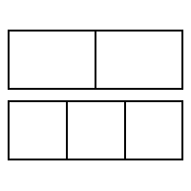  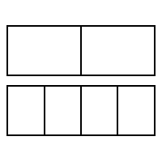  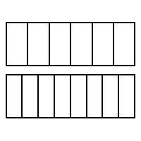  Use fraction bars  Use number lines  0  1  1/6 2/6 3/6 4/6 5/6 6/6  0  1  ¼ 2/4 ¾ 4/4  Continued on next page  3.NF.3. Continued  Students recognize when examining fractions with common denominators, the wholes have been divided into the same number of equal parts. So the fraction with the larger numerator has the larger number of equal parts.  To compare fractions that have the same numerator but different denominators, students understand that each fraction has the same number of equal parts but the size of the parts are different. They can infer that the same number of smaller pieces is less than the same number of bigger pieces.
3.G.2. Partition shapes into parts with equal areas. Express the area of each part as a unit fraction of the whole. For example, partition a shape into 4 parts with equal area, and describe the area of each part as 1/4 of the area of the shape | 3.G.2. Given a shape, students partition it into equal parts, recognizing that these parts all have the same area. They identify the fractional name of each part and are able to partition a shape into parts with equal areas in several different ways.

Concepts  What Students Need to Know | Skills  What Students Need To Be Able To Do | Bloom’s Taxonomy Levels
Equivalence of Fractions  Fractions  Shapes | UNDERSTAND (as same size or same point on number line)  RECOGNIZE (simple equivalent fractions)  GENERATE (simple equivalent fractions)  EXPLAIN (why fractions are equivalent using visual models)  COMPARE (two with same numerator or denominator by reasoning about size)  RECOGNIZE (comparisons are only valid when referring to same whole)  RECORD (results of comparisons using >, =, <)  JUSTIFY (results of comparisons)  EXPRESS (whole numbers as fractions)  RECOGNIZE (when equivalent to whole numbers)  PARTITION (into parts with equal areas)  EXPRESS (area of each part as a unit fraction of the whole shape) | 2  2  2  2  4  2  1  5  2  2  3  3

Standardized Assessment Correlations
(State, College and Career)
Expectations for Learning (in development)
This information will be included as it is developed at the national level. CT is a governing member of the Smarter Balanced Assessment Consortium (SBAC) and has input into the development of the assessment.

Essential Questions

Corresponding Big Ideas

Unit Assessments
The items developed for this section can be used during the course of instruction when deemed appropriate by the teacher.
- Which fraction below is equivalent to?

- *

- Which point on this number line shows the location of the fraction, ?
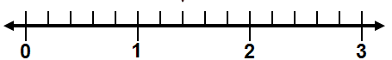
A B C D
• • • •

Answer: C
- Is more than or less than ? Show or explain how you found your answer.
Answer: less than OR is more than. Student explains the answer (answers may vary), for example, student draws a picture of two congruent shapes, one shaded and the other shaded and explains that covers less area than or vice versa. OR, Student explains using the size of each part when a shape is cut into two equal parts compared to a congruent shape cut into 4 equal parts fourths are smaller than halves).

Partial Credit: Student has the correct answer with an incorrect or missing explanation OR has an incorrect answer with a correct explanation.

No Credit: Student has an incorrect answer with an incorrect or missing explanation.
- Which inequality is true?

- < *

- >

- >

- <
- Kim ate 3/8 of a pizza. Jon ate 3/4 of a pizza that was the same size as Kim’s. Who ate more pizza? Show or explain how you found your answer.

Answer: John ate more pizza than Kim, OR Kim ate less pizza than Jon. Student explains the answer (answers may vary), for example, student draws a picture of two congruent circles, one shaded and the other shaded and explains that covers less area than or vice versa. OR, Student explains using the size of each part when a shape is cut into eight equal parts compared to a congruent shape cut into 4 equal parts (eighths are smaller than fourths).

Partial Credit: Student has the correct answer with an incorrect or missing explanation OR has an incorrect answer with a correct explanation.

No Credit: Student has an incorrect answer with an incorrect or missing explanation.
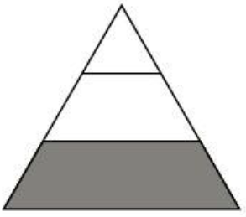
- Is of the triangle shaded? Explain why or why not.

Answer: Student correctly answers no and explanation shows understanding that fractional parts must be equal.

Partial Credit: Student correctly answers no with an incorrect or missing explanation OR answers yes with an explanation that shows understanding that fractional parts must be equal.

No Credit: Student answers no with an incorrect or missing explanation.
- The pictures below show how two students divided a shape into fourths.

A B

Sam claims that one of the shapes is not divided into fourths. Is Sam correct? Explain why you agree or disagree with Sam.

Answer: Sam is correct. Shape A is not divided into fourths because the parts are not equal in size.

Partial Credit: Student correctly answers that Sam is correct with an incorrect or missing explanation OR incorrectly answers that Sam is not correct with an explanation that indicates that the student understands that the four parts must be equal.

No Credit: Student incorrectly answers that Sam is not correct with an incorrect or missing explanation.

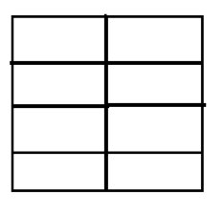
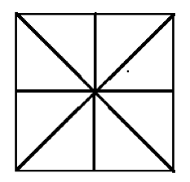
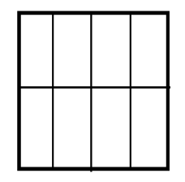
- Show two different ways to divide the shape into eighths.

Answer: Student shows two different ways to divide the shape into 8 equal parts. Possible answers include:

Partial Credit: Student shows one way to divide the shape into eight equal parts
No Credit: Student shows two ways to divide the shape into 8 unequal parts or into parts other than eighths.

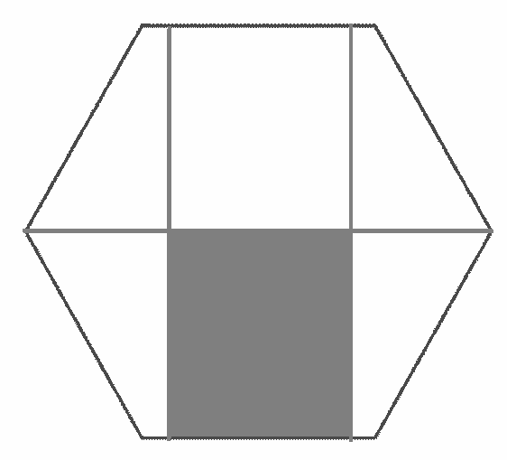
- Is of the hexagon shaded? Explain why or why not.

Answer: No because the hexagon is not divided into 6 equal parts.

Partial Credit: Student correctly answers no with an incorrect or missing explanation OR answers yes with an explanation that shows understanding that fractional parts must be equal.

No Credit: Student answers yes with an incorrect or missing explanation.
- Mike’s mom ordered enough small pizzas that were all the same size for his birthday party.

- Some pizzas were cut into four slices and some were cut into eight slices.
- John got of a pizza and Sarah got of a pizza.
- John said he received less pizza than Sarah.

Is John correct? Show or explain why you agree or disagree with John.
Answer: No, John is not correct. Student shows or explains using pictures that is equivalent to, or that both fractions equal .
Partial Credit: Student correctly answers no, with an incorrect or missing explanation, OR answers yes with an explanation that indicates understanding that and are equivalent or that both fractions equal.
No Credit: Student answers yes with an incorrect or missing explanation.

- Look at the shaded part of the shape below.

Is of the rectangle shaded? Show or explain how you found your answer.

Answer: Yes. Student shows or explains that is equivalent to.

Partial Credit: Student correctly answers yes with an incorrect or missing explanation, OR answers no with an explanation that demonstrates understand that is equivalent to.

No Credit: Student answers no with an incorrect or missing explanation.

