Pacing: 6 weeks (plus 1 week for reteaching/enrichment)
Mathematical Practices
Mathematical Practices #1 and #3 describe a classroom environment that encourages thinking mathematically and are critical for quality teaching and learning.

Practices in bold are to be emphasized in the unit.
1. Make sense of problems and persevere in solving them.
2. Reason abstractly and quantitatively.
3. Construct viable arguments and critique the reasoning of others.
4. Model with mathematics.
5. Use appropriate tools strategically.
6. Attend to precision.
7. Look for and make use of structure.
8. Look for and express regularity in repeated reasoning

Domain and Standards Overview
Number and Operations—Fractions
• Build fractions from unit fractions by applying and extending previous understandings of operations on whole numbers.

Priority and Supporting CCSS | Explanations and Examples*
4.NF.3. Understand a fraction a/b with a > 1 as a sum of fractions 1/b. ³  a. Understand addition and subtraction of fractions as joining and separating parts referring to the same whole.  b. Decompose a fraction into a sum of fractions with the same denominator in more than one way, recording each decomposition by an equation. Justify decompositions, e.g., by using a visual fraction model. Examples: 3/8 = 1/8 + 1/8 + 1/8; 3/8 = 1/8 + 2/8 ;  2 1/8 = 1 + 1 + 1/8 = 8/8 + 8/8 + 1/8.  c. Add and subtract mixed numbers with like denominators, e.g., by replacing each mixed number with an equivalent fraction, and/or by using properties of operations and the relationship between addition and subtraction.  d. Solve word problems involving addition and subtraction of fractions referring to the same whole and having like denominators, e.g., by using visual fraction models and equations to represent the problem.  ³ Grade 4 expectations in this domain are limited to fractions with denominators 2, 3, 4, 5, 6, 8, 10, 12, and 100. | 4.NF.3. A fraction with a numerator of one is called a unit fraction. When students investigate fractions other than unit fractions, such as 2/3, they should be able to decompose the non-unit fraction into a combination of several unit fractions.  Example: 2/3 = 1/3 + 1/3  Being able to visualize this decomposition into unit fractions helps students when adding or subtracting fractions. Students need multiple opportunities to work with mixed numbers and be able to decompose them in more than one way. Students may use visual models to help develop this understanding.  Example:   Example of word problem:  • Mary and Lacey decide to share a pizza. Mary ate 3/6 and Lacey ate 2/6 of the pizza. How much of the pizza did the girls eat together?  Solution: The amount of pizza Mary ate can be thought of a 3/6 or 1/6 and 1/6 and 1/6. The amount of pizza Lacey ate can be thought of a 1/6 and 1/6. The total amount of pizza they ate is 1/6 + 1/6 + 1/6 + 1/6 + 1/6 or 5/6 of the whole pizza.  Continued on next page  4.NF.3. Continued  A separate algorithm for mixed numbers in addition and subtraction is not necessary. Students will tend to add or subtract the whole numbers first and then work with the fractions using the same strategies they have applied to problems that contained only fractions.  Example:  • Susan and Maria need 8 3/8 feet of ribbon to package gift baskets. Susan has 3 1/8 feet of ribbon and Maria has 5 3/8 feet of ribbon. How much ribbon do they have altogether? Will it be enough to complete the project? Explain why or why not.  The student thinks: I can add the ribbon Susan has to the ribbon Maria has to find out how much ribbon they have altogether. Susan has 3 1/8 feet of ribbon and Maria has 5 3/8 feet of ribbon. I can write this as 3 1/8 + 5 3/8. I know they have 8 feet of ribbon by adding the 3 and 5. They also have 1/8 and 3/8 which makes a total of 4/8 more. Altogether they have 8 4/8 feet of ribbon. 8 4/8 is larger than 8 3/8 so they will have enough ribbon to complete the project. They will even have a little extra ribbon left, 1/8 foot.  Example:  • Trevor has 4 1/8 pizzas left over from his soccer party. After giving some pizza to his friend, he has 2 4/8 of a pizza left. How much pizza did Trevor give to his friend?  Solution: Trevor had 4 1/8 pizzas to start. This is 33/8 of a pizza. The x’s show the pizza he has left which is 2 4/8 pizzas or 20/8 pizzas. The shaded rectangles without the x’s are the pizza he gave to his friend which is 13/8 or 1 5/8 pizzas.  x  x  x  x  x  x  x  x  x  x  x  x  x  x  x  x  x  x  x  x
4.NF.4. Apply and extend previous understandings of multiplication to multiply a fraction by a whole number. ³  a. Understand a fraction a/b as a multiple of 1/b. For example, use a visual fraction model to represent 5/4 as the product 5 × (1/4), recording the conclusion by the equation 5/4 = 5 × (1/4).  b. Understand a multiple of a/b as a multiple of 1/b, and use this understanding to multiply a fraction by a whole number. For example, use a visual fraction model to express 3 × (2/5) as 6 × (1/5), recognizing this product as 6/5. (In general, n × (a/b) = (n × a)/b.)  c. Solve word problems involving multiplication of a fraction by a whole number, e.g., by using visual fraction models and equations to represent the problem. For example, if each person at a party will eat 3/8 of a pound of roast beef, and there will be 5 people at the party, how many pounds of roast beef will be needed? Between what two whole numbers does your answer lie?  ³ Grade 4 expectations in this domain are limited to fractions with denominators 2, 3, 4, 5, 6, 8, 10, 12, and 100. | 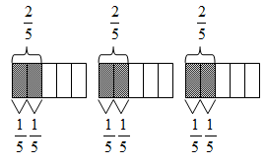  4.NF.4. Students need many opportunities to work with problems in context to understand the connections between models and corresponding equations. Contexts involving a whole number times a fraction lend themselves to modeling and examining patterns.  Examples:  • 3 x (2/5) = 6 x (1/5) = 6/5  • If each person at a party eats 3/8 of a pound of roast beef, and there are 5 people at the party, how many pounds of roast beef are needed?  Between what two whole numbers does your answer lie?  A student may build a fraction model to represent this problem:
4.MD.4. Make a line plot to display a data set of measurements in fractions of a unit (1/2, 1/4, 1/8). Solve problems involving addition and subtraction of fractions by using information presented in line plots. For example, from a line plot find and interpret the difference in length between the longest and shortest specimens in an insect collection. | 4.MD.4.  Example:  Ten students in Room 31 measured their pencils at the end of the day. They recorded their results on the line plot below.  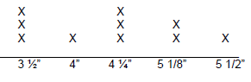  Possible questions:  - What is the difference in length from the longest to the shortest pencil?  - If you were to line up all the pencils, what would the total length be?  - If the ” pencils are placed end to end, what would be their total length

Concepts  What Students Need to Know | Skills  What Students Need To Be Able To Do | Bloom’s Taxonomy Levels
Addition of Fractions  Subtraction of Fractions  Decomposition of Fractions  Mixed Numbers  Multiplication of Fractions  Line Plots | UNDERSTAND (as joining parts referring to the same whole)  SOLVE (word problems with like denominators)  SOLVE (problems using information from line plots)  UNDERSTAND (as separating parts referring to the same whole)  SOLVE (word problems with like denominators)  SOLVE (problems using information from line plots)  RECORD (into a sum of fractions with same denominator in more than one way using an equation)  JUSTIFY (using a visual fraction model)  ADD (with like denominators by replacing with equivalent fractions and/or properties of operations)  SUBTRACT (with like denominators by replacing with equivalent fractions and/or properties of operations)  MULTIPLY (by a whole number)  UNDERSTAND (a fraction a/b as a multiple of 1/b)  UNDERSTAND (a multiple of a/b as a multiple of 1/b)  SOLVE (word problems by a whole number)  MAKE (to display data involving fractions) | 2  3  3  2  3  3  3  5  3  3  3  2  2  3  3

Essential Questions

Corresponding Big Ideas

Standardized Assessment Correlations
(State, College and Career)
Expectations for Learning (in development)
This information will be included as it is developed at the national level. CT is a governing member of the Smarter Balanced Assessment Consortium (SBAC) and has input into the development of the assessment.

Tasks from Inside Mathematics (http://insidemathematics.org/index.php/mathematical-content-standards)

These tasks can be used during the course of instruction when deemed appropriate by the teacher.
NOTE: Most of these tasks have a section for teacher reflection.
LEARNING ACTIVITIES—
Leapfrog Fractions

Unit Assessments
The items developed for this section can be used during the course of instruction when deemed appropriate by the teacher.
1. Which sum equals 1? Choose Yes or No for A-D.
- += O Yes O No
- += O Yes O No
- + = O Yes O No
- += O Yes O No
Answer: YNYY
2. + = Show or explain how you found your answer:
Answer: 1 or with an explanation that may include the use of decomposing the fractions or the use of a fraction model. For example: = + + = + + + + + + + + + = or 1
Partial Credit: Correct answer, 1 or, with an incorrect or missing explanation, OR an incorrect answer with an explanation that demonstrates understanding of adding fractions.

No Credit: Incorrect answer with an incorrect or missing explanation.

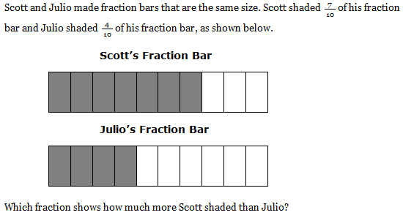
- *

4. Mr. Olson spent 2hours fixing his car. He then spent 3hours fixing his neighbor’s car. How many more hours did Mr. Olson spend fixing his neighbor’s car than his own car? Show or explain how you found your answer.
Answer: or hour, with an explanation that may include the use of decomposing the fractions or the use of a fraction model. For example, 3 = 2 + = 2
2 ̶ 2 = or hour
Partial Credit: Correct answer, orhour with an incorrect or missing explanation, OR an incorrect answer with an explanation that demonstrates understanding of subtracting mixed numbers.

No Credit: Incorrect answer with an incorrect or missing explanation.

5. Elisha spent 2hours reading on Monday. She spent 1hours reading on Tuesday. How many hours did she spend reading on Monday and Tuesday? Show or explain how you found your answer.
Answer: hours with an explanation that may include the use of decomposing the fractions or the use of a fraction model. For example, 2 = 2 + +
1 = 1 + +
+ + + = + = 1 +
2 + 1 + 1 + = hours
Partial Credit: Correct answer, 4hour, with an incorrect or missing explanation, OR an incorrect answer with an explanation that demonstrates understanding of adding mixed numbers.

No Credit: Incorrect answer with an incorrect or missing explanation.

Unit Assessments
The items developed for this section can be used during the course of instruction when deemed appropriate by the teacher.
6. Look at the diagram below.
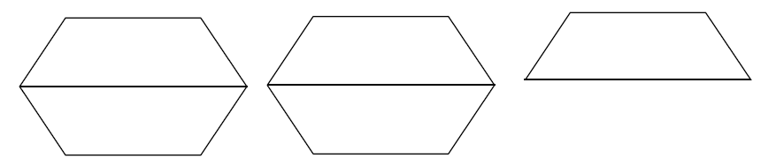
Delores thinks that the diagram represents and 2. Ricky thinks that does not equal 2.
Who is correct? Show or explain how you know that and 2 are equal or are not equal.

Answer: Dolores, with an explanation that may include the use of decomposing the fractions or the use of a fraction model. For example, = ++++ 2 = ++ = ++ ++ OR
The student explains the relationship between the whole and its parts. For 2, the wholes are divided into two parts which are halves and if you count there are five halves.
Partial Credit: Correct answer, Delores, with an incorrect or missing explanation, OR an incorrect answer with an explanation that demonstrates understanding of decomposing a mixed number into unit fractions.

No Credit: Incorrect answer with an incorrect or missing explanation.

Unit Assessments
The items developed for this section can be used during the course of instruction when deemed appropriate by the teacher.
7. 5 x = _____ Show or explain how you found your answer.
Answer: 3 with an explanation that may include the use of a fraction model that represents ++++ or 10 x.
Partial Credit: Correct answer, 3, with an incorrect or missing explanation, OR an incorrect answer with an explanation that demonstrates understanding of multiplying a whole number by a fraction.

No Credit: Incorrect answer with an incorrect or missing explanation.
8. One can of orange soda containscup of sugar.
How many cups of sugar are there in 6 cans of orange soda? Show or explain how you found your answer.

Answer: 2or 2with and explanation that may include the use of a fraction model that represents +++++ or 18 x
Partial Credit: Correct answer, 2or 2, with an incorrect or missing explanation, OR an incorrect answer with an explanation that demonstrates understanding of multiplying a whole number by a fraction.

No Credit: Incorrect answer with an incorrect or missing explanation.

9. Which of these are equal to 3 x ? Choose Yes or No for A – D.
- O Yes O No
- 9 x O Yes O No
- ++ O Yes O No
- + +++++++ O Yes O No
Answer: NYYY

