Pacing: 5 weeks (plus 1 week for reteaching/enrichment)
Mathematical Practices
Mathematical Practices #1 and #3 describe a classroom environment that encourages thinking mathematically and are critical for quality teaching and learning.

Practices in bold are to be emphasized in the unit.
1. Make sense of problems and persevere in solving them.
2. Reason abstractly and quantitatively.
3. Construct viable arguments and critique the reasoning of others.
4. Model with mathematics.
5. Use appropriate tools strategically.
6. Attend to precision.
7. Look for and make use of structure.
8. Look for and express regularity in repeated reasoning.

Domain and Standards Overview
Expressions and Equations
- Understand the connections between proportional relationships, lines, and linear equations.
- Analyze and solve linear equations
Functions
- Define, evaluate, and compare functions.
- Use functions to model relationships between quantities.

Priority and Supporting CCSS | Explanations and Examples*
8.EE.5. Graph proportional relationships, interpreting the unit rate as the slope of the graph. Compare two different proportional relationships represented in different ways. For example, compare a distance-time graph to a distance-time equation to determine which of two moving objects has greater speed.  8.EE.6. Use similar triangles to explain why the slope m is the same between any two distinct points on a non-vertical line in the coordinate plane; derive the equation y = mx for a line through the origin and the equation y = mx + b for a line intercepting the vertical axis at b.. | 8. EE.5. Using graphs of experiences that are familiar to students increases accessibility and supports understanding and interpretation of proportional relationship. Students are expected to both sketch and interpret graphs.  Example:  • Compare the scenarios to determine which represents a greater speed. Include a description of each scenario including the unit rates in your explanation.  8.EE.6. Example:
8.EE.7. Solve linear equations in one variable.  - Give examples of linear equations in one variable with one solution, infinitely many solutions, or no solutions. Show which of these possibilities is the case by successively transforming the given equation into simpler forms, until an equivalent equation of the form x = a, a = a, or a = b results (where a and b are different numbers).  - Solve linear equations with rational number coefficients, including equations whose solutions require expanding expressions using the distributive property and collecting like terms.  8.F.2. Compare properties of two functions each represented in a different way (algebraically, graphically, numerically in tables, or by verbal descriptions). For example, given a linear function represented by a table of values and a linear function represented by an algebraic expression, determine which function has the greater rate of change. | 8.EE.7. As students transform linear equations in one variable into simpler forms, they discover the equations can have one solution, infinitely many solutions, or no solutions.  When the equation has one solution, the variable has one value that makes the equation true as in  12 - 4y =16. The only value for y that makes this equation true is -1.  When the equation has infinitely many solutions, the equation is true for all real numbers as in  7x + 14 = 7(x+2). As this equation is simplified, the variable terms cancel leaving 14 = 14 or 0 = 0. Since the expressions are equivalent, the value for the two sides of the equation will be the same regardless which real number is used for the substitution.  When an equation has no solutions it is also called an inconsistent equation. This is the case when the two expressions are not equivalent as in 5x - 2 = 5(x+1). When simplifying this equation, students will find that the solution appears to be two numbers that are not equal or -2 = 1. In this case, regardless which real number is used for the substitution, the equation is not true and therefore has no solution.  Examples:  8.F.2. Examples:  - Compare the two linear functions listed below and determine which equation represents a greater rate of change.  (Continued on next page)
8.F.1. Understand that a function is a rule that assigns to each input exactly one output. The graph of a function is the set of ordered pairs consisting of an input and the corresponding output.  8.F.3.Interpret the equation y = mx + b as defining a linear function, whose graph is a straight line; give examples of functions that are not linear. For example, the function A = s² giving the area of a square as a function of its side length is not linear because its graph contains the points (1,1), (2,4) and (3,9), which are not on a straight line. | - Compare the two linear functions listed below and determine which has a negative slope.  Function 1: Gift Card  Samantha starts with $20 on a gift card for the book store. She spends $3.50 per week to buy a magazine. Let y be the amount remaining as a function of the number of weeks.  Function 2:  The school bookstore rents graphing calculators for $5 per month. It also collects a non-refundable fee of $10.00 for the school year. Write the rule for the total cost (c) of renting a calculator as a function of the number of months (m).  Solution:  Function 1 is an example of a function whose graph has negative slope. Samantha starts with $20 and spends money each week. The amount of money left on the gift card decreases each week. The graph has a negative slope of -3.5, which is the amount the gift card balance decreases with Samantha’s weekly magazine purchase. Function 2 is an example of a function whose graph has positive slope. Students pay a yearly nonrefundable fee for renting the calculator and pay $5 for each month they rent the calculator. This function has a positive slope of 5 which is the amount of the monthly rental fee. An equation for Example 2 could be c = 5m + 10.  8.F.1. For example, the rule that takes x as input and gives x²+5x+4 as output is a function. Using y to stand for the output we can represent this function with the equation y = x²+5x+4, and the graph of the equation is the graph of the function. Students are not yet expected use function notation such as f(x) = x²+5x+4.  8.F.3. Example:  • Determine which of the functions listed below are linear and which are not linear and explain your reasoning.  o y = -2x² + 3 non linear  o y = 2x linear  o A = πr² non linear  o y = 0.25 + 0.5(x – 2) linear
8.F.4. Construct a function to model a linear relationship between two quantities. Determine the rate of change and initial value of the function from a description of a relationship or from two (x, y) values, including reading these from a table or from a graph. Interpret the rate of change and initial value of a linear function in terms of the situation it models, and in terms of its graph or a table of values.  8.F.5. Describe qualitatively the functional relationship between two quantities by analyzing a graph, (e.g. where the function is increasing or decreasing, linear or nonlinear). Sketch a graph that exhibits the qualitative features of a function that has been described verbally. | 8.F.4. Examples:  • The table below shows the cost of renting a car. The company charges $45 a day for the car as well as charging a one-time $25 fee for the car’s navigation system (GPS).Write an expression for the cost in dollars, c, as a function of the number of days, d.  Students might write the equation c = 45d + 25 using the verbal description or by first making a table.  Students should recognize that the rate of change is 45 (the cost of renting the car) and that initial cost (the first day charge) also includes paying for the navigation system. Classroom discussion about one time fees vs. recurrent fees will help students model contextual situations.  • When scuba divers come back to the surface of the water, they need to be careful not to ascend too quickly. Divers should not come to the surface more quickly than a rate of 0.75 ft per second. If the divers start at a depth of 100 feet, the equation d = 0.75t – 100 shows the relationship between the time of the ascent in seconds (t) and the distance from the surface in feet (d).  o Will they be at the surface in 5 minutes? How long will it take the divers to surface from their dive?  • Make a table of values showing several times and the corresponding distance of the divers from the surface. Explain what your table shows. How do the values in the table relate to your equation?  8.F.5. Example:  • The graph below shows a student’s trip to school. This student walks to his friend’s house and, together, they ride a bus to school. The bus stops once before arriving at school.  Describe how each part A-E of the graph relates to the story.

Concepts  What Students Need to Know | Skills  What Students Need To Be Able To Do | Bloom’s Taxonomy Levels
- Proportional relationships  - Unit rate  - Slope (m)  - Y-intercept (b)  - Linear equations (y = mx and y = mx + b)  - Rational Number Coefficients  - One variable  - One solution  - Infinitely many solutions  - No solutions  - Equations into simple forms  - Expanding Expressions  - Distributive property  - Combining Like terms  - Functions  - Properties  - Linear  - Non-linear  - Input/Output  - Ordered pairs  - Linear/functional relationship  - rate of change  - initial value (function)  - table  - graph  - Similar triangles | - GRAPH (proportional relationships)  - INTERPRET (unit rate as slope)  - COMPARE (proportional relationships)  - EXPLAIN (why slope is the same between any two points on a non-vertical line)  - DERIVE (linear equations (y = mx and y = mx + b)  - SOLVE (linear equations)  - GIVE (example of linear equations)  - TRANSFORM (equations)  - EXPAND (expressions)  - Use (distributive property)  - Collect (like terms)  - UNDERSTAND (function is a rule)  - GRAPH (sets of ordered pairs)  - COMPARE (functions)  - Algebraically  - Graphically  - Numerically in tables  - Verbal descriptions  - CONSTRUCT (function)  - Model (linear relationship)  - DETERMINE (rate of change and initial value of function)  - READ (table or graph)  - INTERPRET  - y = mx + b  - rate of change and initial value of function  - GIVE (examples of non-linear functions)  - DESCRIBE (functional relationship between two quantities)  - DRAW (graph from a verbal description) | 4  2  2  3  3  3  2  3  3  2  3  3  2  2  3  2  2

Essential Questions

Corresponding Big Ideas

Standardized Assessment Correlations
(State, College and Career)
Expectations for Learning (in development)
This information will be included as it is developed at the national level. CT is a governing member of the Smarter Balanced Assessment Consortium (SBAC) and has input into the development of the assessment.

Tasks
These tasks can be used during the course of instruction when deemed appropriate by the teacher.
- Multiple Solutions task. Students are given various equations and inequalities and are asked to find 2 sample solutions to each. Next, students identify whether the equation/inequality falls into the category of: exactly 2 solutions, more than 2 solutions, but not infinitely many solutions, or infinitely many solutions. The task ties into several standards, including those from Number Systems and Expressions and Equations, and may be best used formatively to assess student understanding of prerequisite knowledge.
http://map.mathshell.org/materials/tasks.php?taskid=263&subpage=apprentice
Source: Mathematics Assessment Project (Shell Center/MARS, University of Nottingham & UC Berkeley)
- Interpreting Distance-Time Graphs
http://map.mathshell.org/materials/lessons.php?taskid=208
This is a lesson that can be used formatively.

Tasks and Lessons from the Mathematics Assessment Project (Shell Center/MARS, University of Nottingham & UC Berkeley)

These tasks can be used during the course of instruction when deemed appropriate by the teacher.
TASKS—
Bike Ride (easy task to introduce rate in graph form) http://map.mathshell.org/materials/tasks.php?taskid=363&subpage=apprentice
Journey http://map.mathshell.org/materials/tasks.php?taskid=373&subpage=apprentice
Linear Graphs http://map.mathshell.org/materials/tasks.php?taskid=374&subpage=apprentice
Meal Out http://map.mathshell.org/materials/tasks.php?taskid=376&subpage=apprentice
Shelves http://map.mathshell.org/materials/tasks.php?taskid=382&subpage=apprentice
Hot Under the Collar http://map.mathshell.org/materials/tasks.php?taskid=388&subpage=expert
LESSONS—
Solving Real-Life Problems: Baseball Jerseys http://map.mathshell.org/materials/lessons.php?taskid=433&subpage=problem
Interpreting Distance-Time Graphs http://map.mathshell.org/materials/lessons.php?taskid=208&subpage=concept
Lines and Linear Equations http://map.mathshell.org/materials/lessons.php?taskid=440&subpage=concept
Modeling Situations with Linear Equations (Expert task requiring using multiple variables) http://map.mathshell.org/materials/lessons.php?taskid=211&subpage=concept

Tasks from Inside Mathematics (http://insidemathematics.org/index.php/mathematical-content-standards)

These tasks can be used during the course of instruction when deemed appropriate by the teacher.
NOTE: Most of these tasks have a section for teacher reflection.
Vincent’s Graphs - Linear Relationships. Good task on reading functions from a graph and analyzing them. Question #3 good idea: decrease mass, then increase mass pattern, but ‘stone’ term is less accessible and premise is a little gross.
Party - Linear Relationships. Good task on functions. Formula in question #3 might be tough given constraints. Discussions on question #5 could be valuable.
Squares and Circles - Linear Relationships. Loose connection to 8.EE.7, but standard is in the same unit. Simple step-by-step application problem. Not very rich.

Unit Assessments
The items developed for this section can be used during the course of instruction when deemed appropriate by the teacher.
- Which scenario represents a greater speed. Write a description of each scenario including the unit rates in your explanation.

Show or explain how you found your answer.

Answer: Scenario 1 represents a greater speed with an explanation that may include:
- The unit rate (slope) of scenario 1 is = = 60 mph
- The unit rate (slope) of scenario 2 is = 55 mph

Partial Credit: Correct answer, Scenario 1, with an incorrect or missing explanation, OR an incorrect answer with an explanation that demonstrates understanding of finding unit rate/slope.

No Credit: Incorrect answer with an incorrect or missing explanation.

- The graph below shows the cost to wash a car at Euclid’s Car Wash.
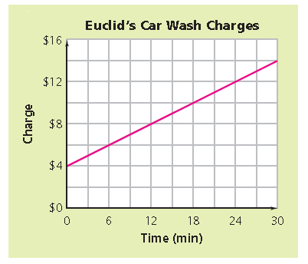
What is the slope of the line? Describe what the graph and slope of the line tell you about the cost to wash a car at Euclid’s car wash? Show or explain how you found your answer.
Answer: Slope = with an explanation that may include:
- The unit rate (slope) of the line is = = , which means that the cost is $1 for every 3 minutes. The graph of the line shows that the cost to wash a car is $4 plus $1 for every 3 minutes of car washing.
Partial Credit: Correct answer, Slope = , with an incorrect or missing explanation, OR an incorrect answer with an explanation that demonstrates understanding of finding unit rate/slope and a correct interpretation of what the graph of the line shows about the cost of a car wash.
No Credit: Incorrect answer with an incorrect or missing explanation.
Source: Thinking with Mathematical Models, Connected Math Program
- The equation below shows the total profit, p, from a school dance. The number of tickets sold is represented by x and the amount paid to the DJ was $600.
p = 8x - 600
What does the 8 represent in the equation?
Answer: The price of each ticket.

- Look at the triangles in the graph below. Sides a and d lie along the same line.
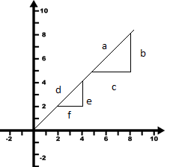
How are the triangles related to each other? Show or explain how you found your answer. (Source: Thinking with Mathematical Models, Connected Mathematics 2)

Answer: The triangles are similar with an explanation that may include:
- Since sides a and d lie on the same line, the slope of the sides are the same. Therefore the ratio of b/c and e/f must be proportional.

Partial Credit: Correct answer with an incorrect or missing explanation OR and incorrect answer with an explanation that demonstrates understanding that the triangles are proportional because the hypotenuse of each triangle lies along the same line, making the sides proportional.

No Credit: Incorrect answer with an incorrect or missing explanation.
- Look at the graph below.
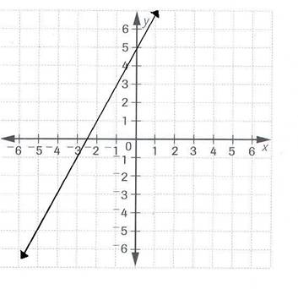
What is the equation of the line shown in the graph?
Answer: y = 2x + 5

- The graph below shows the amount of money earned and the number of weeks worked for Jonah (top/blue line) and Tracey (bottom/pink line).
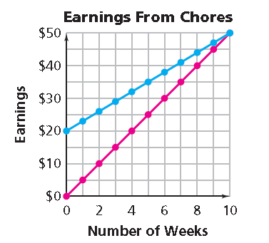
- Write a linear equation for each line in the form y = mx + b. (Source: Thinking with Mathematical Models, Connected Mathematics 2)
Answer: Top/Blue line (Jonah) y = 3x + 20
Bottom/Pink line (Tracey) y = 5x

- What is the y-intercept of each line? What does each y-intercept value represent in this situation?
Answer: Top/Blue line (Jonah) y-intercept = 20, with an explanation that may include that Jonah had $20 before he started earning money for chores. Bottom/Pink line (Tracey) y-intercept = 0, with an explanation that may include that Tracey had no money when she started earning money for chores.

- What is the slope of each line? What does the slope of each line represent in this situation?
Answer: Top/Blue line (Jonah) slope = 3, with an explanation that may include that Jonah earned $3 per week Bottom/Pink line (Tracey) y-intercept = 0, with an explanation that may include that Tracey had no money when she started earning money for chores.
- Look at the graph below.
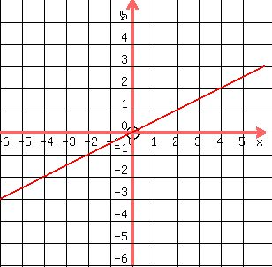
What is the equation of the line shown in the graph?
Answer: y = ½x or y = 0.5x (or any equivalent equation)

- Look at the equation below.
2w + 21 = 5w – 3w + 21
Does the equation have one solution, no solution or an infinite number of solutions? Show or explain how you found your answer

Answer: Infinite number of solutions with an explanation that may include:
- Simplifying the equation to 21 = 21, which is a true statement, therefore, any number substituted for w will result in a true statement
- 2w + 21 equals 2w + 21, therefore any number substituted for w will result in a true statement

Partial Credit: Correct answer with an incorrect or missing explanation, OR an incorrect answer with an explanation that proves that there is an infinite number of solutions to the problem

No Credit: Incorrect answer with an incorrect or missing explanation.
- Look at the equation below.
9k + 1 = 4k – 1 + 5k
Does the equation have one solution, no solution or an infinite number of solutions? Show or explain how you found your answer

Answer: No Solutions with an explanation that may include:
- Simplifying the equation to 2 = 0, which is not true
- 9k + 1 does not equal 9k – 1

Partial Credit: Correct answer with an incorrect or missing explanation, OR an incorrect answer with an explanation that proves that there is no solution to the problem

No Credit: Incorrect answer with an incorrect or missing explanation.
- Solve the equation for x.
3x + 52 = 82
Answer: x = 10
- Solve the equation for x.
4 + 5(x + 2) = 7x
Answer: x = 7
- Solve the equation for x.
$\frac{1}{2}x+4=\frac{2}{3}x$
Answer: x = 24
- Solve the equation for x.
–5x – 35 = 5
Answer: x = –8

- Look at the table below.
x | y
0 | 5
1 | 7
1 | 8
3 | 9

Is this a function? Show or explain how you found your answer.
Answer: No, with an explanation that may include:
- A function can have only one x-value (input) for each y-value (output)
Partial Credit: Correct answer No, with an incorrect or missing explanation, OR an incorrect answer with an explanation that demonstrates understanding of the definition of a function.
No Credit: Incorrect answer with an incorrect or missing explanation.

- Look at the table below.
x | y
-1 | 1
0 | 0
1 | 1
2 | 4

Is this a function? Show or explain how you found your answer.
Answer: Yes, with an explanation that may include:
- A function can have more than one y-value (output) for each x-value (input)
- This table can be defined by the equation y = x² which is a function
Partial Credit: Correct answer Yes, with an incorrect or missing explanation, OR an incorrect answer with an explanation that demonstrates understanding of the definition of a function.
No Credit: Incorrect answer with an incorrect or missing explanation.

- Compare the two linear functions listed below.
Function 1 Function 2
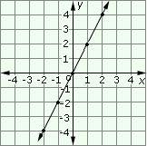
The function whose input x and output y are related by $y=\frac{1}{2}x+7$

Which function represents a greater rate of change? Show or explain how you found your answer.
Answer: Function 1, with an explanation that may include:
- Function 1 has a slope (or rate of change) equal to 2 and Function 2 has a slope (or rate of change) equal to ½.

Partial Credit: Correct answer Function 1, with an incorrect or missing explanation, OR an incorrect answer with an explanation that demonstrates understanding of finding slope (or rate of change) of a linear function.
No Credit: Incorrect answer with an incorrect or missing explanation.

- Compare the two linear functions below.
Function 1 Function 2
x | y
0 | 20
1 | 16.5
2 | 13
3 | 9.5

Which linear function has a negative slope? Show or explain how you found your answer.
Answer: Function 2 with a correct explanation that may include:
- Function 1 has a slope of 2 and Function 2 has a slope of -3.5
- The line for Function 1 moves up and to the right in a positive direction and Function 2 has y-values that decrease as the x values increases resulting in a negative slope.

Partial Credit: Correct answer Function 2, with an incorrect or missing explanation, OR an incorrect answer with an explanation that demonstrates understanding of how to determine whether the slope (or rate of change) of a linear function is positive or negative.
No Credit: Incorrect answer with an incorrect or missing explanation.

- The text message plans of two different cell phone companies are shown below.
- Texstar, charges $0.04 per text message.
- Berizon, charges according to the table of prices below.
Berizon Text Message Charges
# of text messages | Price  ($)
0 - 100 | 5
101 - 200 | 10
201 - 300 | 15
301 - 400 | 20
401 - 500 | 25

Which cell phone company has the least expensive text message plan for up to 500 text messages? Show or explain how you found your answer.
Answer: Texstar, with an explanation that may include:
- The least expensive cost per text for Berizon is $0.05 per text. Texstar charges $0.04 per text.

Partial Credit: Correct answer Texstar, with an incorrect or missing explanation, OR an incorrect answer with an explanation that demonstrates understanding of how to determine which cell phone text message plan is the least expensive.

No Credit: Incorrect answer with an incorrect or missing explanation.
- Look at the equation below.
$y=2x^{2}+8$
Does this equation represent a linear function or a non-linear function? Show or explain how you found your answer.
Answer: Non-linear function, with an explanation that may include:
- The equation is not of the form y = mx + b
- The equation includes an exponent on the variable, x (student may indicate that this is a quadratic equation)
- The graph of the equation is not a straight line which means that it is a non-linear function (student may indicate that the graph is a parabola)

Partial Credit: Correct answer Non-linear equation, with an incorrect or missing explanation, OR an incorrect answer with an explanation that demonstrates understanding of how to determine if a function is linear or non-linear.

No Credit: Incorrect answer with an incorrect or missing explanation.

- Classify each equation by writing linear function or non-linear function next to each. Show or explain how you found you determined your answers.
- y = -2x + 3 __________________________
- y = x² + 3x + 1 __________________________
- y = __________________________
- 4y + x = 3 __________________________
Answer: A. Linear Function
B. Non-Linear Function
C. Non-Linear Function
D. Linear Function
With an explanation that may include:
- A and D are linear functions because they can be written in the form y = mx + b, OR the graph of each equation is a straight line,
- B and C are non-linear functions because they cannot be written in the form y = mx + b, OR the graph of each equation is not a straight line

Partial Credit: Correct answer (see above), with an incorrect or missing explanation, OR an incorrect answer with an explanation that demonstrates understanding of the difference between a linear or non-linear function.

No Credit: Incorrect answer with an incorrect or missing explanation.
- A college bookstore rents graphing calculators for $5 per month. It also collects a non-refundable fee of $10 for the school year. Write an equation for the total cost (c) of renting a calculator as a function of the number of months (m)?
Answer: c = 5m + 10
- Mary walked from her home to the library. About half way to the library, she stopped to talk her friends. She then continued walking at a faster pace until she reached the library. Sketch a graph that shows the relationship between time and distance Mary walked.

Answer: The horizontal axis is labeled “Time” and the vertical axis is labeled “Distance.” The first segment line should have a positive slope, followed by a horizontal segment (slope of 0), and followed by a segment that has a greater slope than the first segment.
To raise the depth of knowledge (DOK), ask students to provide an appropriate scale for each axis and explain why it is reasonable, including a reasonable walking speed related to the slope of the line.

- Look at the graph below.
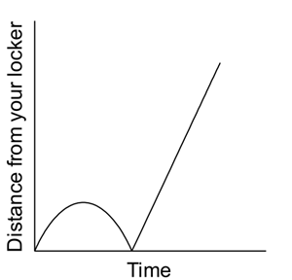
Describe a scenario that is illustrated by this graph.
Answer: The graph shows the relationship between the distance a student is from his/her locker over time. The description should include reasoning as to why the graph curves up and back down and then goes up at a constant rate. This may include:
- “I left my locker and started walking to class and then realized I forgot something and went back to my locker. I then walked at a constant pace to class.

Partial Credit: The description is incomplete or includes an incorrect interpretation of part of the graph.

No Credit: Incorrect or missing description.

- Which graph best represents a person’s distance from the ground while riding a Ferris wheel?
- * 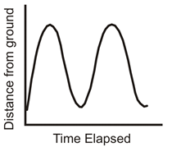 C. 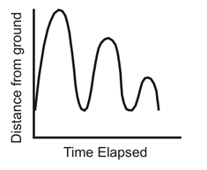

- 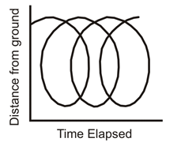 D. 