Complete this form daily and return to the school food service department.

School/site: |  |  |  |  |  | Location:
Grades served: |  |  |  | Date: |  |  | Total snacks received by site:
Today’s snack menu *:
* All snacks must comply with the ASP Meal Pattern for Grades K-12. Snacks must include at least two of the four meal pattern components, which include low-fat milk (unflavored or flavored) or fat-free milk (unflavored or flavored), vegetables/fruits, grains/breads (whole grain or enriched), and meat/meat alternates. Juice cannot be served when milk is the only other component. Schools in Healthy Food Certification (HFC) districts must also comply with the Connecticut Nutrition Standards. Schools must keep the ASP Daily Production Record for Grades K-12 on file. For more information, see the Connecticut State Department of Education’s (CSDE) ASP Handbook and visit the CSDE’s ASP webpage.

Daily Student Snack Count
Cross off number as each student receives a complete snack. Students must receive both snack components before the snack can be counted.
1 | 11 | 21 | 31 |  | 41 | 51 | 61 |  | 71 | 81 | 91 | 101 | 111 | 121 |  | 131 | 141
2 | 12 | 22 | 32 |  | 42 | 52 | 62 |  | 72 | 82 | 92 | 102 | 112 | 122 |  | 132 | 142
3 | 13 | 23 | 33 |  | 43 | 53 | 63 |  | 73 | 83 | 93 | 103 | 113 | 123 |  | 133 | 143
4 | 14 | 24 | 34 |  | 44 | 54 | 64 |  | 74 | 84 | 94 | 104 | 114 | 124 |  | 134 | 144
5 | 15 | 25 | 35 |  | 45 | 55 | 65 |  | 75 | 85 | 95 | 105 | 115 | 125 |  | 135 | 145
6 | 16 | 26 | 36 |  | 46 | 56 | 66 |  | 76 | 86 | 96 | 106 | 116 | 126 |  | 136 | 146
7 | 17 | 27 | 37 |  | 47 | 57 | 67 |  | 77 | 87 | 97 | 107 | 117 | 127 |  | 137 | 147
8 | 18 | 28 | 38 |  | 48 | 58 | 68 |  | 78 | 88 | 98 | 108 | 118 | 128 |  | 138 | 148
9 | 19 | 29 | 39 |  | 49 | 59 | 69 |  | 79 | 89 | 99 | 109 | 119 | 129 |  | 139 | 149
10 | 20 | 30 | 40 |  | 50 | 60 | 70 |  | 80 | 90 | 100 | 110 | 120 | 130 |  | 140 | 150
Today’s attendance: |  |  |  |  |  |  |  | Total snacks served:  (students only)

Daily Adult Snack Count
Snacks served to adults must be paid for by the adult or the school/organization responsible for the programming.
1 | 2 | 3 | 4 | 5 | 6 | 7 | 8 | 9 | 10 | Total snacks served:  (adults only)

Comments:

Person completing form:
 | Print name |  | Signature

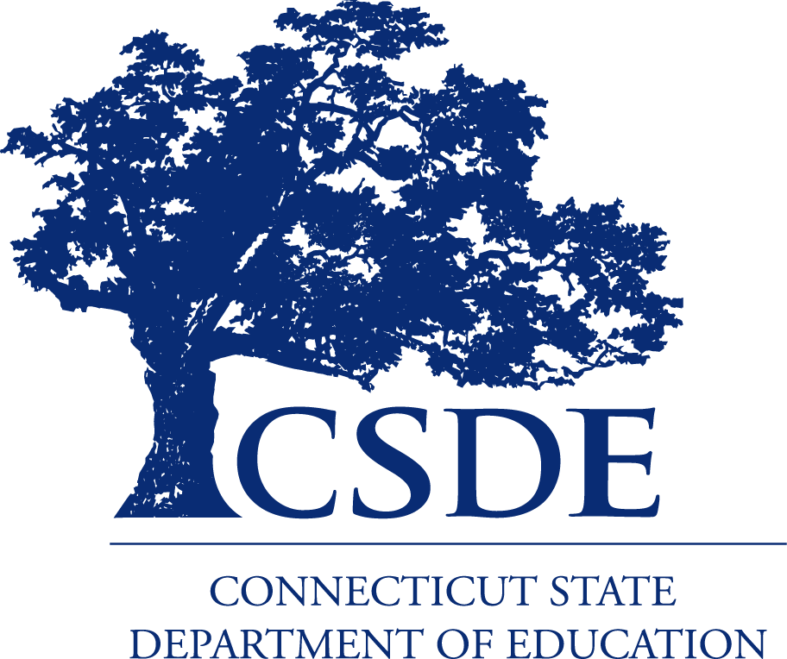
For more information, review the CSDE’s ASP Handbook and visit the CSDE’s ASP webpage or contact the school nutrition programs staff in the CSDE Bureau of Health/Nutrition, Family Services and Adult Education, 450 Columbus Boulevard, Suite 504, Hartford, CT 06103-1841.
This form is available at https://portal.ct.gov/-/media/SDE/Nutrition/ASP/Forms/ASPcountK12.doc.

In accordance with Federal civil rights law and U.S. Department of Agriculture (USDA) civil rights regulations and policies, the USDA, its Agencies, offices, and employees, and institutions participating in or administering USDA programs are prohibited from discriminating based on race, color, national origin, sex, disability, age, or reprisal or retaliation for prior civil rights activity in any program or activity conducted or funded by USDA.  Persons with disabilities who require alternative means of communication for program information (e.g. Braille, large print, audiotape, American Sign Language, etc.), should contact the Agency (State or local) where they applied for benefits. Individuals who are deaf, hard of hearing or have speech disabilities may contact USDA through the Federal Relay Service at (800) 877-8339. Additionally, program information may be made available in languages other than English.  To file a program complaint of discrimination, complete the USDA Program Discrimination Complaint Form, (AD-3027) found online at: How to File a Complaint, and at any USDA office, or write a letter addressed to USDA and provide in the letter all of the information requested in the form. To request a copy of the complaint form, call (866) 632-9992. Submit your completed form or letter to USDA by:  (1) mail: U.S. Department of Agriculture  Office of the Assistant Secretary for Civil Rights  1400 Independence Avenue, SW  Washington, D.C. 20250-9410;  (2) fax: (202) 690-7442; or  (3) email: program.intake@usda.gov.  This institution is an equal opportunity provider. | The Connecticut State Department of Education is committed to a policy of equal opportunity/affirmative action for all qualified persons. The Connecticut Department of Education does not discriminate in any employment practice, education program, or educational activity on the basis of age, ancestry, color, criminal record (in state employment and licensing), gender identity or expression, genetic information, intellectual disability, learning disability, marital status, mental disability (past or present), national origin, physical disability (including blindness), race, religious creed, retaliation for previously opposed discrimination or coercion, sex (pregnancy or sexual harassment), sexual orientation, veteran status or workplace hazards to reproductive systems, unless there is a bona fide occupational qualification excluding persons in any of the aforementioned protected classes.  Inquiries regarding the Connecticut State Department of Education’s nondiscrimination policies should be directed to: Levy Gillespie, Equal Employment Opportunity Director/Americans with Disabilities Coordinator (ADA), Connecticut State Department of Education, 450 Columbus Boulevard, Suite 607, Hartford, CT 06103, 860-807-2071, levy.gillespie@ct.gov.

