Sponsor: |  |  |  |  | Week of: |  | to
Site: |  |  | Ages:

ASP snacks for preschoolers (ages 3-4) must include at least two of the five snack components, which include: low-fat unflavored or fat-free unflavored milk (M); vegetables (V); fruits (F); grains (G); and meat/meat alternates (MMA). Juice cannot be served when milk is the only other component. For more information, see the ASP Meal Pattern for Preschoolers and the Connecticut State Department of Education’s (CSDE) Menu Planning Guide for Preschoolers in the NSLP, SBP, and ASP and ASP Handbook.

Day of snack service | A | B | C |  |  |  |  | D | E | F | G | H | I | J
Day of snack service | Food item | Serving size | Components  Check (✓) at least 2  for each day |  |  |  |  | Temperatures  Potentially hazardous foods (PHFs) only | Total servings prepared | Total amount of food used | Number of snacks served  Complete after snack service |  |  | Number of servings leftover  (I - G)
 |  |  |  |  |  |  |  |  |  |  | STUDENTS  Reimbursable snacks | ADULTS | TOTAL  (G + H) | Number of servings leftover  (I - G)
Day of snack service | Food item | Serving size | M | V | F | G | MMA
Monday
Tuesday
Wednesday
Thursday
Friday

Instructions
Complete columns A-F before snack service.
- Column A – Food item: List each food item from the planned snack menu.
- Column B – Serving size: For each food item in column A, list the serving size. The serving size must be at least the minimum quantity required by the ASP Meal Pattern for Preschoolers.
- Column C – Components: Check (✓) the snack components provided. There must be at least two components. For information on the ASP meal pattern and crediting requirements, see the CSDE’s ASP Meal Pattern for Preschoolers and Menu Planning Guide for Preschoolers in the NSLP, SBP, and ASP.
- Column D – Temperatures for PHFs: When applicable, check and record the actual temperature of any PHFs with a properly calibrated clean and sanitized thermometer. PHFs support the rapid growth of bacteria and must be kept hot (135° F or hotter) or cold (41° F or colder), per the Food and Drug Administration’s (FDA) Food Code. For more information, visit the CSDE’s Food Safety for Child Nutrition Programs webpage.
- Column E – Total servings prepared: For each snack component, indicate the total number of servings prepared for students.
- Column F – Total amount of food used: For each snack component, indicate the total amount of food used to meet the meal pattern requirements. This is based on the serving size (column B) and the number of planned snacks (column E). For example, if a site serves 100 children a snack of a 1-ounce whole-grain roll with 1 ounce of low-fat cheese, the total food used is 100 rolls and 6.25 pounds of low-fat cheese. Use the USDA’s Food Buying Guide for Child Nutrition Programs to determine the amount of purchased food that meets the requirements. For processed foods, review the product’s Child Nutrition (CN) label or product formulation statement (PFS). For more information, see the CSDE’s handouts, Child Nutrition (CN) Labeling Program, Product Formulation Statements, Accepting Processed Product Documentation, and Crediting Commercial Meat/Meat Alternate Products in the NSLP and SBP; and visit the “Crediting Commercial Processed Products” section of the CSDE’s Meal Patterns for Preschoolers in School Nutrition Programs webpage. Foods made on site must have a standardized recipe that documents crediting information. For more information, visit the “Crediting Foods Prepared on Site” section of the CSDE’s Meal Patterns for Preschoolers in School Nutrition Programs webpage.
Complete columns G-J after snack service.
- Column G – Number of snacks served (STUDENTS): Indicate the total number of snacks taken by students. This is the total number of reimbursable snacks served for the day.
- Column H – Number of snacks served (ADULTS): Indicate the total number of snacks taken by adults. Adult snacks are not reimbursable.
- Column I – Number of snacks served (TOTAL): Indicate the total number of snacks taken by students and adults. This equals column G plus column H.
- Column J – Number of servings leftover: Indicate the total number of servings that were prepared but not served. This equals column I minus column G.

A sample completed production record for ages 3-4 is available at https://portal.ct.gov/-/media/SDE/Nutrition/ASP/Forms/ASPproductionrecord34sample.pdf.

Resources

ASP (CSDE website):
https://portal.ct.gov/SDE/Nutrition/Afterschool-Snack-Program
ASP Handbook (CSDE):
https://portal.ct.gov/-/media/SDE/Nutrition/ASP/ASPHandbook.pdf
ASP Meal Pattern for Preschoolers CSDE):
https://portal.ct.gov/-/media/SDE/Nutrition/ASP/ASPmealpatternpreschool.pdf
ASP Sample Menu for Ages 3-4 (CSDE):
https://portal.ct.gov/-/media/SDE/Nutrition/ASP/Forms/ASPmenuform34.pdf
Comparison of Meal Pattern Requirements for Preschool and Grades K-12 in the ASP (CSDE):
https://portal.ct.gov/-/media/SDE/Nutrition/ASP/ASPpreschoolK12.pdf
Connecticut Nutrition Standards (CSDE website):
https://portal.ct.gov/SDE/Nutrition/Connecticut-Nutrition-Standards
Healthy Food Certification (CSDE website):
https://portal.ct.gov/SDE/Nutrition/Healthy-Food-Certification
List of Acceptable Foods and Beverages (CSDE website):
https://portal.ct.gov/SDE/Nutrition/List-of-Acceptable-Foods-and-Beverages
Menu Planning Guide for Preschoolers in the NSLP, SBP, and ASP (CSDE):
https://portal.ct.gov/-/media/SDE/Nutrition/NSLP/Preschool/mpgpreschool.pdf
Menu Planning Guidance for Preschoolers in the ASP (CSDE):
https://portal.ct.gov/-/media/SDE/Nutrition/ASP/ASPmenuguidancepreschool.pdf
Noncreditable Foods for Preschoolers in the NSLP, SBP, and ASP (CSDE):
https://portal.ct.gov/-/media/SDE/Nutrition/NSLP/Crediting/Noncredpreschool.pdf
Serving Size for Vegetables and Fruits for Preschoolers in the ASP (CSDE):
https://portal.ct.gov/-/media/SDE/Nutrition/ASP/aspVFservingpreschool.pdf

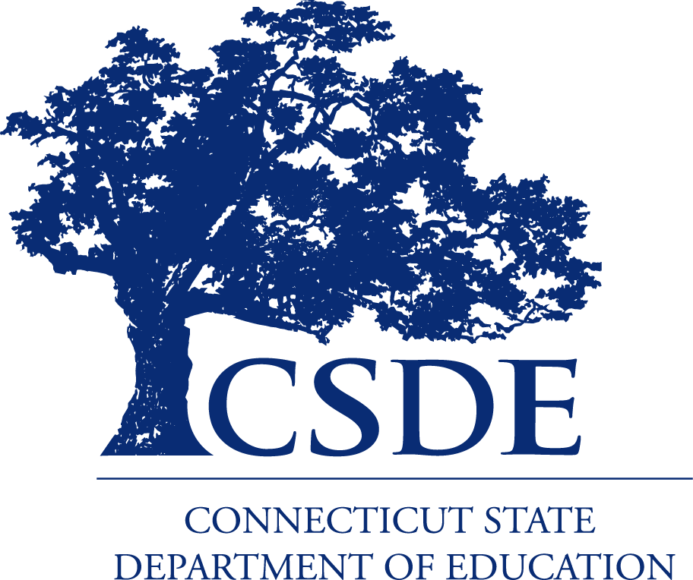
For more information, review the CSDE’s Menu Planning Guide for Preschoolers in the NSLP, SBP, and ASP and
ASP Handbook and visit the CSDE’s ASP webpage, or contact the school nutrition programs staff in the CSDE Bureau of Health/Nutrition, Family Services and Adult Education, 450 Columbus Boulevard, Suite 504, Hartford, CT 06103-1841.
This form is available at https://portal.ct.gov/-/media/SDE/Nutrition/ASP/Forms/ASPproductionrecord34.doc.
In accordance with Federal civil rights law and U.S. Department of Agriculture (USDA) civil rights regulations and policies, the USDA, its Agencies, offices, and employees, and institutions participating in or administering USDA programs are prohibited from discriminating based on race, color, national origin, sex, disability, age, or reprisal or retaliation for prior civil rights activity in any program or activity conducted or funded by USDA.  Persons with disabilities who require alternative means of communication for program information (e.g. Braille, large print, audiotape, American Sign Language, etc.), should contact the Agency (State or local) where they applied for benefits. Individuals who are deaf, hard of hearing or have speech disabilities may contact USDA through the Federal Relay Service at (800) 877-8339. Additionally, program information may be made available in languages other than English.  To file a program complaint of discrimination, complete the USDA Program Discrimination Complaint Form, (AD-3027) found online at: How to File a Complaint, and at any USDA office, or write a letter addressed to USDA and provide in the letter all of the information requested in the form. To request a copy of the complaint form, call (866) 632-9992. Submit your completed form or letter to USDA by:  (1) mail: U.S. Department of Agriculture  Office of the Assistant Secretary for Civil Rights  1400 Independence Avenue, SW  Washington, D.C. 20250-9410;  (2) fax: (202) 690-7442; or  (3) email: program.intake@usda.gov.  This institution is an equal opportunity provider. | The Connecticut State Department of Education is committed to a policy of equal opportunity/affirmative action for all qualified persons. The Connecticut Department of Education does not discriminate in any employment practice, education program, or educational activity on the basis of age, ancestry, color, criminal record (in state employment and licensing), gender identity or expression, genetic information, intellectual disability, learning disability, marital status, mental disability (past or present), national origin, physical disability (including blindness), race, religious creed, retaliation for previously opposed discrimination or coercion, sex (pregnancy or sexual harassment), sexual orientation, veteran status or workplace hazards to reproductive systems, unless there is a bona fide occupational qualification excluding persons in any of the aforementioned protected classes.  Inquiries regarding the Connecticut State Department of Education’s nondiscrimination policies should be directed to: Levy Gillespie, Equal Employment Opportunity Director/Americans with Disabilities Coordinator (ADA), Connecticut State Department of Education, 450 Columbus Boulevard, Suite 607, Hartford, CT 06103, 860-807-2071, levy.gillespie@ct.gov.

