The LEA must attach this information to the LEA’s policy statement for free and reduced-price meals. Upload this information with the policy statement to the Connecticut State Department of Education’s (CSDE) Child Nutrition Program (CNP) Online Application and Claiming System. Do not send a hard copy of this form to the CSDE.

LEA name: |  | Agreement number:

- Does your LEA use web-based applications? Note: A web-based application is part of a software program that allows the parent/guardian to complete and submit the entire application online and thus, avoid using the paper application.

Yes: What software program does your LEA use?

No: How does your LEA ensure that it complies with the federal regulations?

- Describe the LEA’s application approval procedures. Include information regarding how the LEA addresses each procedure below.

  - Notifies the households (e.g., via e-mail, letter, etc.) and collects the applications:

  - Reviews the applications:

  - Approves the applications:

  - Notifies the households of the final determination:

- Describe the process for ensuring that the electronic or manual point of sale (POS) system at the point of service (e.g., the end of the serving line) has the most up-to-date status of a student’s eligibility.

- If the determining official (DO) does not have access to an electronic POS system, describe how the manual system ensures that a student’s current eligibility status is reflected at the point-of-service (i.e., at the cash register):
- Describe the direct certification procedures below.

  - The process and frequency for retrieving and updating the direct certification list:

  - The process and frequency for updating the benefit issuance document (e.g., the master list) to include the direct certification information:

  - If the DO is not the direct certification contact, the process and frequency for sharing the direct certification information with the DO:

- Indicate the LEA’s procedures for the disclosure of children’s free and reduced-price or free milk eligibility information (refer to the CSDE’s form, “Request for Release of Free or Reduced Eligibility Status”). Indicate parties and organizations to whom you provide free and reduced-price meal eligibility data. The LEA must review and comply with the U.S. Department of Agriculture (USDA) disclosure requirements (7 CFR 245.6 (f-k)).

Resources
Application Forms for Free and Reduced Meals and Milk (CSDE webpage):
https://portal.ct.gov/SDE/Lists/Forms-School-Nutrition-Programs/Application-Forms-for-Free-and-Reduced-Meals-and-Milk
Eligibility for Free and Reduced-price Meals and Milk in School Nutrition Programs (CSDE webpage):
https://portal.ct.gov/SDE/Nutrition/Eligibility-for-Free-and-Reduced-price-Meals-and-Milk-in-School-Nutrition-Programs/Documents
Carryover Versus Transfer of a Child’s Eligibility (CSDE):
https://portal.ct.gov/-/media/SDE/Nutrition/NSLP/Forms/FreeRed/CarryoverTransfer.pdf
Direct Certification for School Nutrition Programs (CSDE webpage):
https://portal.ct.gov/SDE/Nutrition/Direct-Certification
Eligibility Manual for School Meals (USDA):
https://portal.ct.gov/-/media/SDE/Nutrition/NSLP/Forms/FreeRed/USDA_eligibility_manual.pdf
Important Points for Notifying Parents of a Child’s Free or Reduced-Price Eligibility (CSDE):
https://portal.ct.gov/-/media/SDE/Nutrition/NSLP/Forms/FreeRed/PointsNotifyParents.pdf
Important Reminders About Processing Applications (CSDE):
https://portal.ct.gov/-/media/SDE/Nutrition/NSLP/Forms/FreeRed/ProcessingApplications.pdf
SNAP/TFA Case Number Guidance (CSDE):
https://portal.ct.gov/-/media/SDE/Nutrition/NSLP/Forms/FreeRed/SNAPTFAnumbers.pdf
Taglines and Providing Meaningful Access to the Child Nutrition Programs (CSDE):
https://portal.ct.gov/-/media/SDE/Nutrition/NSLP/Forms/FreeRed/TaglinesForeignLanguage.pdf
Sample Taglines Form (CSDE):
https://portal.ct.gov/-/media/SDE/Nutrition/NSLP/Forms/FreeRed/TaglinesForm.doc

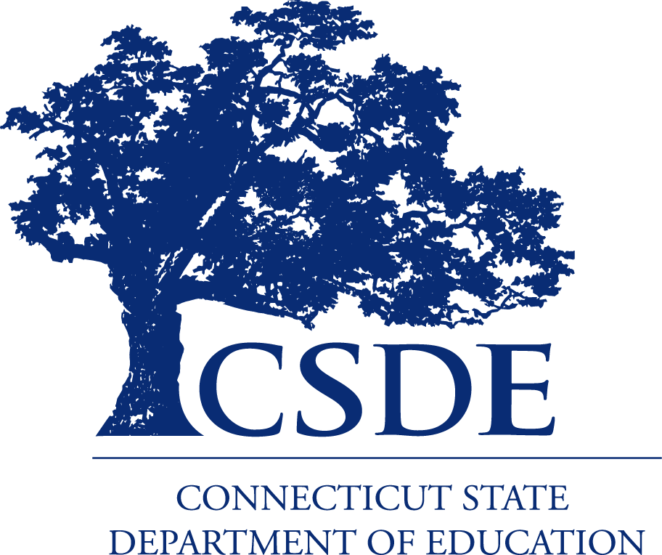
For more information, visit the CSDE’s Meal Counting and Claiming webpage or contact the school nutrition programs staff in the CSDE’s Bureau of Health/Nutrition, Family Services and Adult Education, 450 Columbus Blvd., Suite 504, Hartford, CT 06103-1841.
This document is available at https://portal.ct.gov/-/media/SDE/Nutrition/NSLP/Forms/MealCount/Mealappdataword.doc.

In accordance with Federal civil rights law and U.S. Department of Agriculture (USDA) civil rights regulations and policies, the USDA, its Agencies, offices, and employees, and institutions participating in or administering USDA programs are prohibited from discriminating based on race, color, national origin, sex, disability, age, or reprisal or retaliation for prior civil rights activity in any program or activity conducted or funded by USDA.  Persons with disabilities who require alternative means of communication for program information (e.g. Braille, large print, audiotape, American Sign Language, etc.), should contact the Agency (State or local) where they applied for benefits. Individuals who are deaf, hard of hearing or have speech disabilities may contact USDA through the Federal Relay Service at (800) 877-8339. Additionally, program information may be made available in languages other than English.  To file a program complaint of discrimination, complete the USDA Program Discrimination Complaint Form, (AD-3027) found online at: How to File a Complaint, and at any USDA office, or write a letter addressed to USDA and provide in the letter all of the information requested in the form. To request a copy of the complaint form, call (866) 632-9992. Submit your completed form or letter to USDA by:  (1) mail: U.S. Department of Agriculture  Office of the Assistant Secretary for Civil Rights  1400 Independence Avenue, SW  Washington, D.C. 20250-9410;  (2) fax: (202) 690-7442; or  (3) email: program.intake@usda.gov.  This institution is an equal opportunity provider. | The Connecticut State Department of Education is committed to a policy of equal opportunity/affirmative action for all qualified persons. The Connecticut Department of Education does not discriminate in any employment practice, education program, or educational activity on the basis of age, ancestry, color, criminal record (in state employment and licensing), gender identity or expression, genetic information, intellectual disability, learning disability, marital status, mental disability (past or present), national origin, physical disability (including blindness), race, religious creed, retaliation for previously opposed discrimination or coercion, sex (pregnancy or sexual harassment), sexual orientation, veteran status or workplace hazards to reproductive systems, unless there is a bona fide occupational qualification excluding persons in any of the aforementioned protected classes.  Inquiries regarding the Connecticut State Department of Education’s nondiscrimination policies should be directed to: Levy Gillespie, Equal Employment Opportunity Director/Americans with Disabilities Coordinator (ADA), Connecticut State Department of Education, 450 Columbus Boulevard, Suite 607, Hartford, CT 06103, 860-807-2071, levy.gillespie@ct.gov.

