The (insert name of sponsoring organization) _______________________________________ announces its participation in the federally funded Seamless Summer Option (SSO) of the National School Lunch Program (NSLP). Under the SSO, nutritious meals are provided free of charge to all children 18 years and younger at the following sites:

Name and Address of Sites |  | Meals Available and Serving Times |  |  | Meal Service Dates

Persons interested in receiving more information should contact:
Sponsor Name:
Sponsor Address:
City: |  |  |  | State: |  | Sponsor Phone:

In accordance with Federal civil rights law and U.S. Department of Agriculture (USDA) civil rights regulations and policies, the USDA, its Agencies, offices, and employees, and institutions participating in or administering USDA programs are prohibited from discriminating based on race, color, national origin, sex, disability, age, or reprisal or retaliation for prior civil rights activity in any program or activity conducted or funded by USDA.

Persons with disabilities who require alternative means of communication for program information (e.g. Braille, large print, audiotape, American Sign Language, etc.), should contact the Agency (State or local) where they applied for benefits. Individuals who are deaf, hard of hearing or have speech disabilities may contact USDA through the Federal Relay Service at (800) 877-8339. Additionally, program information may be made available in languages other than English.

To file a program complaint of discrimination, complete the USDA Program Discrimination Complaint Form, (AD-3027) found online at: http://www.ascr.usda.gov/complaint_filing_cust.html, and at any USDA office, or write a letter addressed to USDA and provide in the letter all of the information requested in the form. To request a copy of the complaint form, call (866) 632-9992. Submit your completed form or letter to USDA by:
(1) mail: U.S. Department of Agriculture
Office of the Assistant Secretary for Civil Rights
1400 Independence Avenue, SW
Washington, D.C. 20250-9410;
(2) fax: (202) 690-7442; or
(3) email: program.intake@usda.gov.

This institution is an equal opportunity provider.
Signature of Authorized Representative |  | Date
Directions:
- A copy of the release form must be submitted to the Connecticut State Department of Education prior to the start of your SSO.
- DO NOT pay to have this put into the paper. The regulations require only that you submit the release to the media. The press release will be made available to (insert name of news media): _______________________________________.
- You can personalize your press release by including information about your program. For example, to make the press release more interesting to the reader, include the number of years your organization has participated in the SSO and the number of children who benefit from the program.
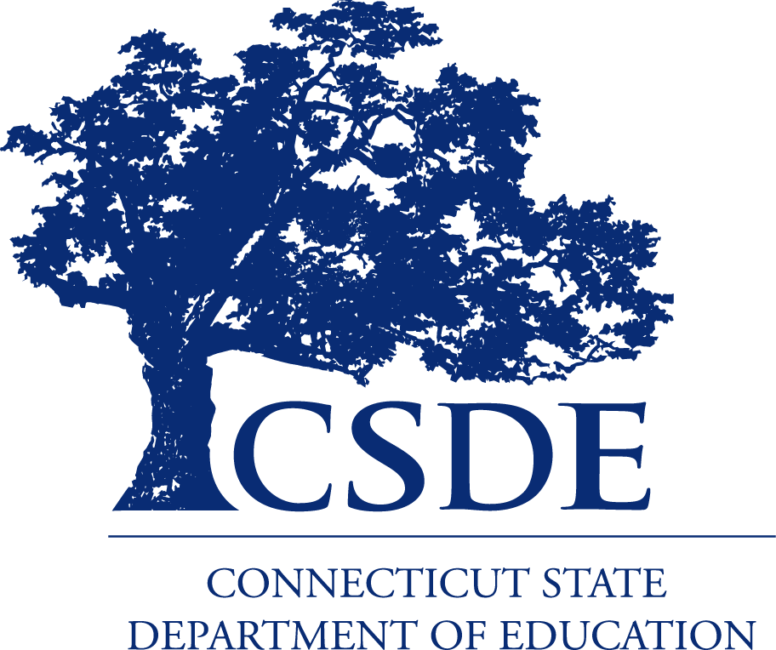
For more information on the SSO, see the Connecticut State Department of Education’s (CSDE) SSO webpage, or contact the school nutrition programs staff in the CSDE Bureau of Health/Nutrition, Family Services and Adult Education, 450 Columbus Boulevard, Suite 504, Hartford, CT 06103.
This handout is available at
http://portal.ct.gov/-/media/SDE/Nutrition/SFSP/PressReleaseSSO.pdf.

In accordance with Federal civil rights law and U.S. Department of Agriculture (USDA) civil rights regulations and policies, the USDA, its Agencies, offices, and employees, and institutions participating in or administering USDA programs are prohibited from discriminating based on race, color, national origin, sex, disability, age, or reprisal or retaliation for prior civil rights activity in any program or activity conducted or funded by USDA.  Persons with disabilities who require alternative means of communication for program information (e.g. Braille, large print, audiotape, American Sign Language, etc.), should contact the Agency (State or local) where they applied for benefits. Individuals who are deaf, hard of hearing or have speech disabilities may contact USDA through the Federal Relay Service at (800) 877-8339. Additionally, program information may be made available in languages other than English.  To file a program complaint of discrimination, complete the USDA Program Discrimination Complaint Form, (AD-3027) found online at: http://www.ascr.usda.gov/complaint_filing_cust.html, and at any USDA office, or write a letter addressed to USDA and provide in the letter all of the information requested in the form. To request a copy of the complaint form, call (866) 632-9992. Submit your completed form or letter to USDA by:  (1) mail: U.S. Department of Agriculture  Office of the Assistant Secretary for Civil Rights  1400 Independence Avenue, SW  Washington, D.C. 20250-9410;  (2) fax: (202) 690-7442; or  (3) email: program.intake@usda.gov.  This institution is an equal opportunity provider. | The Connecticut State Department of Education is committed to a policy of equal opportunity/affirmative action for all qualified persons. The Connecticut State Department of Education does not discriminate in any employment practice, education program, or educational activity on the basis of race, color, religious creed, sex, age, national origin, ancestry, marital status, sexual orientation, gender identity or expression, disability (including, but not limited to, intellectual disability, past or present history of mental disorder, physical disability or learning disability), genetic information, or any other basis prohibited by Connecticut state and/or federal nondiscrimination laws. The Connecticut State Department of Education does not unlawfully discriminate in employment and licensing against qualified persons with a prior criminal conviction. Inquiries regarding the Connecticut State Department of Education’s nondiscrimination policies should be directed to: Levy Gillespie, Equal Employment Opportunity Director/Americans with Disabilities Act Coordinator, Connecticut State Department of Education, 450 Columbus Boulevard, Suite 607, Hartford, CT 06103, 860-807-2071, Levy.Gillespie@ct.gov.

