The VRF Data Collector will be upgraded on December 22nd, 2015.
The main change in this new version is in the way Validation Exceptions are presented. There is also a small change to the Examine page.
Changes to the Validation Exceptions Pages and Features
Current implementation
In the current version, when you click on the Validation Exceptions link, the Data Collector brings up a single page showing the validation exceptions (in all the screen shots the SASIDs and Local IDs are overwritten to exclude Personally Identifiable Information):
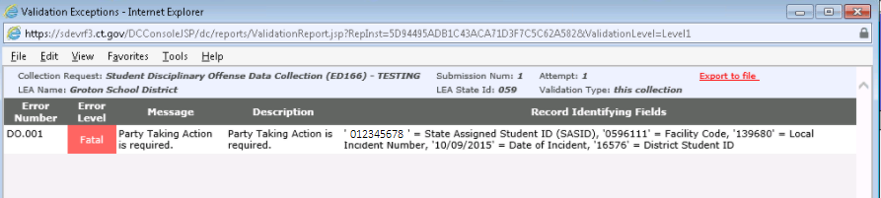
- All the exceptions are listed on the same page, regardless of the type of record which caused the validation exception.
- There is a single column showing all the Record Identifying Fields – the field names and their values form a single comma-separated string. These Record Identifying Fields are intended to help you find the record that caused the validation exception.
- If you want a CSV file of the validation exceptions, instead of looking at them in the browser, you can click the Export to file link.
New implementation, summary
The new version of the VRF Data Collector takes a different approach to presenting the Validation Exceptions:
- The validation exceptions for each Record Type are grouped and presented separately.
- The Record Identifying Fields are treated as individual columns, instead of a single comma-separated column.
- The Validation Exceptions link directs you to a summary page, which presents the overview of the number of validation exceptions, and offers the choice to view the exceptions in the browser or in a CSV file.
- You can select a subset of validation exceptions – you do not need to view all of them at once. For example, you can select just the fatal exceptions, or just the exceptions for one Record Type.
Details of the new implementation: the Validation Summary page
The Validation Exceptions link directs you to the summary page, (a similar approach to the summary page for the Examine link), showing how may validation exceptions were found, by severity, for each Record Type (the PSIS and ED166 collections have a single Record Type which is validated; the TCS collection has several Record Types):
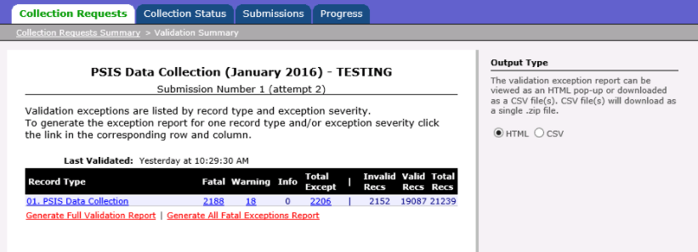
This page shows two sets of columns for each of the Record Types, separated by a vertical bar (the "|" symbol).
The columns on the left of the vertical bar show the number of fatal, warning and informational validation exceptions (and their total). The columns on the right show the number of invalid and valid records (and their total). Note that the two sets of numbers are not directly related – a single record can have many validation exceptions. The numbers on the right – the record counts – are shown for informational purposes only. They show you at a glance the impact of the numbers of validation exceptions on the left. For example, a few records can have multiple fatal exceptions, so a large number of fatal exceptions can still invalidate only a few records. Conversely, a few fatal exceptions can have a cascading effect, invalidating a large number of records.
The numbers on the left (when not 0) serve as links – you can click on each such number to see the specific validation exceptions for the Record Type.
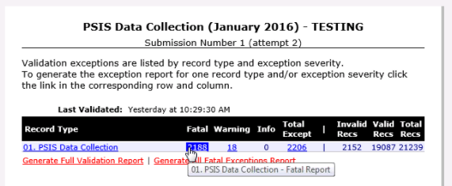
You can click the 2188 link (in this example) to view just the fatal validation exceptions, or click the 18 link to view just the warnings:
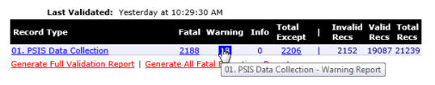
You can also click on the name of the record type to see all the validation exceptions for the record type. Clicking on the name in the Record Type column has the same effect as clicking on the number in the Total Except column for the record type.
At the bottom of the page there are two links:
- Generate Full Validation Report link to view all the validation exceptions (all severities, all record types).
- Generate All Fatal Exceptions Report link to view all the fatal exceptions. The Generate All Fatal Exceptions Report link is only shown when the collection has some fatal validation exceptions.
In the HTML view, validation exceptions for each record type have their own grid, and there is a scroll bar on the bottom (or on the side) when all the columns (or rows) exceed the size on the page.
The radio buttons in the side-bar let you choose viewing the validation exceptions in the browser (HTML) or downloading a CSV file:
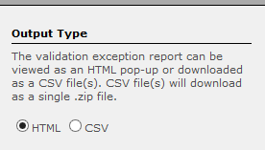
Validation Exceptions: HTML view
When you click on a single-report link, the pop up browser page shows a scrollable grid, displaying the validation exceptions (the grid shows a scrollbar on the right when there are more validation exceptions than fit in the grid):
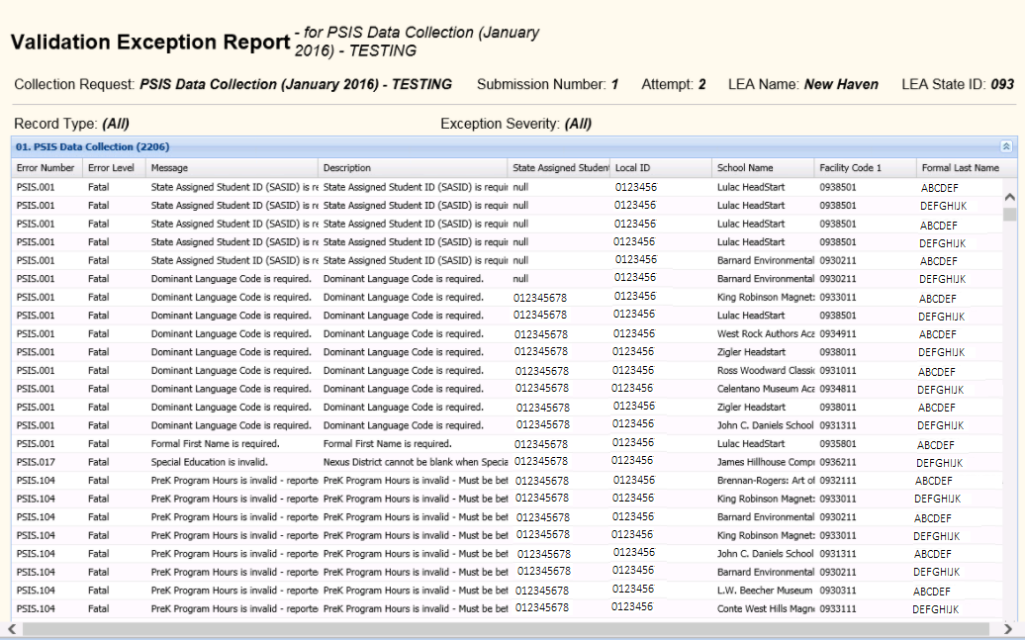
Note that what was previously a single Record Identifying Fields column is now split up into separate columns (State Assigned Student ID, Local ID, School Name, Facility Code 1, etc). You can scroll through all the validation exceptions – none are omitted from the html view.
When you click on a link which includes exceptions for multiple record types (e.g. the Generate All Fatal Exceptions Report link), the exceptions for each record type are displayed in a separate scrollable grid. This allows each record type to have a separate set of Record Identifying Fields columns (currently this applies only to the TCS collection, since this is the only one which has multiple record types which undergo validations):
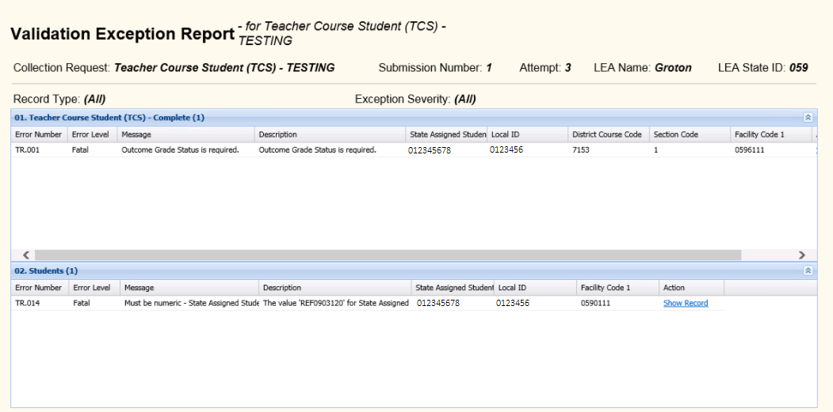
The header of each scrollable grid shows you the name of the record type and the total number of validation exceptions in the grid (regardless of how many you can see). The arrows all the way on the right (the or ) allow you to collapse or expand the contents of the grid.
You can drag the mouse on the scrollable grid to select a few cells, or rows, to select their contents:
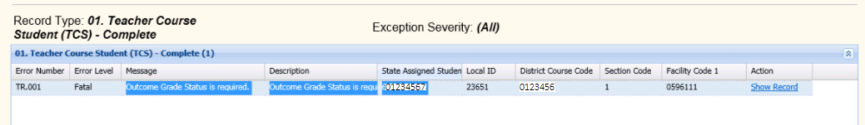
so you can copy and paste them:
Outcome Grade Status is required. Outcome Grade Status is required. 01234567
The rightmost column offers a link (Show Record) which allows you to display the entire record that has the validation exception:
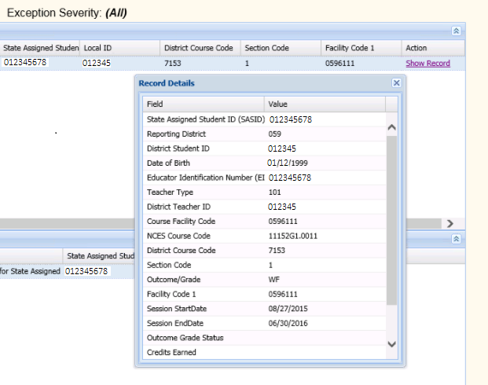

Note: Once you are done looking at the HTML view of the validation exceptions report, it is best to close the report browser window. If you leave the pop-up window alone, and go back to the other browser window, the Validation Exceptions Report window remains open, but behind other windows on your desktop. If you later click on another validation exceptions report link, the open Validation Exceptions Report browser window will repopulate with new data, but will not come to the front of the other windows. You may have the impression that the Validation Exceptions Report window failed to open. Instead, you need to find this window among the open browser windows on your desktop.
Validation Exceptions: Output as CSV files
You can choose to write the validation exceptions to CSV files for download, instead of viewing them in the browser, by selecting the CSV radio button in the side-bar:
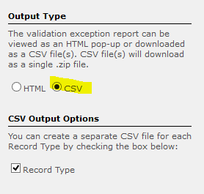
Once the CSV button is selected, the side-bar displays the CSV Output Options. The default is to create a separate CSV file for each Record Type. (Currently only the TCS collection has multiple Record Types.)
When each Record Type is written to a separate file, only the Record Identifying Fields specific to that Record type appear as columns in the CSV file – just as in the html view in the browser.
You can unselect the check box to create a single CSV validation exceptions file that includes all Record Types. When generating a single CSV file the Record Identifying Fields of all included Record Types appear as columns in the file, but for each record only the values that apply to that type are filled in. The columns which do not apply to a Record Type are left empty:
Since the Student record type does not have a District Code or a Section Code column, these columns are left blank in the single CSV output file.
The generated CSV file or files are zipped into a single .zip file, for faster download.
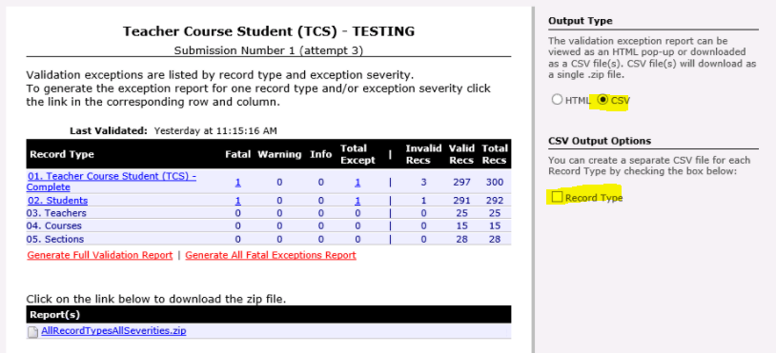
The name of the .zip or CSV file shows whether a single record type or all record types, and whether a single severity or all severities were selected.
The CSV file, inside the .zip file, uses a similar naming convention:
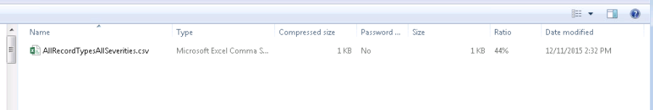
When the Record Type check box is checked, each record type is written to a separate CSV file, with the record type name as the CSV file name:
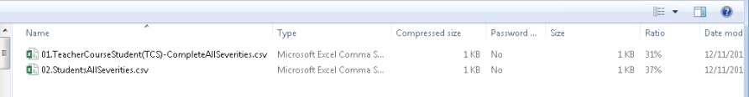
Changes to the Examine page
The Examine page now offers tool tips for each report, when these are provided by CT Department of Education. By moving your mouse over the File name you can see a longer description of the report:
