ED 236  Rev. 9/2011  20 USC 6801 et seq.,  as amended by  P.L. 107-110, Sec. 3001 | Connecticut State Department of Education  Division of Teaching, Learning and Instructional Leadership  Hartford

IMMIGRANT CHILDREN AND YOUTH SURVEY

FOR FISCAL YEAR 2011-12
INSTRUCTIONS:

Submit original and one copy to address
below by November 21, 2011.
RETURN TO:
William Howe, Program Manager
Connecticut State Department of Education
Division of Teaching, Learning and Instructional Leadership
P.O. Box 2219, Room 215
Hartford, CT 06145-2219

FROM: School District Name: _____________________

School District Code: _________

Please indicate on the pages following, the number of eligible immigrant children and youth enrolled in your public and nonpublic elementary and secondary schools as of
October 1, 2011.

Eligible immigrant children and youth* are defined as:
- ages 3 through 21 enrolled full-time in elementary and secondary school;
- not born in any state; and
- have not been attending one or more schools in any one or more states for more than a total of three full academic years.

*Please see page 2 for more information regarding “immigrant children and youth.”

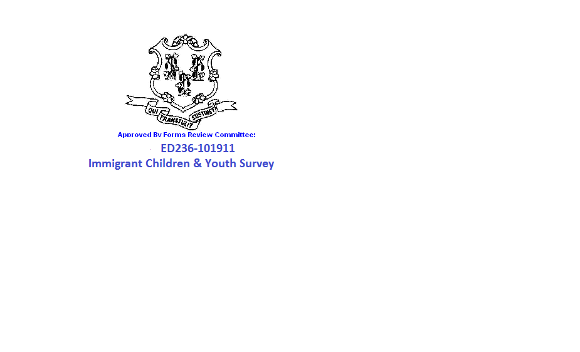

Definition of Immigrant Children and Youth
For Annual Survey - USDOE

Immigrant Children and Youth are:

- Considered to be full-time if the state or Local Educational Agency offers half-day Pre-K programs.

- Children from the Marshall Islands, the Federated States of Micronesia and the Republic of Palau can be counted as immigrants.

- Children adopted from overseas as U.S. citizens, requiring extensive new language and cultural skills, and still within the three point criteria are to be counted as immigrants.

The following do NOT qualify as Immigrant Children and Youth:

- Under No Child Left Behind (NCLB) legislation, the term “State” encompasses the 50 states, the District of Columbia, Puerto Rico, the Virgin Islands, and the outlying areas of American
Samoa, Guam and the Commonwealth of the Northern Mariana Islands. Also, under the
Elementary Secondary Education Act (ESEA) for state-administered programs, Puerto
Rico, the Virgin Islands, the Commonwealth of the Northern Mariana Islands, Guam and
American Samoa are all considered states. Therefore, children from these outlying areas are
not be counted as immigrant children and youth.

- Children born on a U.S. military base (may include civilians).

- Children of U.S. personnel born overseas are not to be included in any count of immigrant children and youth.

- Children born to U.S. citizens overseas that do not require extensive new language and cultural skills.

- Foreign exchange children and youth who come to the United States on a temporary basis to attend school or foreign children and youth in educational exchange programs.

Please indicate in the three right hand columns, the number of eligible immigrant children
and youth from those countries in your public and nonpublic schools.
Country of National Origin | Public | Nonpublic | Total
AFGHANISTAN
ALBANIA

ALGERIA
ANDORRA

ANGOLA
ANTARCTICA
ANTIGUA AND BARBUDA
ARGENTINA
ARMENIA
AUSTRALIA
AUSTRIA
AZERBAIJAN
THE BAHAMAS
BAHRAIN
BANGLADESH
BARBADOS
BELARUS
BELGIUM
BELIZE
BENIN
BHUTAN
BOLIVIA
BOSNIA AND HERZEGOVINA
BOTSWANA
BRAZIL
BRUNEI
BULGARIA
BURKINA FASO
BURMA (MYANMAR)
BURUNDI
CAMBODIA
CAMEROON
CANADA
CAPE VERDE
THE CENTRAL AFRICAN REPUBLIC
CHAD
CHILE
CHINA, PEOPLE’S REPUBLIC & HONG KONG
CHINA (TAIWAN)
COLOMBIA
THE COMOROS
THE CONGO

Country of National Origin | Public | Nonpublic | Total
COSTA RICA
COTE D’IVOIRE (IVORY COAST)
CROATIA
CUBA
CYPRUS
CZECH REPUBLIC
DENMARK
DJIBOUTI
DOMINICA
THE DOMINICAN REPUBLIC
ECUADOR
EGYPT
EL SALVADOR
EQUATORIAL GUINEA
ERITREA
ESTONIA
ETHIOPIA
FIJI
FINLAND
FRANCE
GABON
THE GAMBIA
GEORGIA
GERMANY
GHANA
GREECE
GRENADA
GUATEMALA
GUINEA
GUINEA BISSAU
GUYANA
HAITI
HONDURAS
HUNGARY
ICELAND
INDIA
INDONESIA
IRAN
IRAQ
IRELAND
ISRAEL
ITALY
JAMAICA

Country of National Origin | Public | Nonpublic | Total
JAPAN
JORDAN
KAZAKSTAN
KENYA
KIRIBATI
KOREA, DEMOCRATIC PEOPLE’S REPUBLIC
KOREA, THE REPUBLIC OF (SOUTH KOREA)
KUWAIT
KYRGYZSTAN
LAOS
LATVIA
LEBANON
LESOTHO
LIBERIA
LIBYA
LIECHTENSTEIN
LITHUANIA
LUXEMBOURG
MACEDONIA
MADAGASCAR
MALAWI
MALAYSIA
MALDIVES
MALI
MALTA
THE MARSHALL ISLANDS
MAURITANIA
MAURITIUS
MEXICO
FEDERATED STATES OF MICRONESIA
MOLDOVA
MONACO
MONGOLIA
MOROCCO
MOZAMBIQUE
NAMIBIA
NAURU
NEPAL
THE NETHERLANDS
NEW ZEALAND
NICARAGUA

Country of National Origin | Public | Nonpublic | Total
NIGER
NIGERIA
NORWAY
OMAN
PAKISTAN
PALAU
PALESTINE AUTONOMOUS AREAS
PANAMA
PAPUA NEW GUINEA
PARAGUAY
PERU
THE PHILIPPINES
POLAND
PORTUGAL
QATAR
ROMANIA
THE RUSSIAN FEDERATION
RWANDA
SAINT CHRISTOPHER AND NEVIS
SAINT LUCIA
SAINT VINCENT AND GRENADINES
SAN MARINO
SAO TOME AND PRINCIPE
SAUDI ARABIA
SENEGAL
SEYCHELLES
SIERRA LEONE
SINGAPORE
SLOVAKIA
SLOVENIA
SOLOMON ISLANDS
SOMALIA
SOUTH AFRICA
SPAIN
SRI LANKA
SUDAN
SURINAME
SWAZILAND
SWEDEN
SWITZERLAND
SYRIA
TAJIKISTAN
TANZANIA

Country of National Origin | Public | Nonpublic | Total
THAILAND
TOGO
TONGA
TRINIDAD AND TOBAGO
TUNISIA
TURKEY
TURKMENISTAN
TUVALU
UGANDA
UKRAINE
THE UNITED ARAB EMIRATES
THE UNITED KINGDOM
URUGUAY
UZBEKISTAN
VANUATU
THE VATICAN CITY
VENEZUELA
VIET NAM
WESTERN SAMOA
YEMEN
YUGOSLAVIA
THE DEM. REPUBLIC OF CONGO (ZAIRE)
ZAMBIA
ZIMBABWE
OTHERS
TOTAL

Explain how these data were collected and specific efforts to ensure accuracy:

Name of person completing form: _____________________________________________
Title: ________________________________________Telephone: __________________

E-mail address: ____________________________________________

______________________________________________________ _____________________________

Signature of Superintendent of Schools Date

