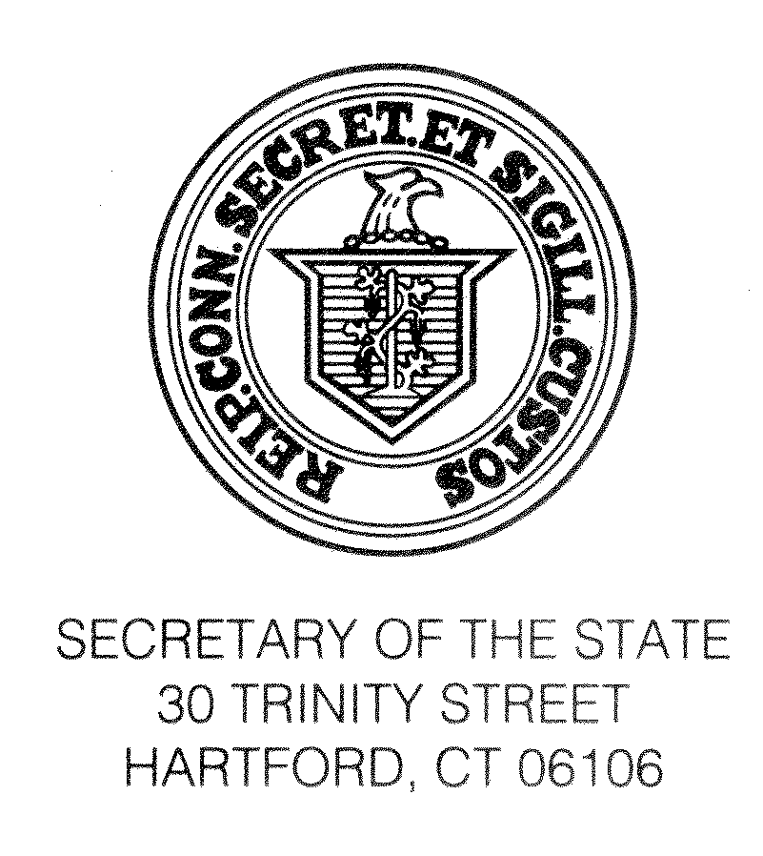

January 3, 2015

TO REGISTRARS OF VOTERS OF TOWNS HOLDING ELECTIONS ON NOVEMBER 3, 2015:

We are pleased to send to you the prescribed form of the nonpartisan literature which you may distribute during the annual canvass of voters required by Section 9-32 of the General Statutes between January 1, 2015 and May 1, 2015 in towns holding elections on November 3, 2015.

Please note that we have enclosed two versions of the nonpartisan literature. One is the form for use in a house-to-house canvass (ED-320). The other form (ED-321) is for use in a canvass by mail to be included with the Notice of Canvass, which we are also sending to you.

The use of the nonpartisan literature is optional. Also optional, as indicated at the bottom of the enclosed forms, is the inclusion by you of information concerning voting districts and/or location of polling places. Although there is no specific statutory requirement (except for Bridgeport, East Hartford, Hartford, Meriden, New Britain, New Haven, New London, Waterbury and Windham, presently), we strongly recommend that municipalities which have 1% or more Hispanic population, but no less than 500 persons, who choose to use the optional nonpartisan literature, use the English and Spanish texts.

We hope that you will call us at (860) 509-6100 whenever we can be of service in any way.

Sincerely,

DENISE MERRILL
Secretary of the State

By:
Theodore E. Bromley
Staff Attorney

Enclosures (ED-320, ED-321)
cc: Printers of Record

(G\massmail\2012\12-12\nonpart)--(Canvass of Electors, non-partisan)

