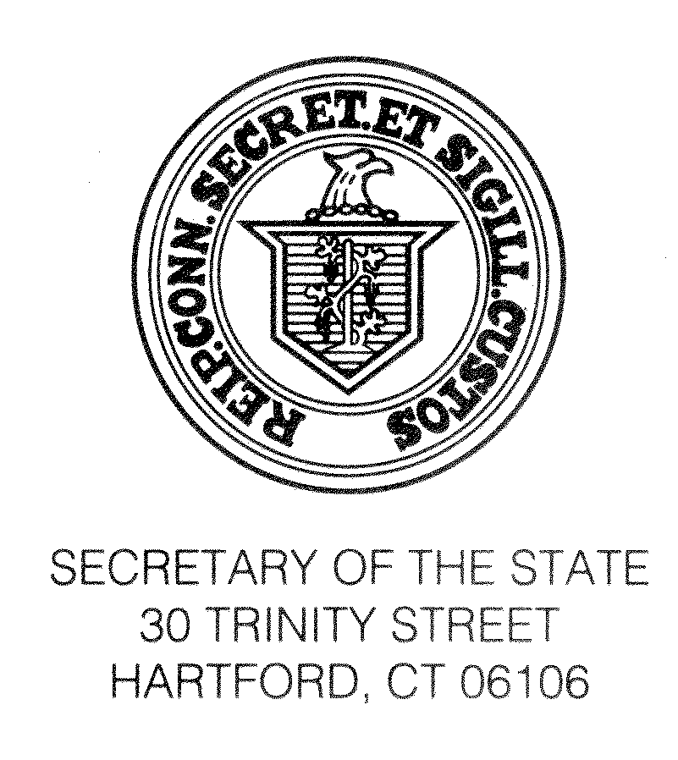

September 21, 2016

TO ALL TOWN CLERKS:

Re: Suggested Form of Warning of November 8, 2016 State Election

For your guidance, we are enclosing a Suggested Form of Warning for the coming November 8, 2016 election.

The suggested form follows the requirements of Conn. Gen. Stat. §§9-225 and 9-369.

Please let us know if you have any questions or if we can be of assistance at (860) 509-6100.

Sincerely,

Denise Merrill
Secretary of the State

By:_____________________
Theodore E. Bromley
Staff Attorney

Enclosure: ED-650
(/tmp/in/input.doc) - (Warning)
(ED-650 - Suggested Form of Warning 2012) [G\forms\ed-600's\ed-650]

SUGGESTED FORM OF WARNING

November 8, 2016 State Election

The Electors of the Town of are hereby warned to meet at their respective polling places in said town on Tuesday, November 8, 2016, for the following purposes:

- To cast their votes for Presidential and Vice-Presidential electors, United States Senator, Representative in Congress, State Senator, State Representative, Registrar of Voters*, (insert any offices involved in special elections or elected annually by special act).

II. (Insert warning for local questions, if any. Include reference to authority, such as charter or special act, under which vote on the question is taken; and state that the full text of the amendment, charter revision, and/or question is available at the Town Clerk's Office for public inspection.)

Notice is hereby given that the location of the polling places is as follows:

Voting District Location of Polling Place

**Absentee Ballots will be counted at the following central location:

.

Voting machines will be used. The polls will be opened at six o'clock in the morning (6:00 a.m.) and will remain open until eight o'clock in the evening (8:00 p.m.).

Dated at , Connecticut, this day of , 2016.
_________________________________
Town Clerk/Assistant Town Clerk
Town of________________________

*Include only if applicable.
**Include only when central counting has been designated under Conn. Gen.
Stats. §9-147a.

