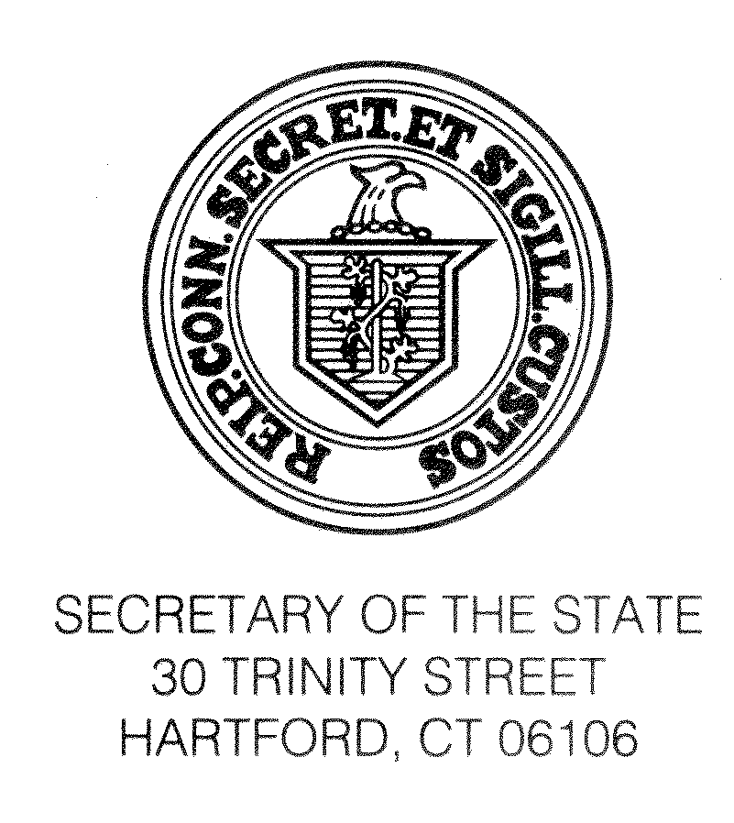

September 17, 2016

TO ALL REGISTRARS OF VOTERS

Re: Certificate of Completion of Canvass

Pursuant to Conn. Gen. Stat. §9-32, the Registrars of Voters must file a certificate with the Secretary of the State that the annual canvass of electors was conducted prior to the November 8, 2016 election in accordance with the requirements of the statute. The deadline to file this certificate is December 8, 2016. The certificate must be on the form prescribed by the Secretary of the State, and must be signed under penalty of false statement by all Registrars of Voters of the municipality. The prescribed form is enclosed. If you need additional space to specify dates of completion, please use the reverse side of the certificate or attach additional sheets.

Please feel free to call us at (860) 509-6100 if you have any questions regarding this certificate or the canvass of electors.
Sincerely,

Denise W. Merrill
Secretary of the State

By:____________________
Theodore E. Bromley
Staff Attorney

Enclosure--ED-632

/tmp/in/input.doc(Canvass--Statement of Completion)

(ED-632-Canvass, Statement of Completion of – 10/04)-[/tmp/in/input.doc]

FROM THE OFFICE OF THE SECRETARY OF THE STATE
Legislation and Elections Administration Division
30 Trinity Street - 2nd Floor
P.O. Box 150470
Hartford CT 06115

CANVASS OF ELECTORS
STATEMENT OF REGISTRARS AS TO COMPLETION
(Section 9-32)

We, the undersigned Registrars, hereby state under penalty of false statement that the canvass of electors required under Section 9-32 of the General Statutes of Connecticut was properly conducted between January 2, 2016 and April 30, 2016, inclusive, on the date(s) specified below and by the method indicated in the:

TOWN OF _______________________________________

METHOD:

- House-to-House Canvass

- Mail Canvass

- National Change of Address System of the U.S. Postal Service

- Telephone Canvass

◻ Combination of House-to-House, Mail and Telephone Canvass as
specified and explained here:

DATE(S) CONDUCTED:

____________________________________________
Registrars of Voters

____________________________________________
Registrars of Voters

____________________________________________
Registrars of Voters

____________________________________________
Registrars of Voters

NOTE: All Registrars of Voters of a town must sign this form

