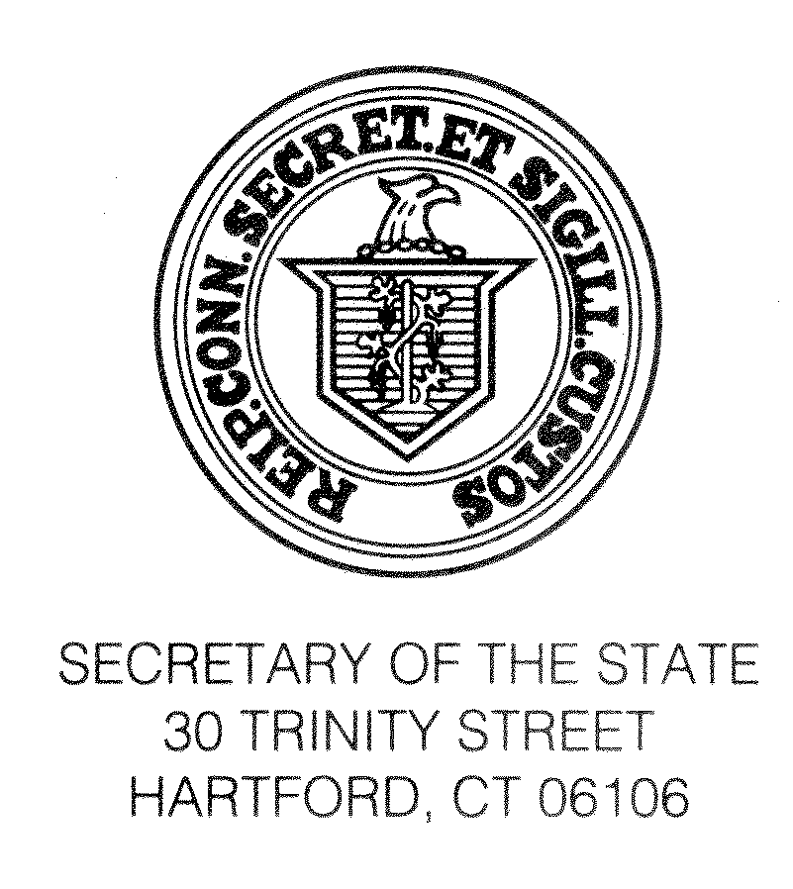

TO: All Registrars of Voters

FROM: Denise W. Merrill
Secretary of the State

DATE: May 2, 2017

RE: Annual Spring Conference
April 19 to April 21
Marriott Mystic Hotel, Groton, CT

Recently, we gathered together again to share ideas and to take part in training that will help each of us to better carry out our duties as election officials. I know that I speak for my staff when I say that we learn as much from these conferences as you do and we enjoy the opportunity to meet colleagues we usually only communicate with via email or phone. Pursuant to Section 9-6 of the Connecticut General Statutes, the Spring Registrars of Voters Conference was held at the Marriott Mystic Hotel in Groton from April 19 to April 21. Secretary of the State Day was Friday, April 21.

It was good to see so many of you taking advantage of this great training opportunity. As many of you know, Section 9-6 of the General Statutes provides that Registrars or Deputies attending the conference shall be compensated by the municipality which they represent at the rate of $35.00 per day, “plus mileage to and from such conference at the rate determined by the municipality, but not less than twenty cents per mile.” This instruction is critical to ensuring that local election officials are up-to-date on new developments and have the tools necessary to effectively carry out their duties.

The consistently high turnout at these conferences demonstrates how crucial training is and how effective it can be to come together as a group of elections officials. I thank Melissa Russell, President of the Registrars of Voters Association of Connecticut, her committee and my staff for all they have done to prepare for this conference.

Finally, I know you will join me in congratulating the 69 newly-certified registrars of voters and also join me in thanking the Training and Certification Committee and our educational partner UConn CITI for all their past and continuing work in developing a comprehensive model curriculum for the training and accreditation of registrars.

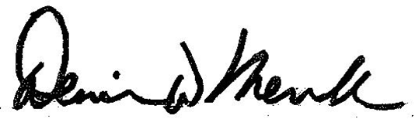
Sincerely,

Denise W. Merrill
Secretary of the State

