THE BESB BUZZ…
A Newsletter for Families of Children
who are Blind or Visually Impaired

Volume 27
Fall/Winter 2021

Published by the State of Connecticut
Department of Aging and Disability Services
Bureau of Education and Services for the Blind (BESB)

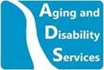

In This Issue:
Staffing Updates 2
Student Events 3
Tech Corner 6
NEAER Virtual Conference 8
Around the Web 9

The BESB Buzz is now fully digital. You can find back issues in English and Spanish on our website, https://portal.ct.gov/AgingandDisability.

Feel free to contact the newsletter’s co-editors at Jessie.Mabry@ct.gov or Jessica.Gibson@ct.gov. We welcome your comments and ideas for future newsletter topics.

Staffing Updates



We are thrilled to welcome a new education consultant to our program this year! Lauren Royce is no stranger to BESB, having served as a special assistant to the blind staff for seven years prior to starting her new career as a teacher of the visually impaired (TVI). As a special assistant collaborating with one of our legally blind TVI’s, Lauren got a unique view into the vocation and was inspired to pursue a master’s degree to become one herself. Working with our access technology specialist also acquainted her with all the tools our students use to be successful in the classroom.

When she wasn’t out on the road with staff, Lauren occasionally managed to find time for special projects around the office, including the creation of an incredibly elaborate gingerbread house for a holiday cubicle-decorating contest one year, which she won hands-down.

In her new role, Lauren is excited to work with a diverse group of students and BESB’s talented and collaborative teachers. Outside of BESB, she enjoys spending time with her family.



In June, we bid farewell to two of our education consultants, Yvonne Locke and Lisa Pruner, (also a former Buzz editor). Both worked with our birth-to-three and preschool population, Yvonne for 10 years and Lisa for 34. Their considerable experience and creative teaching ideas were much appreciated. They will be missed and we wish them the very best!

September also saw the departure of BESB’s executive director, Brian Sigman, who served for seventeen years in that capacity and another seventeen before that as a counselor in our Vocational Rehabilitation Program. We are grateful for his dedicated leadership and all he did to improve the lives of the blind and visually impaired of Connecticut and beyond. We wish him a happy and healthy retirement!

Student Events

BESB teachers work hard every year to organize engaging and educational social events for our students, and this past year was no exception despite COVID-related challenges. We would like to showcase a few virtual activities held recently for some of our younger students.

Shake It Up!
Led by Amy Flores and Others
May 25, 2021
6 Students, 2nd-7th grade
This program was developed to connect students with one another through a very basic Introduction to Cooking Skills. By asking the families to have a kitchen monitor available we were hoping that families would be able to see the skills that were taught so that they could encourage practice of these skills in the future.
It was determined that students needed to have certain adaptive items to use in their homes, so the planning team ordered and shipped or delivered them to the students beforehand. Items used in this event included measuring spoons and cups, cooking mitts, and strawberry slicers (optional). A student gave a refresher on how to use the strawberry slicer for those students who wanted to use it.
Shake It Up! was a 1.5-hour event hosted through the virtual platform Zoom. Many teachers each taught a portion of the program. The lessons and activities included:
- Going through ingredients, cooking implements, and other items needed.
- Where do vanilla and chocolate come from?
- What does salt do to ice?
- Making ice cream in a bag

Fortunes and Giggles
Led by Amy Flores and Others
July 15, 2021
4 Students, 3rd-6th Grade
This was an hour-long event intended to give students an opportunity to meet over the summer in a way that was hands-on, though virtual, and incorporated literacy. The activities included “Telling Fortunes” with origami fortunetellers and then creating Mad Libs.
Students received a package of supplies in the mail prior to the event. These packages contained the elements and instructions needed to make a fortuneteller, including a pre-folded model and a piece of paper that was a fortuneteller marked and unfolded (so that it had all of the folds already creased). They also received 2 Mad Lib templates according to the preferred literacy medium of each.
The actual event occurred during a Zoom meeting. The response was positive. Each student had their fortune told. All of the students participated in the Mad Libs. Many “Giggles” were enjoyed by all.

Middle School Origami Series
Led by Beth Borysewicz
Once monthly in March, April, and May 2021
8 students, 5th-7th grade

This program was designed with Origami artist Ben Parker with the goal to bring the art of Origami to our students in an adaptive format. Working with Ben and the students, we collaborated to figure out the best approach to teaching the art with the added challenge of conveying the instruction virtually.
Students were initially mailed only the flat squares of paper needed to make their models, but as we got deeper into the program, we improved on it. By the last session, students received a premade model with their paper packet so that they could get a sense of what all their folding would lead to.
Creations included a crane, a sailboat, and a dog. Students got the chance to practice spatial awareness, listening skills, and math in a hobby they could build upon. The series was a great learning experience and we hope to continue working with Ben in the future.

Preschool Music Class Series
Collaboration with CT Music Therapy

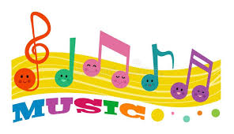

BESB is thrilled to offer a monthly virtual music class for our birth-to-three and preschool aged students. During each session, Kelsy Gati of CT Music Therapy leads the children in an interactive program with songs, instruments, and body movements. It’s impossible to leave the session without a smile on your face! This is an ongoing program throughout the year and registration is month-to-month. Please reach out to your TVI if interested!

Tech Corner

While the world of mainstream technology is ever evolving, often too fast for us to keep up, access technology doesn’t always seem to change as quickly. We see a lot of the same types of devices year after year, with maybe a couple new features or performance enhancements. However, there has been a spike in innovation this year, both in software and hardware, that promises many benefits for our students. Jessie Mabry, our access tech specialist, has a few product highlights to share. They all provide a relatively good value for the price, considering the included features.

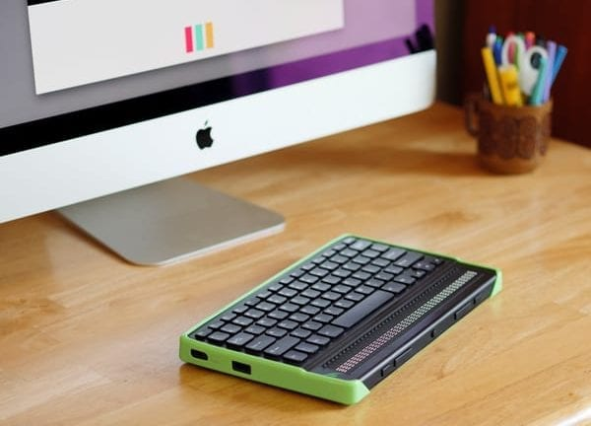
Mantis Q40

The Mantis Q40 is the first refreshable Braille device of its kind. It has a 40-cell display and a laptop-style QWERTY keyboard. It can connect to almost any popular mainstream device to display screen reader output in Braille, but it also has some internal applications for notetaking, downloading books, and reading without needing to connect to another device.
The Mantis helps students migrate from the Braille keyboard they are familiar with to the computer keyboard required to keep up with sighted peers, without losing the Braille output they need to maintain literacy and proofread easily. It retails for $2,495.00 from APH. To learn more, visit their Mantis product page.

CloverBook
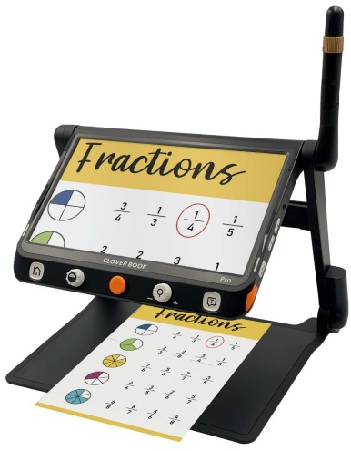
The CloverBook is a lightweight 12.5-inch CCTV built into a collapsible custom stand. There are several versions to choose from, depending on whether a student needs distance magnification, the ability to scan and hear text read aloud, etc.
The device’s form factor and ability to read aloud aren’t all that unusual in the market; what I think makes the CloverBook unique is the convenient placement of the distance camera and split-screen capability. The latter is exclusive to the Pro version and involves vertically mounting an additional monitor above the CCTV to show a distance view on one screen and near view on the other.

The CloverBook series can be purchased from New England Low Vision and other retailers, ranging from $1,895.00 to $3,344.00, depending on the model. For more information and several helpful videos, visit New England Low Vision’s CloverBook Pro product page.

forScore


forScore is an app for the iPad, iPhone, iPod Touch, and Mac that converts scanned or digital sheet music into reflowed PDF documents for easy reading and annotation. Features include the ability to purchase digital music, attach audio files to sheet music files, turn pages hands-free with a bluetooth foot pedal, and more.
The app has been around for many years and just keeps getting better. It is marketed to anyone who prefers sheet music in a digital format, but it is particularly helpful for our blind and low-vision students because unlike with printed sheet music, they can conveniently control font size, color contrast, and other features to meet their visual needs.
forScore is available from the Apple App Store on your child’s chosen device for $19.99. To learn more visit https://forscore.co.

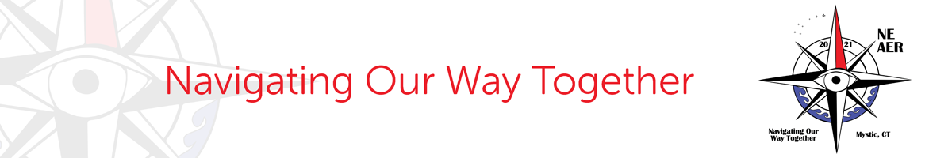

NEAER Virtual Conference
Navigating Our Way Together
November 4 and 5, 2021

BESB was honored to plan and host NEAER’s annual conference this past fall. (NEAER is the New England chapter of AER, the Association for the Education and Rehabilitation for the Blind and Visually Impaired.) The conference was originally planned for Mystic, CT, but the ongoing pandemic required the conference committee to change course and plan an entirely virtual event.

Over 150 professionals in the field of blindness and visual impairment attended. Throughout both days of the conference, attendees had the opportunity to choose from a variety of programs that covered all age ranges and areas of the Expanded Core Curriculum. Several of BESB’s current and former education consultants shared their expertise including:

- Peg Palmer and Matt Tietjen’s presentation, Imagining CVI: An Array of Simulations
- Hope Pardee’s presentation, Low Vision Simulator Apps: A Smart Use for Smartphones
- Dennis Gallant’s presentation, How to Create a Sensory Garden
- Matt Tietjen presenting Sensory Balance Approach: An LMA Supplement for Children with CVI

In addition to exceptional presenters, attendees were treated to a keynote address by renowned singer-songwriter and contestant from NBC’s The Voice, Blessing Offor. If you’d like to read more about Blessing and hear some of his music, please check out his YouTube page here.

Many thanks to our conference chairs, Lori Cornelius and Evie Furey, and NEAER President Faith Horter, for bringing the vision of a virtual conference to life!

Around the Web

As amply demonstrated during the NEAER conference, BESB education consultants have a wealth of knowledge and experience to share with families and other teachers in the field. There are many online publications that allow them to reach a national and international audience. Paths to Literacy and Paths to Technology, both affiliated with the Perkins School for the Blind, are two of the most popular.
Below, we are pleased to highlight two articles recently published by our very own BESBees on these blogs. Read on to discover how to create CVI friendly flashcards and how to turn your smartphone into a vision simulator!

Creating CVI-Friendly Beginning Readers and Flashcards
Paths to Literacy
May 20, 2021

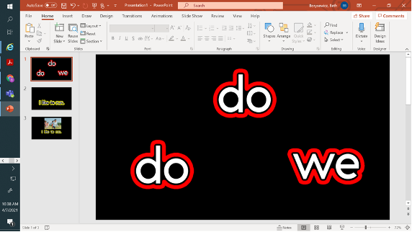

In this article, Beth Borysewicz gives step-by-step instructions on using Roman Word Bubbling and Power Point to create adapted flashcards for a student with CVI that can be shared virtually or in person. For more information, you can access the full article here.

Low Vision Simulator Apps and Frequently Asked Questions
Paths to Technology
May 5, 2021

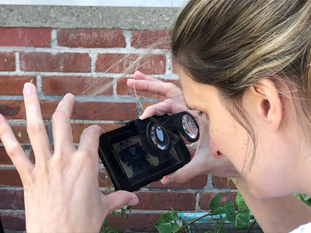

Using a question and answer format, Hope Pardee describes the purposes and benefits of low vision simulation apps for smartphones that can be supplemented with virtual reality glasses. They provide teachers and families with an approximation of how various eye conditions could affect a child’s vision. To learn more, you can find the full article here.


From all of us at ADS-BESB, we wish you a Happy, Healthy New Year!
See you in 2022!

