State of Connecticut
Department of Consumer Protection
Liquor Control Commission
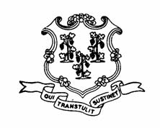
THE LIQUOR PERMIT OF:

LOADING DOCK WINE & SPIRITS
1469-B Boston Post Rd.
Milford
LIP.14109

HAS PAID A FINE OF $2,750 AND HAS BEEN
SUSPENDED
for the following dates:

APRIL 15 through and including
APRIL 19, 2013

This suspension has been imposed for alleged violation of
the following statutes or regulations:

§30-6-A41(a) RESTRICTIONS ON SALES & PURCHASES
§30-76 PURCHASE FOR RESALE
§30-6-A35(a) LABELS, LABELING & REGISTRATION OF BRANDS

