State of Connecticut
Department of Consumer Protection
Liquor Control Commission
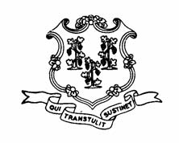
THE LIQUOR PERMIT OF:

PLAINFIELD NORTHEAST WINE & SPIRIT
81 LATHROP ROAD
PLAINFIELD
LIP.14545

HAS PAID A FINE OF $1000 AND HAS BEEN
SUSPENDED
for the following dates:

FEBRUARY 4 & 5, 2013

This suspension has been imposed for alleged violation of
the following statutes or regulations:

§30-86(b) SALE TO MINOR

