State of Connecticut
Department of Consumer Protection
Liquor Control Commission
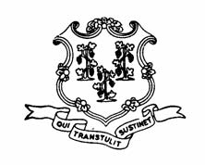
THE LIQUOR PERMIT OF:

STOP & SHOP SUPERMARKET
54 Highland Ave.
Enfield
LGB.12452

HAS PAID A FINE OF $3000 AND HAS BEEN
SUSPENDED
for the following dates:

APRIL 10, 2013

This suspension has been imposed for alleged violation of
the following statutes or regulations:

§30-86(b) SALE TO MINOR

