State of Connecticut
Department of Consumer Protection

Liquor Commission
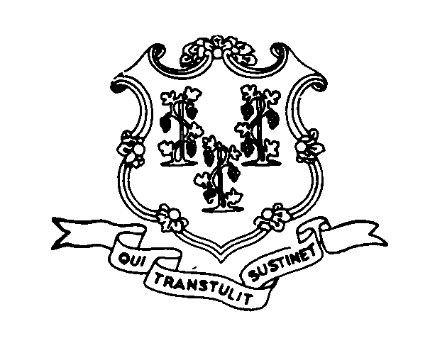
Commissioner Jerry Farrell, Jr.
Commissioner Gary Koval

THE LIQUOR PERMIT OF:

DOTCOM WINE & SPIRITS

23-29 CROSSROADS PLAZA, WEST HARTFORD, CT

HAS PAID A FINE OF $3,000. AND HAS BEEN

SUSPENDED

for the following date:

JANUARY 22, 2007

This suspension has been imposed for violation of
the following statutes or regulations:

30-86 Sale to minor

