State of Connecticut
Department of Consumer Protection
Liquor Control Commission
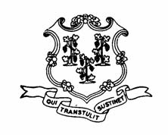
THE LIQUOR PERMIT OF:

ATHENS PIZZA
140 School St.
Putnam
LIR.18378

HAS PAID A FINE OF $500 AND HAS BEEN
SUSPENDED
for the following dates:

September 9, 2013

This suspension has been imposed for alleged violation of
the following statutes or regulations:

§30-86(b) SALE TO MINOR
§30-90 MINOR IN BARROOM
§30-6-B28(c) AREA, SEATING CAPACITY, FACILITIES
§30-6-B29 SEPARATE BARROOMS, PARITITIONS

