Enter the Individual’s First Name & Last Name, DDS#, Case Manager’s Name and the Meeting Date:
Mary Person Centered Plan DDS #
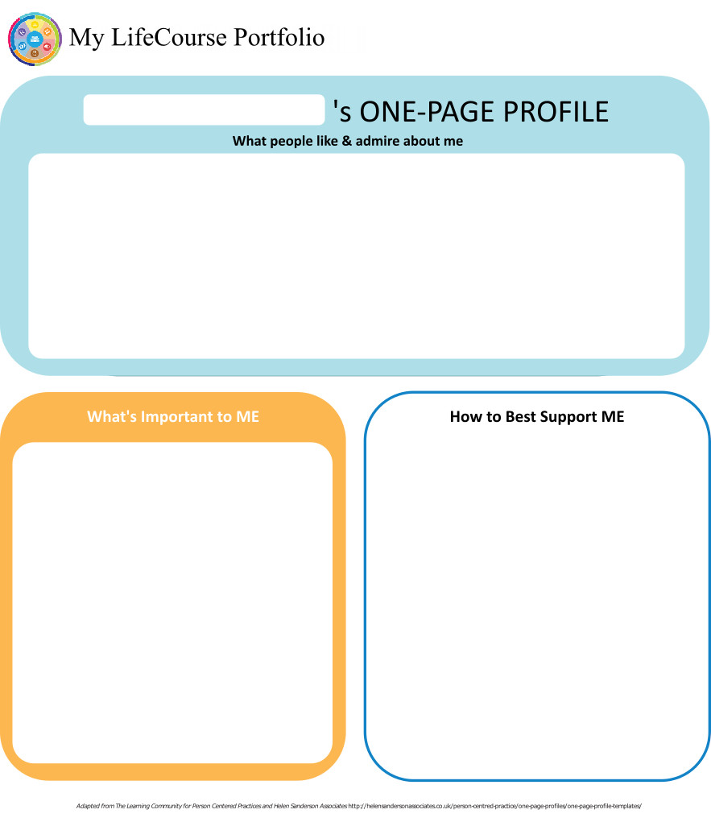
Case Manager: S Meeting Date: 11/08/18

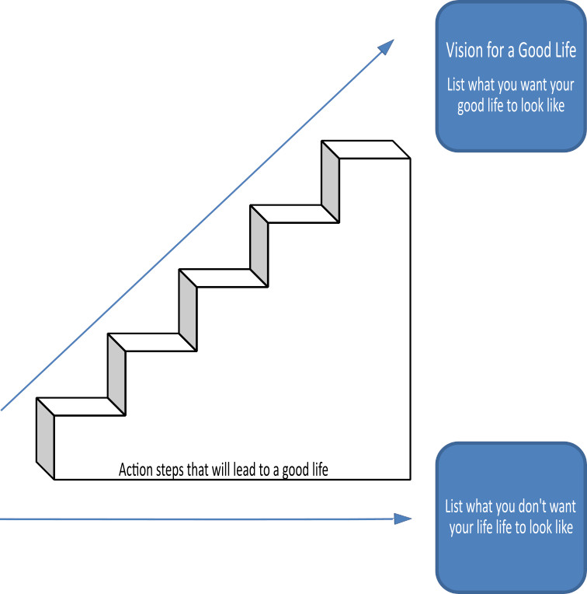

Home Life
Current Status Please include schedule, supports received, supervision needs, LON Risk areas, and accomplishments: Mary had lived her entire life with her mother until she passed away in February of 2018. She had not had any interaction with other programs or many activities outside the home since she graduated high school. She has transitioned well to her CCH.
Mary is a risk for being taken advantage of financially. CCH licensee B… supports Mary to manage her finances. IPP SW M… visits the CCH at least monthly to review financial ledgers, bank statements, COH, and receipts. The team reviews finances at least Q 6 months.

Mary typically chooses to get in her pajamas after dinner @ 7:30 and watch TV, particularly the game shows Jeopardy and Wheel of Fortune. She sometimes falls asleep with the TV on; when this occurs B… will turn the TV off for her. Mary usually wakes up once during the night to use the bathroom, and falls asleep again easily.

It was discussed during this IP year that Mary typically rides in the back seat of the vehicle when the CCH family goes out together. Mary expressed wanting to sit in the front seat, but it has been observed that due to her weight she is not able to easily get in to the front seat and the seatbelt does not fit around her body. The seatbelt in the backseat fits properly. In an effort to address this delicately with Mary, B… and E… have explained to her simply that it is safest for her to sit in the back seat when they travel together. The team agreed this is appropriate.

Mary has no house key of her own. The CCH family decided that it may be a risk of losing the key if she carries one, and opted to leave the house unlocked for the brief period of time in the afternoon when typically the house is empty. They have several close, trusted neighbors who are aware of this arrangement and keep an eye out for Mary (and for the two boys as well). There is a spare key kept inside the house in the event that Mary or another family member had plans to leave the house and needed to lock it up. Mary knows where this key is kept. The team agreed this arrangement appears appropriate.

Supervision:
Evacuation: Mary evacuates quickly with a verbal prompt.

Bathing: Mary requires hands on assistance for bathing/showering. Specifically she typically needs prompting for showering but sometimes needs hands on assistance to ensure she cleans her body thoroughly. Mary is physically able to wash her body but she sometimes chooses not to. CCH licensee B… provides this level of support.

Swimming: Mary has strong swimming skills and can swim in deep water with supervision. See aquatic activity screening.

Time alone w/o supervision: Mary is permitted to have up to 4 hours of alone time, but this has been implemented only minimally. This is in part due to concerns that she overate on more than one occasion when she was left home alone. The daily schedule of the family tends to limit alone time on a regular basis anyway. The team agreed this is appropriate.

- What I want my Home to be like How do you like to spend your time at home: I like to spend time as a family. Watching TV and playing piano.

- Would you like to live anywhere else, what’s your vision? No because I'm happy where I am.

- What Supports do you need to help with this? I have everything that I need.

- Do you need support with your finances?
Providers please include financial assessment and report if applicable. Do you have a representative payee? Please list.

B… helps when I need it. We work together to budget and track spending.
- You are required to obtain and maintain Medicaid benefits. Do you require help maintaining
Medicaid?
- If yes, who is responsible to help you? B….

- Financial Information:
- Earned Income none
- Benefits Income (list programs and amounts) SSI $1281 and DSS $113 per month
- Bank AccountsTD Bank checking account balance $260.44 and COH $183.00
- Burial/Funeral Account? none
- Total assets: as documented above
- Are you satisfied with the supports you are receiving at home?
Describe: They support me by staying together as a family.

- Emergency contact: J…., sister and C…, brother in law. Address is …... Phone number is……..

- Emergency Back-Up Plan:
An Emergency Back-Up plan must be completed for individuals who receive waiver services and live in their own home, family home or other settings where staff might not be continuously available, and who receive personal care and/or supervision supports and the failure of those supports to be available would lead to an immediate risk to the individual’s health and/or safety.

Work, Day, Retirement or School
Current Status Description/schedule of what the individual is doing, level of support and supervision needed, identify any LON Risk areas, modes of transportation, accomplishments: Mary is supported by ……. in a DSO program, Monday to Friday, up to 30 hours per week. ADA provides transportation. Mary needs supervision available when she is in the community. Mary has many friendships at …… and enjoys being very actively involved in music events which use her talents for singing and playing the piano! Mary is especially close with her friend N…..
Mary is a graduate of ………..Technical High School. She participated in the culinary arts program. Mary has had very little employment history. She did have a few jobs in the past but explains that she was let go from both. Prior to beginning at ……., Mary spent 20 + years with no formal day programming.

- Do you like the job you have or the activities you do during the day? yes.
- What do you like about it, what would you like to change? I get to play bingo, go dance and play piano. I like it the way it is.
- What new skills, education or activities would you like to learn or take part in this year? I'd like to learn about computers or secretary work. The team further discussed ways that Mary might be able to learn specific computer skills. Some ideas were to insert clip art in to the concert flyers she creates. Other ideas were to insert tables, try different font types, font sizes, color, etc. The team agreed to set a general goal to capture all these ideas as "features/functions".
- What are your career goals? Vision for the future? To do the best job I can. To be a receptionist.

- What supports do you need during work or activities? Support from others to help me with problems.

- Do you have Transportation to get you to and from work on time?

Describe: I get picked up by CT Transit and they are mostly on time.
- Do you make minimum wage or better? n/a

- Are you satisfied with your wages?

Describe: I don't have any wages.
- Do you make enough money to do the things you want? yes

- What can you do this year to make more money? just live life.

- Are you satisfied with the supports you are receiving?
Describe: They help me with medical benefits and support from the government.

Health and Wellness
Current Status: How is your health? What supports are you receiving? What activities do you do to stay healthy? Please include current medications, diagnosis, doctor’s orders, dental, last physical, known allergies, adaptive equipment, brief overview of health history unless noted in Nursing Report, attach Nursing Report to plan if available. Is there a behavior plan in place? Please attach.
Mary is diagnosed with Mild IDD, elevated blood pressure, hematurua, knee pain, myopia, obesity, pre-diabetes, rosacea, shortness of breath, Vitamin D Deficiency.

Mary has lost a great deal of weight in the past year, more than 60 pounds due to a healthy diet and regular exercise! Mary goes swimming at a local pool with the CCH family several evenings each week. She is a very strong swimmer.

J…. shared that there is a family history of high blood pressure and diabetes.

Today the team reviewed the self-administration of medication assessment. Mary does not have the cognitive ability to full self administer her own medications. She is able to self adminster topical creams with daily reminders from the CCH provider to ensure MD orders are being followed. Scheduled oral medications or PRN medications are administered by the CCH provider.

Today the team reviewed the mobility assessment and fall prevention plan. Mary walks independently and she is not at high risk for falls. She uses no adaptive equipment. The environment should be kept clutter free. Any falls or injuries will be reported to nursing immediately.

There is not a current need for behavioral support services, but this will be considered in the future if concerns arise. Some behavioral concerns were noted in the past IP year, related to the new residential CCH setting, but have since resolved.
- What’s Important to me about my health and safety Any areas you want or need to work on? Hygiene and to not gain a lot of weight.
2. Are you up to date on routine medical tests and visits?
Are you able to follow recommended health guidelines? List any deferrals.
Explain: I am super up to date!
3. What supports do you need to improve your health and safety? Please include a plan to support any health risk identified in your LON. I don't need any. Mary would be at risk for being taken advantage of sexually. Currently the team has established that Mary can safely be left at home alone for up to 4 hours, though this is rarely implemented. Currently Mary has no permitted alone time in the community, though this may change to allow her to pursue her desire to sing in a choir at church. If changes are made to alone time, the full P&ST will discuss and agree to specific parameters which ensure that her safety needs remain consistently met.
4. Are you satisfied with the supports you are receiving?
Describe: They help me with medical benefits.

Friendships, Relationships and Activities

- Who do you enjoy spending time with? Family, friends, co-workers, acquaintances? Any special relationships? My family - J…., C… and at home with A…, B…, C… and E…. It is important to note that Mary's mother passed away on 2/03/18. Mary was very close to her mother, but has processed the loss this past year with support from family and friends.

- What are your interests and hobbies? reading, piano, bowling, movies, church, swimming

- Do you participate in any Groups? …….. Chorus

- Would you like to increase the time you spend with family, friends or doing hobbies or favorite activities? no.

- What help do you need to accomplish this? I don't need any help, its plenty of time. The team discussed Mary's desire to become involved in a choir, either at church or in the community. The team discussed some potential risks with Mary's proposed alone time in the community for this goal to become a reality. Concerns expressed included that Mary may not decline a ride from a stranger, she has a history of falling victim to scams designed to make a stranger seem familiar ("Hey! You remember me?! I used to be your neighbor! Could I have $10?"). The team agreed that walking alone would not be safe for health reasons, including limited mobility and potential fatigue with moderate distance. The team agreed that J… will be consulted for alone time parameters as this goal is pursued and the specific schedule becomes known to B…. The team discussed that B… and E… would make every effort to accommodate a rehearsal schedule to minimize any alone time needed, as well as to encourage healthy community connections with trusted individuals who might provide a reliable resource to assist with transportation.



Action Plan
Desired Outcome  (What Do You Hope to Accomplish?) | Why is this Important to you? | Actions and Steps | Responsible Person(s) | Date to be  Completed or  Time frame monitored
- I would like to expand my computer skills. | - I like using the computer and want to learn new skills. In the future I want to be a secretary or receptionist. | 1A:Mary will be supported to learn one new feature or function on the computer per month. | Mary, ….agency | monthly
- I would like to expand my computer skills. |  | 1B:Mary will be supported to print out the weekly schedule, with assistance as needed. | Mary, ….agency | weekly
- I would like to expand my computer skills. |  | 1C:
- I would like to expand my computer skills. |  | 1D:

- I will use my musical talents to perform for others. | - I like to play the piano and sing. | 2A:Mary will plan and participate in upcoming events/performances. | Mary, ….agency | monthly
- I will use my musical talents to perform for others. | - I like to play the piano and sing. | 2B:
- I will use my musical talents to perform for others. | - I like to play the piano and sing. | 2C:
- I will use my musical talents to perform for others. | - I like to play the piano and sing. | 2D:

- I want to continue losing weight. | - I am proud of the weight I've lost and I feel better than I used to. | 3A:Mary will use the treadmill or elliptical machine (at home or at the hospital) at least twice per week. | Mary, CCH | weekly
- I want to continue losing weight. |  | 3B:
- I want to continue losing weight. |  | 3C:
- I want to continue losing weight. |  | 3D:

- I want to sing in a choir at church or in the community. | - I used to sing in a church choir and I want to become involved again. | 4A:Mary will be supported to talk with staff at Sacred Heart church to discuss options for involvement. | Mary, CCH | 1/2019
- I want to sing in a choir at church or in the community. |  | 4B:Mary will be supported to inquire if there are any community choirs, if Sacred Heart has no opportunities. | Mary, CCH | 2/2019
- I want to sing in a choir at church or in the community. |  | 4C:Alone time parameters for choir practices and events will be discussed and agreed upon by all team members prior to being implemented. | Mary, J…., CCH, …agency, DDS | prior to being implemented, review by 3/19
- I want to sing in a choir at church or in the community. |  | 4D:

- I want to increase my independence with things I am able to do on my own by doing them with less reminders from Beata and Eugene. | - I want to be as independent as I can. | 5A:Mary will independently turn the TV off when she feels tired and will fall asleep in bed, instead of falling asleep in the chair with the TV on. | Mary, CCH | daily
 | - I want to be as independent as I can. | 5B:Mary will independently throw all trash in the kitchen garbage can, instead of keeping trash in her bedroom closet. | Mary, CCH | daily
 | - I want to be as independent as I can. | 5C:
 | - I want to be as independent as I can. | 5D:

6A:
6B:
6C:
6D:

7A:
7B:
7C:
7D:

Summary of Supports and Services:
Agency/individual/Vendor | Type of Support/Service  (identify all including HCBS Waiver Services, non-waiver services and any other supports) | Amount of Support/Service  Hours per week/month/year
B…. CCH | residential support services | 24/7
…agency Social Worker | CCH support services | monthly contact and as needed
…agency RN | Nursing support services | quarterly contact and as needed
…..agency | vocational support services (DSH) | up to 30 hours per week per master contract
DDS | Special Support Payment – to be used for respite and any health/safety need that arises. Ongoing the licensee is encouraged to save 25% for any major health or safety need that may arise. | LON 4 funding
FI | ADA tickets | $1400 annually
DDS | Case Management | Quarterly contact and as needed

For Extension Purposes Only
Plan remains appropriate and Team agreed to extend plan as per DDS extension procedure on:
Case Manager Signature:

Summary of Representation, Participation & Plan Monitoring

Choice and Decision Making
Would you like the assistance of a guardian (in some or many areas) or an advocate in making important decisions in your life? Does your team feel this assistance may be needed? Team should note steps to be taken in this area.

Mary’s sister J… is Durable Power of Attorney and limited guardian in the areas of abode, medical and release of records.

Individual’s Participation in Planning Process
Were you part of the planning for your meeting and the development of this plan? How can the team assist you with improving your participation in the future? Please identify those steps for next year’s meeting.

Mary actively participated in her planning meeting today. She will be included in all future meetings.

Representative’s Participation in Planning Process
Did your family/guardian/advocate/legal or personal representative take part in the planning process and meeting? Are you satisfied with their level of participation? Team should note steps to be taken in this area for any increased participation.

J… actively participated in today’s meeting and she will continue to be invited to all future meetings.

Monitoring and Evaluation of the Plan
Contact your case manager with any concerns or progress updates throughout the year. Providers will complete and distribute an Individual Progress Review every six months. Your case manager will conduct a Quality Service Review with you once a year.

The team will review the plan Q 6 months and sooner if deemed necessary.

Aquatic Activity Screening Individual Plan and Individual Short Plan Addendum
Name: Mary | DDS#: | Date: 11/08/18
An individual’s aquatic activity screening* is effective for one year from the date on this form as part of the IP or for up to three years for an individual with an IP Short Form. Request for any changes or updates to this form shall be made through the Planning and Support Team process.
*For individuals without an IP and assigned case manager, this form shall be completed by the Helpline Case Manager and the individual’s family when access to aquatic activities at DDS-funded sites or with DDS-funded staff are planned (i.e., camp, respite centers, family support).
SECTION 1 SCREENING FOR PRESENCE AND PARTICIPATION IN AQUATIC ACTIVITIES
Definitions:
- “Aquatic Activities” means all water-related activities including swimming, boating, fishing, hot tubs, water parks and those activities that take place near to water.
- “Near To Water” means aquatic activities at any location where there is a body of water at the intended destination that is open and accessible to individuals. This means that there are no barriers to prevent access such as secure fencing or padlocked gates. Contact with the water may, or may not be intended. Bodies of water include, but are not limited to, streams, creeks, oceans, lakes, ponds, pools, hot tubs, wading pools, or natural or man-made water areas. Near to water activities include, but are not limited to, picnics in a park where there is water, feeding ducks at a pond, unrestricted access to backyard wading or swimming pools or hot tubs, or walks on the beach.
- “Shallow Water” means water at or below the height of the individual’s chest.
- “Deep Water” means water above the height of the individual’s chest.
The Planning and Support Team should assign an Aquatic Activity Code “0” to “6”for the individual Aquatic Activity Code
0 = Individual does not swim or participate in any aquatic activities.
If coded as “0”, Section 2 should have “NO” checked for all activities listed.
1= Near to Water Activities Only and Must Be With Staff
Individual participates only in activities near to water.
2 = Shallow Water Only Individual has limited or no swimming skills and does not respond to verbal redirection and may not recognize dangerous situations.
3 = Shallow Water Only Individual has limited or no swimming skills but usually responds to verbal redirection and may or may not recognize dangerous situations.
4 = Deep Water Swimmer Individual can swim in deep water with staff supervision (Comments in Section 2 may define supervision type).
5 = Aquatic Activity Level Not Known. Individual is approved only for aquatic activities as permitted in Section 2 and must be in a One-to-One enhanced staff-to-individual ratio at all of these activities until aquatic activity code is determined and approved.
6 = Independently Accesses Aquatic Activities Individual requires no supervision for aquatic activities. Do not complete Section 2.
SECTION 2 AQUATIC ACTIVITIES - SUPERVISION NEEDS
Complete this section for individuals with an Aquatic Activity Code of “0” to “5”only.
NOTE: If you check off ‘yes’ for any of the activities below, there must be a “staff-to-individual” ratio included. These ratios are for staff to ensure they provide adequate supervision. Safe staff ratios cannot exceed 1 staff to 7 individuals for any of the activities listed. If supervision needs are unknown due to lack of previous participation, the individual must be in a 1:1 staff to individual ratio at all aquatic activities, until a safe appropriate ratio can be determined and approved.
AQUATIC ACTIVITY | ABLE TO  PARTICIPATE | SUPERVISION NEEDS | COMMENTS (arms-length, line of sight, seizures, lifejacket, etc.)
Activities Near to Water |  | # 1 staff to # 5 individuals
Boating: follow site directions for life jacket use. |  | # 1 staff to # 5 individuals
Swimming |  | # 1 staff to # 5 individuals
Water Parks |  | # 1 staff to # 5 individuals
Hot Tub Use |  | # staff to # individuals

Individual’s Name: Mary DDS #

Provider: Submitted By:

Case Manager: S Date: Period Covered: to

Six Month Annual Other: Date of next Review Meeting :

Are there any significant updates or changes regarding the person’s status in any of the following areas?

What’s important to me? Vision for a Good Life Home Life Finances Work, Day, Retirement or School
Health and Wellness Friendships, Relationships and Activities Integrated Support Star

Updates/Changes:

Copies should be sent to: Individual/Family/Guardian, Case Manager, Residential Provider, Day Provider
Waiver Service(s) (from Summary of Supports and Services):

#1 Desired Outcome: I would like to expand my computer skills.
Progress made towards Actions and Steps Yes No Outcome not addressed (must comment below)
Include information about progress, whether steps should continue or be modified.
A: Mary will be supported to learn one new feature or function on the computer per month.
B: Mary will be supported to print out the weekly schedule, with assistance as needed.
C:
D:

See Attached

Concerns/Comments/Recommendations:
Waiver Service(s) (from Summary of Supports and Services):

#2 Desired Outcome: I will use my musical talents to perform for others.
Progress made towards Actions and Steps Yes No Outcome not addressed (must comment below)
Include information about progress, whether steps should continue or be modified.
A: Mary will plan and participate in upcoming events/performances.
B:
C:
D:

See Attached
Concerns/Comments/Recommendations:

Individual’s Name: Mary DDS #
Waiver Service(s) (from Summary of Supports and Services):

#3Desired Outcome: I want to continue losing weight.
Progress made towards Actions and Steps Yes No Outcome not addressed (must comment below)
Include information about progress, whether steps should continue or be modified.
A: Mary will use the treadmill or elliptical machine (at home or at the hospital) at least twice per week.
B:
C:
D:

See Attached
Concerns/Comments/Recommendations:
Waiver Service(s) (from Summary of Supports and Services):

#4 Desired Outcome: I want to sing in a choir at church or in the community.
Progress made towards Actions and Steps Yes No Outcome not addressed (must comment below)
Include information about progress, whether steps should continue or be modified.
A: Mary will be supported to talk with staff at Sacred Heart church to discuss options for involvement.
B: Mary will be supported to inquire if there are any community choirs, if Sacred Heart has no opportunities.
C: Alone time parameters for choir practices and events will be discussed and agreed upon by all team members prior to being implemented.
D:

See Attached
Concerns/Comments/Recommendations:

Waiver Service(s) (from Summary of Supports and Services):

#5 Desired Outcome: I want to increase my independence with things I am able to do on my own by doing them with less reminders from Beata and Eugene.
Progress made towards Actions and Steps Yes No Outcome not addressed (must comment below)
Include information about progress, whether steps should continue or be modified.
A: Mary will independently turn the TV off when she feels tired and will fall asleep in bed, instead of falling asleep in the chair with the TV on.
B: Mary will independently throw all trash in the kitchen garbage can, instead of keeping trash in her bedroom closet.
C:
D:

See Attached
Concerns/Comments/Recommendations:

Individual’s Name: Mary DDS #
Waiver Service(s) (from Summary of Supports and Services):

#6 Desired Outcome:
Progress made towards Actions and Steps Yes No Outcome not addressed (must comment below)
Include information about progress, whether steps should continue or be modified.
A:
B:
C:
D:

See Attached
Concerns/Comments/Recommendations:
Waiver Service(s) (from Summary of Supports and Services):

#7 Desired Outcome:
Progress made towards Actions and Steps Yes No Outcome not addressed (must comment below)
Include information about progress, whether steps should continue or be modified.
A:
B:
C:
D:

See Attached
Concerns/Comments/Recommendations:

