Enter the Individual’s First Name & Last Name, DDS#, Case Manager’s Name and the Meeting Date:
Lawrence (Brad) Person Centered Plan DDS # 12345
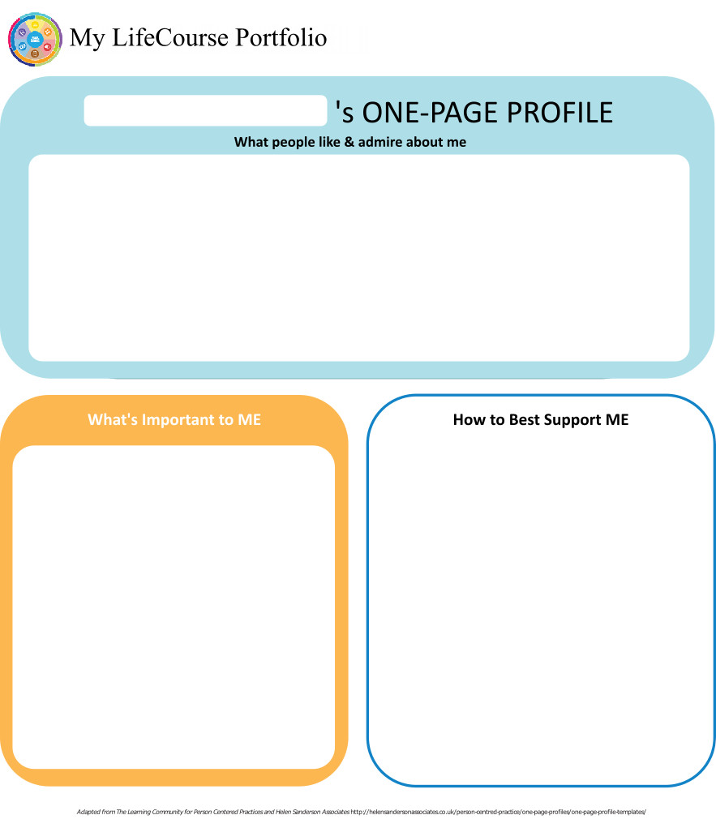
Case Manager: R…..... Meeting Date: 7/16/18

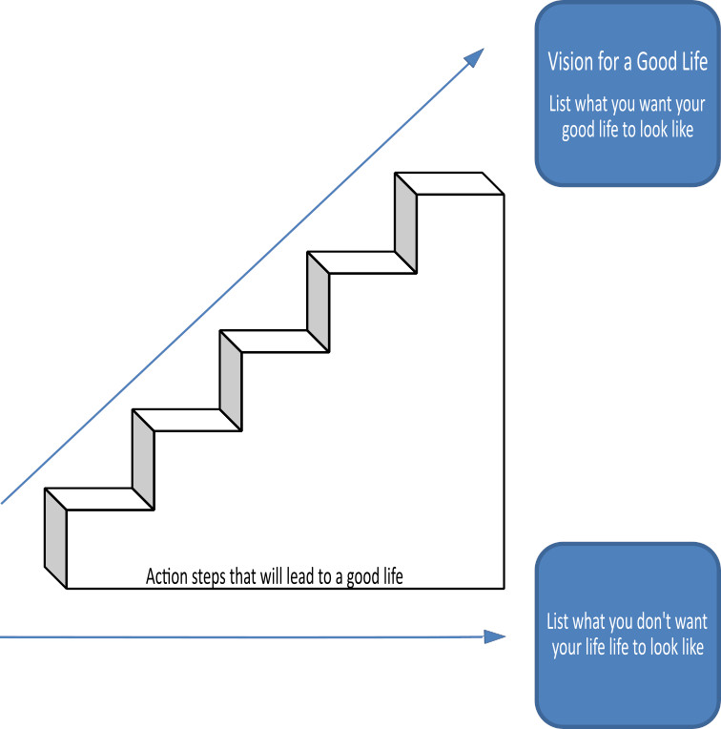

Home Life
Current Status Please include schedule, supports received, supervision needs, LON Risk areas, and accomplishments:
* Brad lives in R… with his mother, father, older sister and younger sister. He also has an older brother who lives nearby.
* Mom reports that due to the home's size, space & privacy is difficult.
* When Brad is home he typically watches TV, plays video games or goes out in the community.
* Mom continues to report that Brad doesn't like chores but will walk the dog, but it is on his terms.
* Mom states that Brad also doesn't like to shower or take a bath & this can be a struggle.
* Brad currently receives 19 hours per week of IHS support which is self-directed, 100 hours per year of hourly respite support which is also self-directed and Clinical Behavior support via an ABC/Agency. His self-directed staff primarily include B…. and his brother D….. Staff are working with Brad to build general independence and ADL skills, including doing his laundry, shopping for personal items he needs and recycling for the household. They also assist Brad in accessing the community for leisure and recreation. Brad did verbalize that he doesn't feel that B…. is a good match for him, however, mom expressed that she feels Brad feels this way because B….. is firm and has expectations of Brad and Brad resists any demands that are placed on him.
* Brad continues to struggle on occasion with behavior. His Clinical Behaviorist is working with the family and staff to implement general interventions to address Brad's negative behaviors if/when they arise, which has been infrequent. Part of the difficulty, which the family acknowedges, is that in the past, A: many times consequence were either not clear, or they were clear but not enforced or B) Rewards were still given after negative behaviors have been exhibited. Over the past few years, mom and dad have tried very hard to change this pattern, but still often times the result is the same, with Brad exhibiting non-compliance or resistance. It is something the family continues to struggle with. During the IP, team agreed that ABC/agency would inplement data sheets for both self-directed staff and the family to track any/all incidents that occur. ABC/agency will update behavior plan and provide data tracking sheets within 30 days of this meeting, to include risk of Bolting. Specifically to this behavior, Brad does have his own cell phone which allows him to check-in and his parents to contact him.
* Most recently, Brad was arrested on July 2, 2018 for assaulting a police office (statue 53a-167c). Per his mother, Brad had stolen some money from his sister, when dad intervened to try to get the money back, Brad escalated. Per mom, dad called 911 to have them assist in getting the money returned. However, Brad became increasingly upset and when officers gave him several verbal directives which he refused to do, they moved in physically leading Brad to become physical. Brad does have a follow-up court date on 7/20/18. His parents have already had communication with the Courts Social Worker and they will be assisting Brad in attending this next court date as well as navigating the process moving forward.
* Brad's family and staff regularly discuss being mindful and aware of his surroundings at all times to help avoid risk of being taken advantage of financially or sexually.
* At home, mom reports that Brad can be home alone unsupervised for up to 3 hours

- What I want my Home to be like How do you like to spend your time at home: I want to live alone. I like to play online. I want to be able to smoke cigarrettes inside my house. I want to keep using a lot of social media (Facebook, Twitter, Instagram.

- Would you like to live anywhere else, what’s your vision? I want to live in Florida by myself.

- What Supports do you need to help with this? I need support. Team felt that Brad would need supervision in any residence he lives in to help him learn the skills for him to be independent.

- Do you need support with your finances?
Providers please include financial assessment and report if applicable. Do you have a representative payee? Please list.

Brad stated, he needs lots of money to buy lots of things. Brad's parents are his Representative Payee and they deposit small amounts of money based on his needs into a checking account, which is under his & his father's names. Brad does have a debit card which he carries on him and can access the ATM independently.
- You are required to obtain and maintain Medicaid benefits. Do you require help maintaining
Medicaid?
- If yes, who is responsible to help you? Brad's mother is his Authorized Representative.

- Financial Information:
- Earned Income School reports Brad's earnings vary based upon available work and his production. Avg. $20 - $50 weekly
- Benefits Income (list programs and amounts) Brad receives $750.00 per month from Social Security.
- Bank AccountsBrad does have a checking account which is under both his & his father's names.
- Burial/Funeral Account? None
- Total assets: $300
- Are you satisfied with the supports you are receiving at home?
Describe: I don't see a difference between before I was getting help from DDS and now.
Brad's parents report that they are happy with the support/services that DDS is providing. Mom noted that she feels it helps Brad to get out in the community and build his independence with daily living skills that he will need if/when he moves out.

- Emergency contact: D… at #########

- Emergency Back-Up Plan:
An Emergency Back-Up plan must be completed for individuals who receive waiver services and live in their own home, family home or other settings where staff might not be continuously available, and who receive personal care and/or supervision supports and the failure of those supports to be available would lead to an immediate risk to the individual’s health and/or safety.

Work, Day, Retirement or School
Current Status Description/schedule of what the individual is doing, level of support and supervision needed, identify any LON Risk areas, modes of transportation, accomplishments: * Brad now participates in M……. High School's transition program.
* His attendance both in the previous several years, up to and including this year, has been very inconsisent. Many days Brad refuses to leave the house and attend program.
* He has been attending a work site via the school district, where he takes the bus to/from independently.
* Brad can be in a large group setting at school.

- Do you like the job you have or the activities you do during the day? Yeah, it's ok.
- What do you like about it, what would you like to change? I like that I make money, but I want more hours.
- What new skills, education or activities would you like to learn or take part in this year? I want to take music lessons so I can learn to play the bass guitar.
- What are your career goals? Vision for the future? I want to be in a band and do music. I want to get a few other people my age to make a band and hopefully put videos up on Youtube

- What supports do you need during work or activities? Brad did not respond to this question. The team acknowledged Brad's long term goal of being a famous musician, however pointed out that this is a long-term goal for a very competitive industry to get involved in. When asked what other work he would like to do in the interim, while he's building his music career, he expressed working with animals/cats.

- Do you have Transportation to get you to and from work on time?

Describe: Brad currently utilizes public transporation to get to/from his work site offered & overseen by the M……. school district.
- Do you make minimum wage or better? "I don't know." Brad is in a school transition program with piece rate pay for work that does not equal minimum wage.

- Are you satisfied with your wages?

Describe: I want to earn more, get more hours.
- Do you make enough money to do the things you want? No, I need more money to get what I want.

- What can you do this year to make more money? I just applied for a job where I could work 15 hours a week for $15.00 an hour. Upon team discussion, it was noted that this job would be for a custodial assistant in the Madison library. When asked if he thinks he will like that type of work, Brad stated "No, but I like that I'd be making $15.00 an hour and I'd have money to do the things I want to do.

- Are you satisfied with the supports you are receiving?
Describe: Brad expressed that he no longer wants to go to school, but when asked what he would do if he weren't going to school, did not provide an alternative plan.

Health and Wellness
Current Status: How is your health? What supports are you receiving? What activities do you do to stay healthy? Please include current medications, diagnosis, doctor’s orders, dental, last physical, known allergies, adaptive equipment, brief overview of health history unless noted in Nursing Report, attach Nursing Report to plan if available. Is there a behavior plan in place? Please attach.
* Brad is overall a healthy young man. He describes himself as a lazy person, but stated that he is not sure why that is.
* He is diagnosed with Mild Intellectual Disability, Bi-Polar Disorder, Oppositional Deviant Disorder and PDD.
* He sees his Primary Dr., Dentist & Psychiatrist on a regular basis. His parents assist with coordinating, scheduling and attending most appointments with him. They also remind him daily to take his medication and monitor how he is doing.
* He also sees a therapist through O…… Health for weekly counseling sessions.
* Brad is currenlty taking 20mg of Trintelex per day.
* Brad has no known allergies and currently does not use any adaptive equipment.
- What’s Important to me about my health and safety Any areas you want or need to work on? Brad did not respond. However, he does need assistance in managing, scheduling and follow-up from appointments. He also needs monitoring, prompts and reminders to take his medication. Mom has reported in the past that Brad may refuse or not take his medication when he is not in a good headspace.
2. Are you up to date on routine medical tests and visits?
Are you able to follow recommended health guidelines? List any deferrals.
Explain: Brad's parents assist him with managing, overseeing and following-up on his medical care
3. What supports do you need to improve your health and safety? Please include a plan to support any health risk identified in your LON. I don't know. Relative to risks identified in the LON Health/Medical, Brad's medications require careful monitoring for side effects. His parents assist him with verbal prompts and reminders to take his medication, and monitor him regularly for any potential side effects.
4. Are you satisfied with the supports you are receiving?
Describe: Brad continues to attend medical appointments as needed. He attends his weekly therapy sessions with little/infrequent issues. However, he was also attending group therapy but has discontinued this. Per mom's report, Brad just decided he no longer wanted to go.

Friendships, Relationships and Activities

- Who do you enjoy spending time with? Family, friends, co-workers, acquaintances? Any special relationships? I have friends out-of-state that I talk to online, like social media. It feels like we've known each other for a long time, like we've grown up together.

- What are your interests and hobbies? I like playing on my IPAD, mostly social media. I still do some gaming once in a while. I like music and want to keep going to concerts.

- Do you participate in any Groups? No.

- Would you like to increase the time you spend with family, friends or doing hobbies or favorite activities? Yes, I want to keep going to concerts and watching out for bands that I like that are coming to the area.

- What help do you need to accomplish this? I don't know. The team feels that it would be helpful for Brad to continue working with his IHS support staff on exploring different events online and in the local community. Staff may assist Brad to sign-up for newsletters for some of his favorite spots in the community so he could potentially attend more activities/events and meet others who have similar interests. Staff can also assist Brad by making a plan on how to save money so that he can afford to attend more community events/activities.



Action Plan
Desired Outcome  (What Do You Hope to Accomplish?) | Why is this Important to you? | Actions and Steps | Responsible Person(s) | Date to be  Completed or  Time frame monitored
- to live on my own. | - I want to move out of my parents house. | 1A:Develop and implement a Teaching strategy for shopping routine for personal care items. | Brad & Staff | 10/31/19
- to live on my own. | - I want to move out of my parents house. | 1B:Develop and implement a Teaching strategy for doing laundry. | Brad & Staff | 10/31/19
- to live on my own. | - I want to move out of my parents house. | 1C:Develop and implement a Teaching strategy for household chores | Brad & Staff | 10/31/19
- to live on my own. | - I want to move out of my parents house. | 1D:Develop and implement a Teaching strategy for increasing access to his community for recreation & leisure.  1E. To get a self medication assessment completed. | Brad & Staff Brad's parents,  CM | 10/31/19  1/31/19

- To get a job | - To make money. | 2A:Continue working at the site provided by the M……. BOE. | Brad, Parents & M……. BOE | during school hours
- To get a job | - To make money. | 2B:Self-directed staff to assist Brad in identifying any potential jobs in his community. | Brad & Staff | 10/31/19
- To get a job | - To make money. | 2C:Self-directed staff to assist Brad in completing & submitting applications to any available jobs that Brad is interested in pursuing | Brad & Staff | 10/31/19
- To get a job | - To make money. | 2D:

- To keep my relationship with my online friends. | - I like them & feel comfortable with them, like we've grown up together. | 3A:Continue to have access to computer and/or phone in order to access social media to keep these connections. | Brad & Parents | daily
- To keep my relationship with my online friends. |  | 3B:Continue to work with Behaviorist & follow behavior plan as written in order have appropriate interactions within his relationships. | Brad, parents & ABC/Agency | implementd daily
- To keep my relationship with my online friends. |  | 3C:
- To keep my relationship with my online friends. |  | 3D:

- Learn to play the bass guitar | - I want to be a famous musician as a career. | 4A:Work with staff to explore music lessons offered in the area, cost and budget to save for lessons | Brad & Staff | 1/31/19
- Learn to play the bass guitar | - I want to be a famous musician as a career. | 4B:
- Learn to play the bass guitar | - I want to be a famous musician as a career. | 4C:
- Learn to play the bass guitar | - I want to be a famous musician as a career. | 4D:

- Attend concerts for bands that I'm interested in, that perform in the area | - I like music and want to be a musician | 5A:With assistance Brad will keep track of the bands he likes coming to CT. | Brad, parents & Staff | monthly
 | - I like music and want to be a musician | 5B:With assistance Brad will budget for concerts he wants to go to and figure out supports needed to attend | Brad, parents & Staff | 1/31/19
 | - I like music and want to be a musician | 5C:
 | - I like music and want to be a musician | 5D:

6A:
6B:
6C:
6D:

7A:
7B:
7C:
7D:

Summary of Supports and Services:
Agency/individual/Vendor | Type of Support/Service  (identify all including HCBS Waiver Services, non-waiver services and any other supports) | Amount of Support/Service  Hours per week/month/year
CT Behavioral Health | Clinical Behavior Supports | .50hrs/wk, 2.0hrs/mth, 26hrs/yr
Self Hire | Individualized Home Support | 19 hrs/wk, 76hrs/mth, 988hrs/yr
Self Hire | OW - Activity Fee - Employee | $400/yr
Self Hire | OW - Background Check | $100/yr
Self Hire | Respite Hourly | 100hrs/yr
Self Hire | Staff Training CDS | $410/yr
M…….. Board of Education | Academic/Transition Program | Varies
Dept. of Rehab Services via BOE | Assessment of vocational ability | Varies
DDS | Case Management | Quarterly contact and as needed

For Extension Purposes Only
Plan remains appropriate and Team agreed to extend plan as per DDS extension procedure on:
Case Manager Signature:

Summary of Representation, Participation & Plan Monitoring

Choice and Decision Making
Would you like the assistance of a guardian (in some or many areas) or an advocate in making important decisions in your life? Does your team feel this assistance may be needed? Team should note steps to be taken in this area.

Given both his Intellectual Disability and his mental health struggles it is difficult for Brad to make healthy & safe choices for himself. Brad's parents are his legal guardians.

Individual’s Participation in Planning Process
Were you part of the planning for your meeting and the development of this plan? How can the team assist you with improving your participation in the future? Please identify those steps for next year’s meeting.

Brad fully participated in his planning meeting. His goals were derived directly from his input, feedback and suggestions.

Representative’s Participation in Planning Process
Did your family/guardian/advocate/legal or personal representative take part in the planning process and meeting? Are you satisfied with their level of participation? Team should note steps to be taken in this area for any increased participation.

Brad's mother fully participated in the planning meeting. Her input, feedback and suggestions were also considered in the creation of the plan.

Monitoring and Evaluation of the Plan
Contact your case manager with any concerns or progress updates throughout the year. Providers will complete and distribute an Individual Progress Review every six months. Your case manager will conduct a Quality Service Review with you once a year.

The team will meet annually per DDS policy & procedure. However, an IDT/team meeting can be held at any time which the Individual or a team member feels there are issues/concerns that require the teams attention.

Aquatic Activity Screening Individual Plan and Individual Short Plan Addendum
Name: Lawrence (Brad) | DDS#: 12345 | Date: 7/16/18
An individual’s aquatic activity screening* is effective for one year from the date on this form as part of the IP or for up to three years for an individual with an IP Short Form. Request for any changes or updates to this form shall be made through the Planning and Support Team process.
*For individuals without an IP and assigned case manager, this form shall be completed by the Helpline Case Manager and the individual’s family when access to aquatic activities at DDS-funded sites or with DDS-funded staff are planned (i.e., camp, respite centers, family support).
SECTION 1 SCREENING FOR PRESENCE AND PARTICIPATION IN AQUATIC ACTIVITIES
Definitions:
- “Aquatic Activities” means all water-related activities including swimming, boating, fishing, hot tubs, water parks and those activities that take place near to water.
- “Near To Water” means aquatic activities at any location where there is a body of water at the intended destination that is open and accessible to individuals. This means that there are no barriers to prevent access such as secure fencing or padlocked gates. Contact with the water may, or may not be intended. Bodies of water include, but are not limited to, streams, creeks, oceans, lakes, ponds, pools, hot tubs, wading pools, or natural or man-made water areas. Near to water activities include, but are not limited to, picnics in a park where there is water, feeding ducks at a pond, unrestricted access to backyard wading or swimming pools or hot tubs, or walks on the beach.
- “Shallow Water” means water at or below the height of the individual’s chest.
- “Deep Water” means water above the height of the individual’s chest.
The Planning and Support Team should assign an Aquatic Activity Code “0” to “6”for the individual Aquatic Activity Code
0 = Individual does not swim or participate in any aquatic activities.
If coded as “0”, Section 2 should have “NO” checked for all activities listed.
1= Near to Water Activities Only and Must Be With Staff
Individual participates only in activities near to water.
2 = Shallow Water Only Individual has limited or no swimming skills and does not respond to verbal redirection and may not recognize dangerous situations.
3 = Shallow Water Only Individual has limited or no swimming skills but usually responds to verbal redirection and may or may not recognize dangerous situations.
4 = Deep Water Swimmer Individual can swim in deep water with staff supervision (Comments in Section 2 may define supervision type).
5 = Aquatic Activity Level Not Known. Individual is approved only for aquatic activities as permitted in Section 2 and must be in a One-to-One enhanced staff-to-individual ratio at all of these activities until aquatic activity code is determined and approved.
6 = Independently Accesses Aquatic Activities Individual requires no supervision for aquatic activities. Do not complete Section 2.
SECTION 2 AQUATIC ACTIVITIES - SUPERVISION NEEDS
Complete this section for individuals with an Aquatic Activity Code of “0” to “5”only.
NOTE: If you check off ‘yes’ for any of the activities below, there must be a “staff-to-individual” ratio included. These ratios are for staff to ensure they provide adequate supervision. Safe staff ratios cannot exceed 1 staff to 7 individuals for any of the activities listed. If supervision needs are unknown due to lack of previous participation, the individual must be in a 1:1 staff to individual ratio at all aquatic activities, until a safe appropriate ratio can be determined and approved.
AQUATIC ACTIVITY | ABLE TO  PARTICIPATE | SUPERVISION NEEDS | COMMENTS (arms-length, line of sight, seizures, lifejacket, etc.)
Activities Near to Water |  | # staff to # individuals
Boating: follow site directions for life jacket use. |  | # staff to # individuals
Swimming |  | # staff to # individuals
Water Parks |  | # staff to # individuals
Hot Tub Use |  | # staff to # individuals

Individual’s Name: Lawrence (Brad) DDS # 12345

Provider: Submitted By:

Case Manager: R…..... Date: Period Covered: to

Six Month Annual Other: Date of next Review Meeting :

Are there any significant updates or changes regarding the person’s status in any of the following areas?

What’s important to me? Vision for a Good Life Home Life Finances Work, Day, Retirement or School
Health and Wellness Friendships, Relationships and Activities Integrated Support Star

Updates/Changes:

Copies should be sent to: Individual/Family/Guardian, Case Manager, Residential Provider, Day Provider
Waiver Service(s) (from Summary of Supports and Services):

#1 Desired Outcome: to live on my own.
Progress made towards Actions and Steps Yes No Outcome not addressed (must comment below)
Include information about progress, whether steps should continue or be modified.
A: Develop and implement a Teaching strategy for shopping routine for personal care items.
B: Develop and implement a Teaching strategy for doing laundry.
C: Develop and implement a Teaching strategy for household chores
D: Develop and implement a Teaching strategy for increasing access to his community for recreation & leisure.

See Attached

Concerns/Comments/Recommendations:
Waiver Service(s) (from Summary of Supports and Services):

#2 Desired Outcome: To get a job
Progress made towards Actions and Steps Yes No Outcome not addressed (must comment below)
Include information about progress, whether steps should continue or be modified.
A: Continue working at the site provided by the M……. BOE.
B: Self-directed staff to assist Brad in identifying any potential jobs in his community.
C: Self-directed staff to assist Brad in completing & submitting applications to any available jobs that Brad is interested in pursuing
D:

See Attached
Concerns/Comments/Recommendations:

Individual’s Name: Lawrence (Brad) DDS # 12345
Waiver Service(s) (from Summary of Supports and Services):

#3Desired Outcome: To keep my relationship with my online friends.
Progress made towards Actions and Steps Yes No Outcome not addressed (must comment below)
Include information about progress, whether steps should continue or be modified.
A: Continue to have access to computer and/or phone in order to access social media to keep these connections.
B: Continue to work with Behaviorist & follow behavior plan as written in order have appropriate interactions within his relationships.
C:
D:

See Attached
Concerns/Comments/Recommendations:
Waiver Service(s) (from Summary of Supports and Services):

#4 Desired Outcome: Learn to play the bass guitar
Progress made towards Actions and Steps Yes No Outcome not addressed (must comment below)
Include information about progress, whether steps should continue or be modified.
A: Work with staff to explore music lessons offered in the area, cost and budget to save for lessons
B:
C:
D:

See Attached
Concerns/Comments/Recommendations:

Waiver Service(s) (from Summary of Supports and Services):

#5 Desired Outcome: Attend concerts for bands that I'm interested in, that perform in the area
Progress made towards Actions and Steps Yes No Outcome not addressed (must comment below)
Include information about progress, whether steps should continue or be modified.
A: With assistance Brad will keep track of the bands he likes coming to CT.
B: With assistance Brad will budget for concerts he wants to go to and figure out supports needed to attend
C:
D:

See Attached
Concerns/Comments/Recommendations:

Individual’s Name: Lawrence (Brad) DDS # 12345
Waiver Service(s) (from Summary of Supports and Services):

#6 Desired Outcome:
Progress made towards Actions and Steps Yes No Outcome not addressed (must comment below)
Include information about progress, whether steps should continue or be modified.
A:
B:
C:
D:

See Attached
Concerns/Comments/Recommendations:
Waiver Service(s) (from Summary of Supports and Services):

#7 Desired Outcome:
Progress made towards Actions and Steps Yes No Outcome not addressed (must comment below)
Include information about progress, whether steps should continue or be modified.
A:
B:
C:
D:

See Attached
Concerns/Comments/Recommendations:

