Enter the Individual’s First Name & Last Name, DDS#, Case Manager’s Name and the Meeting Date:
Bill Person Centered Plan DDS # 12345
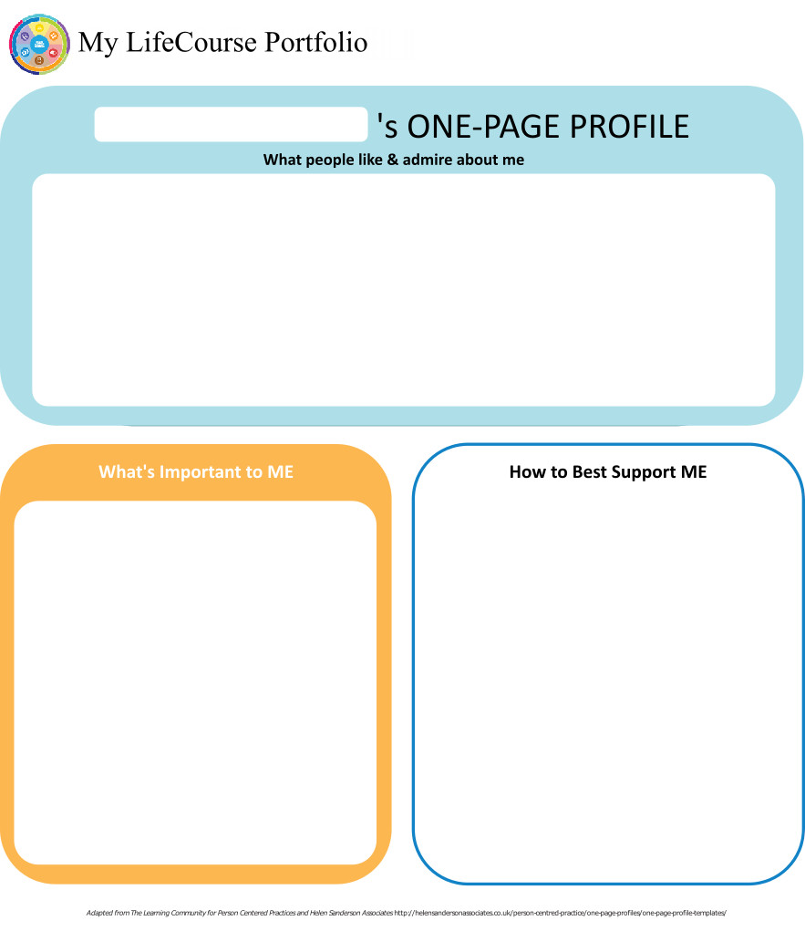
Case Manager: P….. Meeting Date: 10/3/18

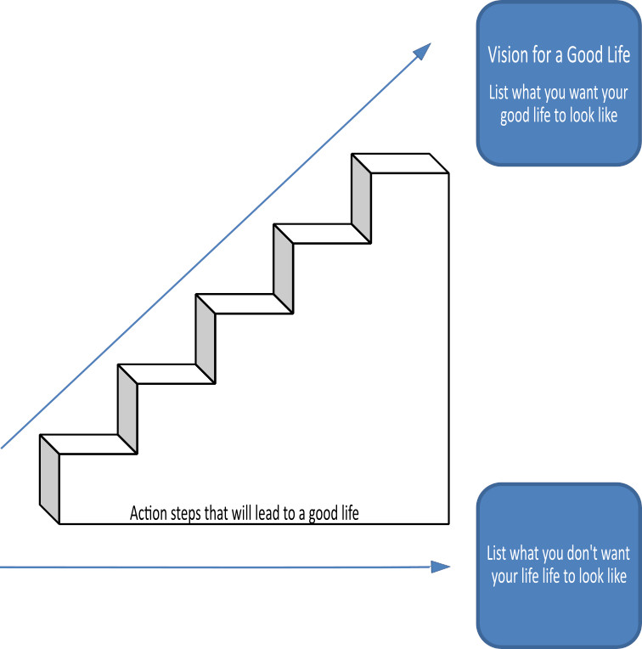

Home Life
Current Status Please include schedule, supports received, supervision needs, LON Risk areas, and accomplishments: I receive IHS supports. I see staff once a week or more if I have appointments-and if they are not too busy. Staff take me to my doctor's appointments and grocery shopping. They help me pay my bills. I don’t need that much help at home.

Bill receives individualized home supports from the DDS public IHS program. He receives supports at least once a week for 3-8 hours/week. He lives in his own apartment in Uncasville. He smokes heavily.

I am on probation. My team wants to me move, but I don't want to.

Bill's neighbor called the police on him and he was arrested and charged with breach of peace 2 and public indecency after a sexually inapprorpriate interction with her. His team feels he is at risk if he stays in his apartment, but Bill does not want to move. He is to have no contact with his neighbor, who lives in the same apartment building and he has to walk by her door to enter/exit his building.

I want to be friends with her once my probation is over. Bill's team has advised him against that.

- What I want my Home to be like How do you like to spend your time at home: I like my apartment. I smoke, watch TV, and listen to my police scanner.

- Would you like to live anywhere else, what’s your vision? I want to stay where I am. Bill's team is recommending that he moves.

- What Supports do you need to help with this? I need help paying my bills. I don’t want to move.

- Do you need support with your finances?
Providers please include financial assessment and report if applicable. Do you have a representative payee? Please list.

Staff help me pay my bills. They write out checks and I sign. Bill is at risk of being taken advantage of finanically, staff assist and monitor his finances.
- You are required to obtain and maintain Medicaid benefits. Do you require help maintaining
Medicaid?
- If yes, who is responsible to help you? IHS staff

- Financial Information:
- Earned Income retired
- Benefits Income (list programs and amounts) social security $575
- Bank AccountsChecking account- Credit Union
- Burial/Funeral Account? Yes
- Total assets: unknown
- Are you satisfied with the supports you are receiving at home?
Describe: I like my staff and my program

- Emergency contact: IHS staff: ###########. Bill's limited medical guardian is resigning. Probate court is sending an assessment request. I don’t want another guardian

- Emergency Back-Up Plan:
An Emergency Back-Up plan must be completed for individuals who receive waiver services and live in their own home, family home or other settings where staff might not be continuously available, and who receive personal care and/or supervision supports and the failure of those supports to be available would lead to an immediate risk to the individual’s health and/or safety.

Work, Day, Retirement or School
Current Status Description/schedule of what the individual is doing, level of support and supervision needed, identify any LON Risk areas, modes of transportation, accomplishments: I am retired. I go out to breakfast with D…. whenever I can.
Bill has a self-directed individualized day program (non-vocational). He get 8 hours of support a week. The goal of this is to decrease isolation and get a good solid meal in him (his eating habits have improved, but still aren't ideal). He and his staff typically go out to breakfast.

- Do you like the job you have or the activities you do during the day? Yes. Bill's team is happy he has this additional support. It gets him out of the house and socializing and also provides him with a healthy meal to start his day.
- What do you like about it, what would you like to change? I like D…. I like going out to eat and shooting the shit. I don't want to change anything
- What new skills, education or activities would you like to learn or take part in this year? None
- What are your career goals? Vision for the future? I am happy to be retired

- What supports do you need during work or activities? I need rides

- Do you have Transportation to get you to and from work on time?

Describe: D… picks me up and brings me home in his car.
- Do you make minimum wage or better? N/A

- Are you satisfied with your wages?

Describe: I'm retired
- Do you make enough money to do the things you want? yes

- What can you do this year to make more money? N/A

- Are you satisfied with the supports you are receiving?
Describe: I like going out with D….

Health and Wellness
Current Status: How is your health? What supports are you receiving? What activities do you do to stay healthy? Please include current medications, diagnosis, doctor’s orders, dental, last physical, known allergies, adaptive equipment, brief overview of health history unless noted in Nursing Report, attach Nursing Report to plan if available. Is there a behavior plan in place? Please attach.
My health is alright.
Bill uses a med minder. He occasionally misses a few doses (a month), and the med minder definitely seems to help. Staff reminded Bill that he should let them know right away if he has any symptoms or medical concerns--rather than waiting until he feels really bad or is really sick.
I smoke and I don't want to quit.
Bill's team discusses this risks associated with this. Bill is aware of these risks and the health compilcations.
Medical DX: Mild ID, ADD, Strabismus, Amblyopia, BPH, macular degeneration OU, hyperlipidemia, hypothyroidism, Blepharitis, posterior vitreous detachment, mild-moderate hearing loss, H/O intermittent explosive disorder, COPD.
Current Meds: Simvastatin 80mg daily, Flomax 0.4mg daily, Vit D 50,000ui once a week, Finasteride 5mg daily, Synthroid 75mcg daily
Allergies: PTU
See Nursing Report for more details.
- What’s Important to me about my health and safety Any areas you want or need to work on? Nah, I'm good. Bill's team would like him to cut back or quit smoking, but he doesn't want to. HIs team would like him to take a healthy relationships course--he says he will think about it. His team would like him to move because they think staying is such close proximity to his neighbor places him at risk, but he does not want to move.
2. Are you up to date on routine medical tests and visits?
Are you able to follow recommended health guidelines? List any deferrals.
Explain:
3. What supports do you need to improve your health and safety? Please include a plan to support any health risk identified in your LON. Bill smokes cigarettes. He team and physicans discuss smoking cessation aids and assistance and the risks associated with his cigarette use. Bill has a Med Minder device to help him remember to take his medications.
4. Are you satisfied with the supports you are receiving?
Describe:

Friendships, Relationships and Activities

- Who do you enjoy spending time with? Family, friends, co-workers, acquaintances? Any special relationships? M….. , J….., J….., my neighbor R…, P…, D…, R… T

- What are your interests and hobbies? I like listening to my police scanner. I like going out to eat. I like people watching. I like going to fairs, dances, and picnics are alright.

- Do you participate in any Groups? No

- Would you like to increase the time you spend with family, friends or doing hobbies or favorite activities? Maybe. I might like to go to a fair or a dance or something.

- What help do you need to accomplish this? I'm good. My staff will offer. I would need a ride



Action Plan
Desired Outcome  (What Do You Hope to Accomplish?) | Why is this Important to you? | Actions and Steps | Responsible Person(s) | Date to be  Completed or  Time frame monitored
- I want to feel good | - So I can live my life | 1A:Attend my appointments and take my medications (using my Med Minder) | Bill, DDS Nurse, IHS Staff | 10/31/19
- I want to feel good | - So I can live my life | 1B:My team would like me to tell them if I feel sick or have any medical problems right away | Bill, IHS Staff | 10/31/19
- I want to feel good | - So I can live my life | 1C:
- I want to feel good | - So I can live my life | 1D:

- Continue going out | - I like to get out and see people | 2A:Go out to breakfast | Bill, IDN staff | 10/31/19
- Continue going out | - I like to get out and see people | 2B:Meet up with my friend R… T | Bill, IHS and IDN staff | 04/2019
- Continue going out | - I like to get out and see people | 2C:Go to fairs, dances, and picnics | Bill, IHS and IDN staff | 10/31/19
- Continue going out | - I like to get out and see people | 2D:

- Stay out of trouble. Complete probation | - I don't want to go to jail | 3A:Meet with behaviorist monthly to discuss any concerns and issues with a focus on relationships, boundaries, and consent | Bill, BMPS | Monthly  10/31/19
- Stay out of trouble. Complete probation | - I don't want to go to jail | 3B:Participate in a healthy relationships course | Bill, DDS Team | When offered
- Stay out of trouble. Complete probation | - I don't want to go to jail | 3C:
- Stay out of trouble. Complete probation | - I don't want to go to jail | 3D:

4A:
4B:
4C:
4D:

5A:
5B:
5C:
5D:

6A:
6B:
6C:
6D:

7A:
7B:
7C:
7D:

Summary of Supports and Services:
Agency/individual/Vendor | Type of Support/Service  (identify all including HCBS Waiver Services, non-waiver services and any other supports) | Amount of Support/Service  Hours per week/month/year
Provider | IHS | 3-6 hours/week
Self-Directed Supports | IDN | 8 hours/week
DDS | Case Management | Quarterly contact and as needed

For Extension Purposes Only
Plan remains appropriate and Team agreed to extend plan as per DDS extension procedure on:
Case Manager Signature:

Summary of Representation, Participation & Plan Monitoring

Choice and Decision Making
Would you like the assistance of a guardian (in some or many areas) or an advocate in making important decisions in your life? Does your team feel this assistance may be needed? Team should note steps to be taken in this area.

My guardian is resigning. I do not feel like I need a guardian. Team believes Bill is able to make informed decisions in many areas. Court reports they will request an assessment soon to determine whether another guardian should be appointed. Team will discuss further at that time. Bill's guardian was only a limited guardian over 2 areas routine, elective, and emergency dental care and decisions related to finances, budgeting, and banking. She however was not very involved at all, and never made any decisions or had anything to do with financial matters.

Individual’s Participation in Planning Process
Were you part of the planning for your meeting and the development of this plan? How can the team assist you with improving your participation in the future? Please identify those steps for next year’s meeting.

I came to my meeting and said what I want and don't want. Bill fully participated in his plan.

Representative’s Participation in Planning Process
Did your family/guardian/advocate/legal or personal representative take part in the planning process and meeting? Are you satisfied with their level of participation? Team should note steps to be taken in this area for any increased participation.

I can invite whoever I want. My guardian submitted a note to resign. She did not come. I did not want her to. I don’t need (or want) anyone at my meetings (except my DDS team).

Monitoring and Evaluation of the Plan
Contact your case manager with any concerns or progress updates throughout the year. Providers will complete and distribute an Individual Progress Review every six months. Your case manager will conduct a Quality Service Review with you once a year.

Plan is reviewed twice a year. The service providers will forward progress reports documenting progress on the action plan to case manager at 6 month intervals. The case manager will receive the reports for the planning meeting/review 2 weeks prior to the meeting/review being held. The case manager will provide quarterly contact and other contact as needed.

Aquatic Activity Screening Individual Plan and Individual Short Plan Addendum
Name: Bill | DDS#: 12345 | Date: 10/3/18
An individual’s aquatic activity screening* is effective for one year from the date on this form as part of the IP or for up to three years for an individual with an IP Short Form. Request for any changes or updates to this form shall be made through the Planning and Support Team process.
*For individuals without an IP and assigned case manager, this form shall be completed by the Helpline Case Manager and the individual’s family when access to aquatic activities at DDS-funded sites or with DDS-funded staff are planned (i.e., camp, respite centers, family support).
SECTION 1 SCREENING FOR PRESENCE AND PARTICIPATION IN AQUATIC ACTIVITIES
Definitions:
- “Aquatic Activities” means all water-related activities including swimming, boating, fishing, hot tubs, water parks and those activities that take place near to water.
- “Near To Water” means aquatic activities at any location where there is a body of water at the intended destination that is open and accessible to individuals. This means that there are no barriers to prevent access such as secure fencing or padlocked gates. Contact with the water may, or may not be intended. Bodies of water include, but are not limited to, streams, creeks, oceans, lakes, ponds, pools, hot tubs, wading pools, or natural or man-made water areas. Near to water activities include, but are not limited to, picnics in a park where there is water, feeding ducks at a pond, unrestricted access to backyard wading or swimming pools or hot tubs, or walks on the beach.
- “Shallow Water” means water at or below the height of the individual’s chest.
- “Deep Water” means water above the height of the individual’s chest.
The Planning and Support Team should assign an Aquatic Activity Code “0” to “6”for the individual Aquatic Activity Code
0 = Individual does not swim or participate in any aquatic activities.
If coded as “0”, Section 2 should have “NO” checked for all activities listed.
1= Near to Water Activities Only and Must Be With Staff
Individual participates only in activities near to water.
2 = Shallow Water Only Individual has limited or no swimming skills and does not respond to verbal redirection and may not recognize dangerous situations.
3 = Shallow Water Only Individual has limited or no swimming skills but usually responds to verbal redirection and may or may not recognize dangerous situations.
4 = Deep Water Swimmer Individual can swim in deep water with staff supervision (Comments in Section 2 may define supervision type).
5 = Aquatic Activity Level Not Known. Individual is approved only for aquatic activities as permitted in Section 2 and must be in a One-to-One enhanced staff-to-individual ratio at all of these activities until aquatic activity code is determined and approved.
6 = Independently Accesses Aquatic Activities Individual requires no supervision for aquatic activities. Do not complete Section 2.
SECTION 2 AQUATIC ACTIVITIES - SUPERVISION NEEDS
Complete this section for individuals with an Aquatic Activity Code of “0” to “5”only.
NOTE: If you check off ‘yes’ for any of the activities below, there must be a “staff-to-individual” ratio included. These ratios are for staff to ensure they provide adequate supervision. Safe staff ratios cannot exceed 1 staff to 7 individuals for any of the activities listed. If supervision needs are unknown due to lack of previous participation, the individual must be in a 1:1 staff to individual ratio at all aquatic activities, until a safe appropriate ratio can be determined and approved.
AQUATIC ACTIVITY | ABLE TO  PARTICIPATE | SUPERVISION NEEDS | COMMENTS (arms-length, line of sight, seizures, lifejacket, etc.)
Activities Near to Water |  | # staff to # individuals
Boating: follow site directions for life jacket use. |  | # staff to # individuals
Swimming |  | # staff to # individuals
Water Parks |  | # staff to # individuals
Hot Tub Use |  | # staff to # individuals

Individual’s Name: Bill DDS # 12345

Provider: Submitted By:

Case Manager: P….. Date: Period Covered: to

Six Month Annual Other: Date of next Review Meeting :

Are there any significant updates or changes regarding the person’s status in any of the following areas?

What’s important to me? Vision for a Good Life Home Life Finances Work, Day, Retirement or School
Health and Wellness Friendships, Relationships and Activities Integrated Support Star

Updates/Changes:

Copies should be sent to: Individual/Family/Guardian, Case Manager, Residential Provider, Day Provider
Waiver Service(s) (from Summary of Supports and Services):

#1 Desired Outcome: I want to feel good
Progress made towards Actions and Steps Yes No Outcome not addressed (must comment below)
Include information about progress, whether steps should continue or be modified.
A: Attend my appointments and take my medications (using my Med Minder)
B: My team would like me to tell them if I feel sick or have any medical problems right away
C:
D:

See Attached

Concerns/Comments/Recommendations:
Waiver Service(s) (from Summary of Supports and Services):

#2 Desired Outcome: Continue going out
Progress made towards Actions and Steps Yes No Outcome not addressed (must comment below)
Include information about progress, whether steps should continue or be modified.
A: Go out to breakfast
B: Meet up with my friend R… T
C: Go to fairs, dances, and picnics
D:

See Attached
Concerns/Comments/Recommendations:

Individual’s Name: Bill DDS # 12345
Waiver Service(s) (from Summary of Supports and Services):

#3Desired Outcome: Stay out of trouble. Complete probation
Progress made towards Actions and Steps Yes No Outcome not addressed (must comment below)
Include information about progress, whether steps should continue or be modified.
A: Meet with behaviorist monthly to discuss any concerns and issues with a focus on relationships, boundaries, and consent
B: Participate in a healthy relationships course
C:
D:

See Attached
Concerns/Comments/Recommendations:
Waiver Service(s) (from Summary of Supports and Services):

#4 Desired Outcome:
Progress made towards Actions and Steps Yes No Outcome not addressed (must comment below)
Include information about progress, whether steps should continue or be modified.
A:
B:
C:
D:

See Attached
Concerns/Comments/Recommendations:

Waiver Service(s) (from Summary of Supports and Services):

#5 Desired Outcome:
Progress made towards Actions and Steps Yes No Outcome not addressed (must comment below)
Include information about progress, whether steps should continue or be modified.
A:
B:
C:
D:

See Attached
Concerns/Comments/Recommendations:

Individual’s Name: Bill DDS # 12345
Waiver Service(s) (from Summary of Supports and Services):

#6 Desired Outcome:
Progress made towards Actions and Steps Yes No Outcome not addressed (must comment below)
Include information about progress, whether steps should continue or be modified.
A:
B:
C:
D:

See Attached
Concerns/Comments/Recommendations:
Waiver Service(s) (from Summary of Supports and Services):

#7 Desired Outcome:
Progress made towards Actions and Steps Yes No Outcome not addressed (must comment below)
Include information about progress, whether steps should continue or be modified.
A:
B:
C:
D:

See Attached
Concerns/Comments/Recommendations:

