Enter the Individual’s First Name & Last Name, DDS#, Case Manager’s Name and the Meeting Date:
Alan Person Centered Plan DDS # 12345
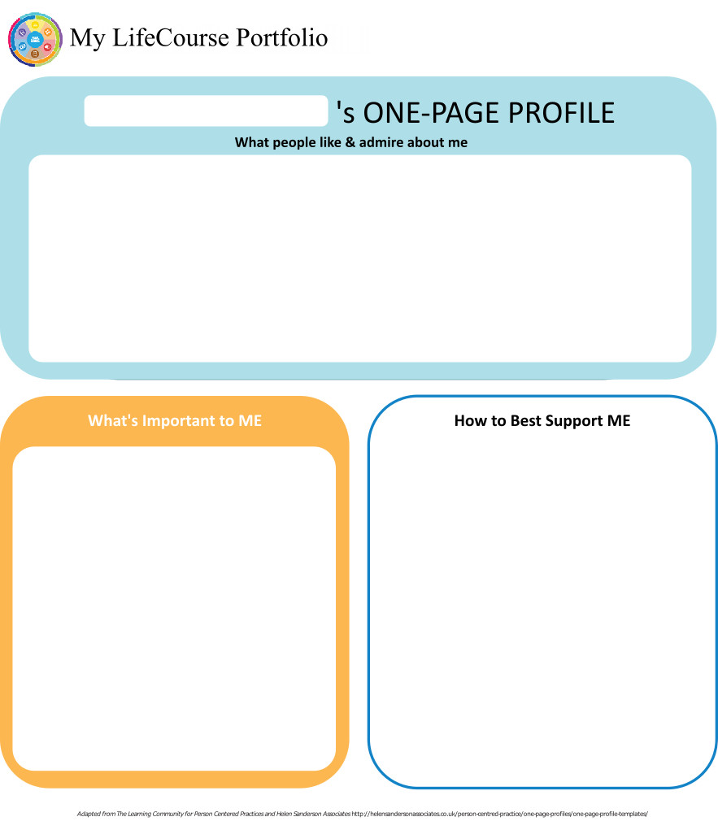
Case Manager: T……. Meeting Date: 7/25/18

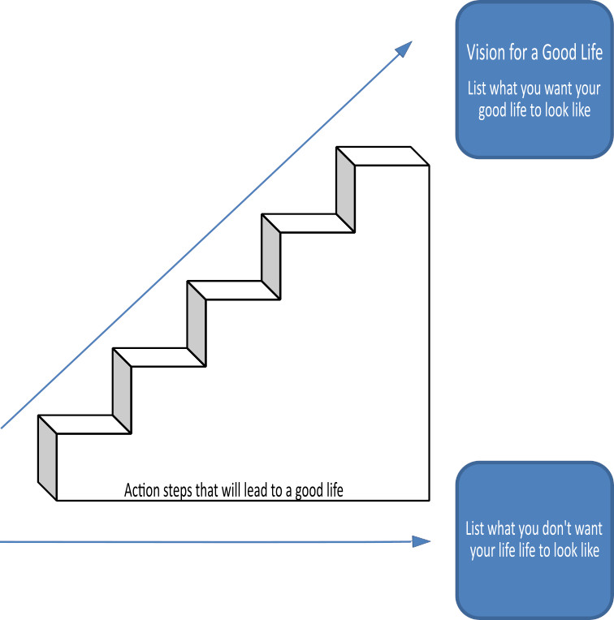

Home Life
Current Status Please include schedule, supports received, supervision needs, LON Risk areas, and accomplishments: Alan resides in his family home with his shared live-in staff. Alan requires 24-hour care. He and his parents have self-hired staff that have been with Alan for many years. Having consistent staff is important to Alan and has helped him progress in many areas over the years. Anxiety and troubled times have been fewer for him and he is able to take part in more activities and vacations due to his improved behavior. Both S.C.and S.H. work in a relaxed and calm manner with him which is the best approach and which Alan appreciates. He has a great relationship with both of them. They help Alan with arranging his schedule and to keep it as consistent as possible.There were a couple of issues this past year that made Alan upset but he recovered quickly. This has been due to the positive interaction of S…and S…. and Alan's personal growth.
Alan has been learning to cook more things at home and hopes to continue. Having 24 care provides the supervison he requires to manage his LON risks and needs.

- What I want my Home to be like How do you like to spend your time at home: Prior to the meeting, Alan had provided the pictures that showed he likes to relax and eat at home. Routine is important to Alan so living in the same home, with the people who know him and treat him respectifully and patiently is also important.

- Would you like to live anywhere else, what’s your vision? Alan signed "No" to this question. He and his team identified pictures that outlined what he likes best in his life. See attached.

- What Supports do you need to help with this? Alan would require supervison to take part in the activities he identified in the pictures.

- Do you need support with your finances?
Providers please include financial assessment and report if applicable. Do you have a representative payee? Please list.

Currently Alan's parents handle all of Alan's finances and entitlements. Alan's representative payee is his parents.
- You are required to obtain and maintain Medicaid benefits. Do you require help maintaining
Medicaid?
- If yes, who is responsible to help you? Alan's parents

- Financial Information:
- Earned Income $110wk take home, varies based upon weekly schedule
- Benefits Income (list programs and amounts) 1,100.00mo. - SSDI
- Bank Accountschecking
- Burial/Funeral Account? no
- Total assets: About 200.00
- Are you satisfied with the supports you are receiving at home?
Describe: When asked Alan expressed that he is very happy with his services.

- Emergency contact: 1. S.C., 2. parents, 3. S.H. - during the day (signature sheet has contact numbers)

- Emergency Back-Up Plan:
An Emergency Back-Up plan must be completed for individuals who receive waiver services and live in their own home, family home or other settings where staff might not be continuously available, and who receive personal care and/or supervision supports and the failure of those supports to be available would lead to an immediate risk to the individual’s health and/or safety.

LON concern: unable to avoid being taken advantage of financially, sexually and internet, this is addressed with 1:1 staffing and his parents assist with his finances.

Work, Day, Retirement or School
Current Status Description/schedule of what the individual is doing, level of support and supervision needed, identify any LON Risk areas, modes of transportation, accomplishments: Alan currently works at Burger King. Day agency…. staff provide supervision on the job, S.H. provides transportation for Alan to and from. He works part time cleaning the eating areas and in back, cleaning and restocking trays and some set up for the cooking areas.

- Do you like the job you have or the activities you do during the day? Alan signed "Yes" when asked this question. He has been at Burger King for seven years.
- What do you like about it, what would you like to change? Alan appreciates when people recognize he is a working man. Wearing a uniform identifies him as an employee. He is proud to be working like anyone else his age. He likes to make money as he knows it means he is earning to pay for vacation.
- What new skills, education or activities would you like to learn or take part in this year? Possibly seek employment at Wendy's if they can offer more hours/wages. Alan's team thinks he may want to change jobs at some point if he gets that opportunity. Cooking may be another skill he would like to learn as he enjoys it at home. Alan reacted positively when the subject was brought up at the meeting. His team also felt he could also work on staying on task.
- What are your career goals? Vision for the future? Alan enjoys positive interactions and when people show him the same respoect as any other employee at a company.His vision is to work more to make more and go on more vacations.

- What supports do you need during work or activities? Alan needs 1-1 supports at all times as he can intermittently and unexpectantly get upset and hurt himself, others or damage property.

- Do you have Transportation to get you to and from work on time?

Describe: Alan pointed to S.H.
- Do you make minimum wage or better? yes

- Are you satisfied with your wages?

Describe: Alan signed I'm happy that I make money
- Do you make enough money to do the things you want? Alan signed Yes, but his team knows he would need to make more so he can go on more vacations and he spends a lot!

- What can you do this year to make more money? Get a job at Wendy's

- Are you satisfied with the supports you are receiving?
Describe: Alan signed " happy" with my supports

Health and Wellness
Current Status: How is your health? What supports are you receiving? What activities do you do to stay healthy? Please include current medications, diagnosis, doctor’s orders, dental, last physical, known allergies, adaptive equipment, brief overview of health history unless noted in Nursing Report, attach Nursing Report to plan if available. Is there a behavior plan in place? Please attach.
Overall Alan is in good health.
Diagnoses: Autism
Alan's parents report all medical appointments are up to date. He sees Dr. K…. for his medical needs and Dr. R….. for dental.
Allergies: Seasonal
Medications: Generic Trileptal (Oxcarbazepine) 600 mg, Risperidone 3mg tablet, Fluoxetine HCL, Vitamin D, medications are subject to change within the IP year.
Adaptive equipment : Alan uses an IPAD for different purposes including how to express how he may be feeling.
LON Concerns: History of choking, medications require careful monitoring for side effects ,eat with reminders and chews with encouragment - all staff are aware that Alan needs encouragment to chew slowly and cut up food if needed. Medications are monitored by his parents and MD.
- What’s Important to me about my health and safety Any areas you want or need to work on? I need help with my anxiety. Alan is aware of his axiety and doesn't like the way it makes him feel.
2. Are you up to date on routine medical tests and visits?
Are you able to follow recommended health guidelines? List any deferrals.
Explain: When Alan was asked if he goes to the doctors he pointed to his dad and to S.H., who take him to all of his appointments
3. What supports do you need to improve your health and safety? Please include a plan to support any health risk identified in your LON. Alan's Behavioral support plan needs to be updated by his team as needed. His doctor is assisting to help with anxiety through medication and monitoring. Alan needs help transitioning in activities like ending something, starting something new, showering and shaving, etc. as these are times that cause him the most stress.
LON concerns: physical assault, bolting, self-injurious behavior, impulsive food /liquid ingestion, wandering away, requires a greater level of support due to behavioral concerns when out in the community and sexually inappropriate in past year - all of the above is being addressed formally and informally, all his staff are aware of the concerns and Alan is always a 1:1.
4. Are you satisfied with the supports you are receiving?
Describe: Alan signed "Yes". Going to the doctors used to be an issue but because the same staff or his dad take him all the time , he is ok with it

Friendships, Relationships and Activities

- Who do you enjoy spending time with? Family, friends, co-workers, acquaintances? Any special relationships? I have been with S.H. for about 19 years, S.C. for about 16 years. Alan loves to visit his mom and dad, He really enjoys going on family vacations. His friend Jerry. He also now enjoys spending time with the people at the ……….CLA.

- What are your interests and hobbies? Alan likes layers when relaxing/sleeping, loves kids, being around people, air planes, vacations,

- Do you participate in any Groups? 1x a week dinner at Jerry's home, Mall walks with a group of other individuals he has met in the community.

- Would you like to increase the time you spend with family, friends or doing hobbies or favorite activities? Yes, going on vacation. Alan loves to travel. He loves looking and beign around airplanes. He responded "vacation" anytime he was asked what activity he would like to increase.

- What help do you need to accomplish this? Earn more money



Action Plan
Desired Outcome  (What Do You Hope to Accomplish?) | Why is this Important to you? | Actions and Steps | Responsible Person(s) | Date to be  Completed or  Time frame monitored
- Get another part-time job and volunteer | - Alan want to meet people and earn more money for vacations | 1A:Assess availability of jobs in area | Alan, Agency staff | 6/30/2018
- Get another part-time job and volunteer | - Alan want to meet people and earn more money for vacations | 1B:Assess availability of volunteer positions area | Alan, Agency staff | 6/30/2018
- Get another part-time job and volunteer | - Alan want to meet people and earn more money for vacations | 1C:Attempt to improve skills , duration and independence at a paid or volunteer job | Alan, Agency staff | 7/2019
- Get another part-time job and volunteer | - Alan want to meet people and earn more money for vacations | 1D:

- to visit and socialize with his peers | - To make friends | 2A:1x a week  Alan will attempt to participate in an activity with his peers and will try to tolerate a group or shared experience | Alan, Agency staff | weekly
- to visit and socialize with his peers | - To make friends | 2B:
- to visit and socialize with his peers | - To make friends | 2C:
- to visit and socialize with his peers | - To make friends | 2D:

- To have less anxiety | - Alan wants to be happy and enjoy his life | 3A:Update behavioral support plan - attempt to use coping skills as outlined in plan | Alan, Agency staff | 10/31/2018
- To have less anxiety | - Alan wants to be happy and enjoy his life | 3B: staff will keep data on aggression, signs of anxiety, and bolting - the data will be shared with his team so they can better assist him | Alan,live in staff, Agency staff, MD | 7/2019
- To have less anxiety | - Alan wants to be happy and enjoy his life | 3C:Attend all medical appointments as needed | Alan, Agency staff | 7/2019
- To have less anxiety | - Alan wants to be happy and enjoy his life | 3D:

- Learn new food ideas | - Alan like to eat | 4A:Attempt to look up receipes on IPAD, magazine | Alan, Live in staff | monthly
- Learn new food ideas | - Alan like to eat | 4B:Attempt to create receipe book for future reference and to see progress | Alan, Live in staff | 7/2019
- Learn new food ideas | - Alan like to eat | 4C:
- Learn new food ideas | - Alan like to eat | 4D:

- plan for vacations | - Alan loves to travel | 5A:Alan and his parents will look up places to visit and what money is needed to go there. | Alan, his parents, live in staff | 1/30/19
- plan for vacations | - Alan loves to travel | 5B:Alan will go away on vacation twice this year. | Alan, his parents, live in staff | 7/2019
- plan for vacations | - Alan loves to travel | 5C:
- plan for vacations | - Alan loves to travel | 5D:

6A:
6B:
6C:
6D:

7A:
7B:
7C:
7D:

Summary of Supports and Services:
Agency/individual/Vendor | Type of Support/Service  (identify all including HCBS Waiver Services, non-waiver services and any other supports) | Amount of Support/Service  Hours per week/month/year
Private Hire | PERS
 | Shared Live in | 27 per week
 | Respite | Hourly/Daily out of home
Master Contract | IND | 30 hours per week
IP 6 Attached to this IP
DDS | Case Management | Quarterly contact and as needed

For Extension Purposes Only
Plan remains appropriate and Team agreed to extend plan as per DDS extension procedure on:
Case Manager Signature:

Summary of Representation, Participation & Plan Monitoring

Choice and Decision Making
Would you like the assistance of a guardian (in some or many areas) or an advocate in making important decisions in your life? Does your team feel this assistance may be needed? Team should note steps to be taken in this area.

Team feels Alan is not capable at this time of making informed decisions for himself. Alan's parents are his guardian.

Individual’s Participation in Planning Process
Were you part of the planning for your meeting and the development of this plan? How can the team assist you with improving your participation in the future? Please identify those steps for next year’s meeting.

Alan attended and fully participated in today's meeting and the development of his plan. Alan is non-verbal, has communication difficulties but does know some minimal sign language. His parents and staff worked with him prior to the meeting on putting pictures together to express his thoughts for his plan and with completing the first two pages. Alan stayed for his whole meeting (a first) and frequently looked at those pictures.He answered some questions addressed to him with simple signs of yes and no. Next year the team will involve him in putting together new photos or other media that can show any progress he has made or to help him provide any input to his plan.

Representative’s Participation in Planning Process
Did your family/guardian/advocate/legal or personal representative take part in the planning process and meeting? Are you satisfied with their level of participation? Team should note steps to be taken in this area for any increased participation.

Alan's parents attended and helped him with assembling pictures as noted above. They offered their thoughts and opinions on Alan's plan for the upcoming year.

Monitoring and Evaluation of the Plan
Contact your case manager with any concerns or progress updates throughout the year. Providers will complete and distribute an Individual Progress Review every six months. Your case manager will conduct a Quality Service Review with you once a year.

Alan's plan will be formally evaluated every 6 months and his case manager will conduct a quality service review at least one time per year. Day and residential staff will provide 6 month Individual Progress Reports.

Aquatic Activity Screening Individual Plan and Individual Short Plan Addendum
Name: Alan | DDS#: 12345 | Date: 7/25/18
An individual’s aquatic activity screening* is effective for one year from the date on this form as part of the IP or for up to three years for an individual with an IP Short Form. Request for any changes or updates to this form shall be made through the Planning and Support Team process.
*For individuals without an IP and assigned case manager, this form shall be completed by the Helpline Case Manager and the individual’s family when access to aquatic activities at DDS-funded sites or with DDS-funded staff are planned (i.e., camp, respite centers, family support).
SECTION 1 SCREENING FOR PRESENCE AND PARTICIPATION IN AQUATIC ACTIVITIES
Definitions:
- “Aquatic Activities” means all water-related activities including swimming, boating, fishing, hot tubs, water parks and those activities that take place near to water.
- “Near To Water” means aquatic activities at any location where there is a body of water at the intended destination that is open and accessible to individuals. This means that there are no barriers to prevent access such as secure fencing or padlocked gates. Contact with the water may, or may not be intended. Bodies of water include, but are not limited to, streams, creeks, oceans, lakes, ponds, pools, hot tubs, wading pools, or natural or man-made water areas. Near to water activities include, but are not limited to, picnics in a park where there is water, feeding ducks at a pond, unrestricted access to backyard wading or swimming pools or hot tubs, or walks on the beach.
- “Shallow Water” means water at or below the height of the individual’s chest.
- “Deep Water” means water above the height of the individual’s chest.
The Planning and Support Team should assign an Aquatic Activity Code “0” to “6”for the individual Aquatic Activity Code
0 = Individual does not swim or participate in any aquatic activities.
If coded as “0”, Section 2 should have “NO” checked for all activities listed.
1= Near to Water Activities Only and Must Be With Staff
Individual participates only in activities near to water.
2 = Shallow Water Only Individual has limited or no swimming skills and does not respond to verbal redirection and may not recognize dangerous situations.
3 = Shallow Water Only Individual has limited or no swimming skills but usually responds to verbal redirection and may or may not recognize dangerous situations.
4 = Deep Water Swimmer Individual can swim in deep water with staff supervision (Comments in Section 2 may define supervision type).
5 = Aquatic Activity Level Not Known. Individual is approved only for aquatic activities as permitted in Section 2 and must be in a One-to-One enhanced staff-to-individual ratio at all of these activities until aquatic activity code is determined and approved.
6 = Independently Accesses Aquatic Activities Individual requires no supervision for aquatic activities. Do not complete Section 2.
SECTION 2 AQUATIC ACTIVITIES - SUPERVISION NEEDS
Complete this section for individuals with an Aquatic Activity Code of “0” to “5”only.
NOTE: If you check off ‘yes’ for any of the activities below, there must be a “staff-to-individual” ratio included. These ratios are for staff to ensure they provide adequate supervision. Safe staff ratios cannot exceed 1 staff to 7 individuals for any of the activities listed. If supervision needs are unknown due to lack of previous participation, the individual must be in a 1:1 staff to individual ratio at all aquatic activities, until a safe appropriate ratio can be determined and approved.
AQUATIC ACTIVITY | ABLE TO  PARTICIPATE | SUPERVISION NEEDS | COMMENTS (arms-length, line of sight, seizures, lifejacket, etc.)
Activities Near to Water |  | # staff to # individuals
Boating: follow site directions for life jacket use. |  | # staff to # individuals
Swimming |  | # staff to # individuals
Water Parks |  | # staff to # individuals
Hot Tub Use |  | # staff to # individuals

Individual’s Name: Alan DDS # 12345

Provider: Submitted By:

Case Manager: T……. Date: Period Covered: to

Six Month Annual Other: Date of next Review Meeting :

Are there any significant updates or changes regarding the person’s status in any of the following areas?

What’s important to me? Vision for a Good Life Home Life Finances Work, Day, Retirement or School
Health and Wellness Friendships, Relationships and Activities Integrated Support Star

Updates/Changes:

Copies should be sent to: Individual/Family/Guardian, Case Manager, Residential Provider, Day Provider
Waiver Service(s) (from Summary of Supports and Services):

#1 Desired Outcome: Get another part-time job and volunteer
Progress made towards Actions and Steps Yes No Outcome not addressed (must comment below)
Include information about progress, whether steps should continue or be modified.
A: Assess availability of jobs in area
B: Assess availability of volunteer positions area
C: Attempt to improve skills , duration and independence at a paid or volunteer job
D:

See Attached

Concerns/Comments/Recommendations:
Waiver Service(s) (from Summary of Supports and Services):

#2 Desired Outcome: to visit and socialize with his peers
Progress made towards Actions and Steps Yes No Outcome not addressed (must comment below)
Include information about progress, whether steps should continue or be modified.
A: 1x a week
B:
C:
D:

See Attached
Concerns/Comments/Recommendations:

Individual’s Name: Alan DDS # 12345
Waiver Service(s) (from Summary of Supports and Services):

#3Desired Outcome: To have less anxiety
Progress made towards Actions and Steps Yes No Outcome not addressed (must comment below)
Include information about progress, whether steps should continue or be modified.
A: Update behavioral support plan - attempt to use coping skills as outlined in plan
B: staff will keep data on aggression, signs of anxiety, and bolting - the data will be shared with his team so they can better assist him
C: Attend all medical appointments as needed
D:

See Attached
Concerns/Comments/Recommendations:
Waiver Service(s) (from Summary of Supports and Services):

#4 Desired Outcome: Learn new food ideas
Progress made towards Actions and Steps Yes No Outcome not addressed (must comment below)
Include information about progress, whether steps should continue or be modified.
A: Attempt to look up receipes on IPAD, magazine
B: Attempt to create receipe book for future reference and to see progress
C:
D:

See Attached
Concerns/Comments/Recommendations:

Waiver Service(s) (from Summary of Supports and Services):

#5 Desired Outcome: plan for vacations
Progress made towards Actions and Steps Yes No Outcome not addressed (must comment below)
Include information about progress, whether steps should continue or be modified.
A: Alan and his parents will look up places to visit and what money is needed to go there.
B: Alan will go away on vacation twice this year.
C:
D:

See Attached
Concerns/Comments/Recommendations:

Individual’s Name: Alan DDS # 12345
Waiver Service(s) (from Summary of Supports and Services):

#6 Desired Outcome:
Progress made towards Actions and Steps Yes No Outcome not addressed (must comment below)
Include information about progress, whether steps should continue or be modified.
A:
B:
C:
D:

See Attached
Concerns/Comments/Recommendations:
Waiver Service(s) (from Summary of Supports and Services):

#7 Desired Outcome:
Progress made towards Actions and Steps Yes No Outcome not addressed (must comment below)
Include information about progress, whether steps should continue or be modified.
A:
B:
C:
D:

See Attached
Concerns/Comments/Recommendations:

