Enter the Individual’s First Name & Last Name, DDS#, Case Manager’s Name and the Meeting Date:
James …….. Person Centered Plan DDS # 12345
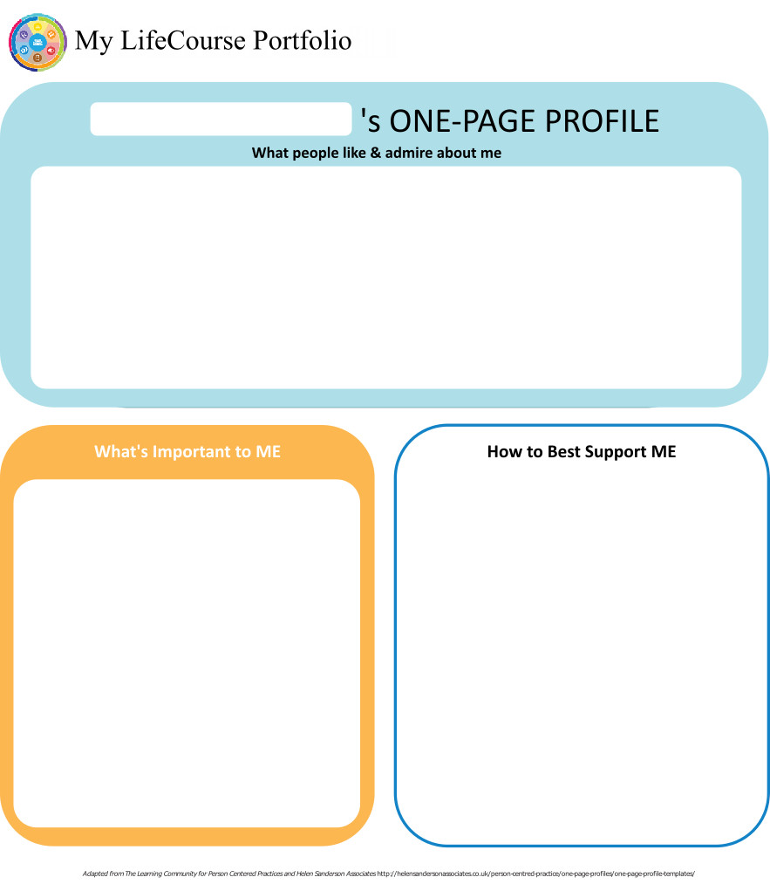
Case Manager: K………. Meeting Date: 9/27/18

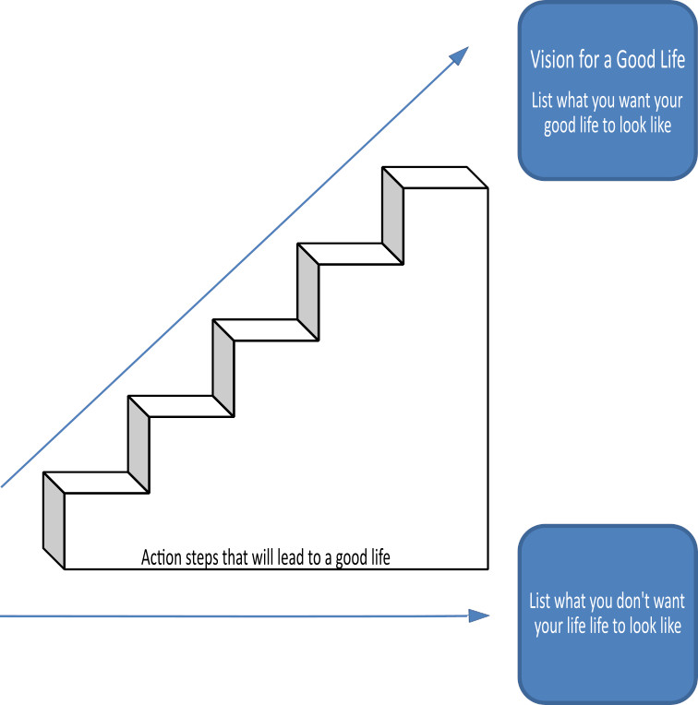

Home Life
Current Status Please include schedule, supports received, supervision needs, LON Risk areas, and accomplishments: Jimmy is a friendly man with dark brown hair and brown eyes. Jimmy moved into a …..residential agency home located on ………… in Durham two years ago; he shares his home with four housemates. He has his own bedroom on the second floor that has been nicely decorated. He enjoys spending time in his room. Jimmy also likes to do activities with the home's staff and his housemates though his interactions with them are minimal.

Jimmy has the following allergies: Dilantin, Phenobarbital, Risperdal, Lexapro, Ativan. His diet is low fat, low cholesterol, no added salt, no concentrated sweeteners and has a whole consistency with thin liquid. Jimmy requires monitoring while eating for safe pace and to ensure that he is not taking food from his housemates.

Jimmy is non-verbal and uses gestures and facial expressions to communicate his wants and needs. Jimmy also uses some sign language to communicate.

Jimmy has a diagnosis of PICA. All staff working with him must be aware of his behavior plan that details PICA concerns. Jimmy’s PICA menu includes leaves and plants, paper including but not limited to notebooks, food boxes, fire extinguisher tags, cardboard, coins, paper clips and thumbtacks, staples, soda can tops, coffee cup plastic lids and plastic tabs from lids, labels from his own clothing or other people’s clothing, plastic twist ties or tabs used to close bags, tops of Ziploc plastic bags, Foil, Hooks from Christmas tree ornaments, Band-Aids, screw caps for beverage bottles. It is important to note that paper napkins have not been part of this list. His parents feel that it is okay for provide him with paper napkins if cloth napkins are not available, for example at his Day Program. Should paper napkins become a concern, this should be recorded and reported accordingly.

Staff will conduct daily PICA sweeps at the group home at 4am, 7:30am, 1:30pm, and 6pm. PICA sweeps need to be conducted on any vehicle Jimmy will be riding in prior to him entering the vehicle. Although these scheduled sweeps take place daily, staff must remain vigilant while in the home and in the community to ensure that items have not entered the environment that may be appealing to Jimmy.

When Jimmy is using the bathroom staff are to remain outside the door but with the door slightly ajar to ensure that line of sight is maintained. Jimmy should remain within arm’s reach while in the community including while exiting the home to get into the van. Jimmy has a history of removing his seatbelt and attempting to exit the vehicle. Child safety locks must be engaged at all times while Jimmy is being transported. HRC approval was obtained for a buckle guard however after three consecutive months of zero incidents this was discontinued. Jimmy has begun to exhibit this behavior once again and the buckle guard will again be utilized and HRC approval sought. The behavior of seatbelt removal is being tracked as a safety precaution. Staff must exit the vehicle before Jimmy as he lacks traffic safety awareness. Staff should keep in mind that Jimmy will display aggression while riding on the van, towards staff and other consumers.

It is important to note that Jimmy has been the subject of OPA investigations due to injuries of unknown origin. As a result HRC approval was granted for an audio monitor and body checks. The audio monitor is switched on while Jimmy is in his bedroom sleeping so that staff can hear if he wakes up in the middle of the night. Body checks are conducted three times daily, while Jimmy is getting dressed in the morning, when he returned from day program and/or any activity outside of the CLA's supervision and while he is showering at night. Staff documents each body check and only take photos if an injury is discovered.

A behavior plan is in place to reduce target behaviors including the noted PICA behaviors, and increase positive behaviors. All staff must review this plan before working with Jimmy. (attached)

Jimmy has displayed aggression in the past; most of these have been around his hygiene times, in the morning time and during transportation. Jimmy will slap staff in their arms or legs and has also slapped staff in their head. When Jimmy initially moved in to …..CLA, Jimmy had one extended period of aggression following a seizure that took place at the group home. He had shown improvement with a lower incidence of aggressive behavior.

Routine is important to Jimmy. Staff working with him must give him step by step instructions regarding what is going to happen next in his routine. When assisting Jimmy with his hygiene, staff should be mindful that Jimmy does not like to be touched and he should be given multiple breaks throughout each task and given verbal praise for the duration. See behavior plan.

Jimmy requires 24 hour supervision and support at home and in the community. Jimmy is unable to avoid being taken advantage of sexually or financially. Jimmy needs prompting to exit during a fire drill and must remain within arm’s reach while exiting the home.

- What I want my Home to be like How do you like to spend your time at home: Jimmy was unable to directly answer this question. When shown the collage with pictures of him at home he liked the ones that showed him in his room and doing chores and activities. Jimmy's team feels that he needs his personal space in his home with a regular routine. They also feel he should have regular activities offerred to him, especially in the community.

- Would you like to live anywhere else, what’s your vision? Jimmy was shown different pictures of homes but it didn't seem like he understood what was being asked of him for this question. Team noted Jimmy moved into this house from his family's home two years ago and has made a good transition to it. Agression and behavior issues have been fewer in the past year.

- What Supports do you need to help with this? Jimmy was unable to answer this question directly. As noted earlier concerning the picture with his hand on his shoulder, team feels Jimmy does not like to be touched. They also feel his PICA concerns and targeted behavior needs require 24/7 supervision. He does best with a consistent routine and opportunities for outside activities.

- Do you need support with your finances?
Providers please include financial assessment and report if applicable. Do you have a representative payee? Please list.

Jimmy's parents are his rep payee and handle all of his finances. Jimmy does not appear to understand the concept of money, financial assessment from CLA attached.
- You are required to obtain and maintain Medicaid benefits. Do you require help maintaining
Medicaid?
- If yes, who is responsible to help you? Parents

- Financial Information:
- Earned Income none
- Benefits Income (list programs and amounts) SSDI -$750
- Bank AccountsChecking - Websters bank
- Burial/Funeral Account? no
- Total assets:
- Are you satisfied with the supports you are receiving at home?
Describe: Jimmy appears happy at home and enjoyed looking at the pictures of himself doing things in his home. Negative behaviors have been fewer in the past year. Parents are satisfied with the supports he has in his CLA.

- Emergency contact: Mr. …… and Mrs. …………at "address"-(203)######## (home), (203) ####### (cell)

- Emergency Back-Up Plan:
An Emergency Back-Up plan must be completed for individuals who receive waiver services and live in their own home, family home or other settings where staff might not be continuously available, and who receive personal care and/or supervision supports and the failure of those supports to be available would lead to an immediate risk to the individual’s health and/or safety.

Work, Day, Retirement or School
Current Status Description/schedule of what the individual is doing, level of support and supervision needed, identify any LON Risk areas, modes of transportation, accomplishments: Jimmy participates in …..Day agency DSO Program. He attends 5 days a week, for 6 hours a day. At program he has 1:1 staffing supports. He participates in a variety of community based volunteer activities including Meals on Wheels, Community Plates, Diaper Bank, FISH and recycling. Jimmy also enjoys a variety of in-house activities. Jimmy has done overall well the past year. He has participated in many different community activities including, but not limited to; Bowling, walks at several parks, meals on wheels, the arcade, shopping at several different stores, movies, Jump Off, and out to eat at several restaurants. Jimmy prefers being out in the community, however in these winter months, he has had a change in behavior. We have seen a significant decrease in his in-house programing. Jimmy used to participate in rollerblading, tabletop puzzles, enjoyed listening to staff read books, going to visit his peers at our neighboring program, music/drumming, watching documentaries and participating in group activities. We have also seen a significant increase in Jimmy’s pacing throughout the program and refuses to sit for group activities and signs to go out in the community throughout the day from the time he arrives and the time he leaves program.
When Jimmy arrives in the morning he puts his belongings away, with prompting from staff. He will then participate in morning meeting followed by morning meditation also with multiple prompts. Jimmy will then either participate in a community outing or in-house activities. Jimmy will then prepare his lunch with prompting from staff. Staff will then prompt Jimmy to communicate when he has completed his lunch by signing finished, which at times requires hand over hand assistance from staff. Jimmy will then participate in afternoon activities, which generally consists of listening to a story or rollerblading, or a music movement activity. Jimmy knows what is expected of him on a daily basis and has acclimated to the routine at ….Program. There have been several staff and peer changes in the past six months. This has not seemed to bother him.
Jimmy's PICA guidelines and his eating protocols need to be followed by Day staff at all times. Behavior plan is attached.

- Do you like the job you have or the activities you do during the day? Jimmy was unable to answer this directly but did point to activities on his collage that showed him doing community activities. Based on his most recent changes in behavior and lack of interest in some of the activities he used to enjoy, the team agrees that Jimmy may be ready to explore other day program options if agency is unable offer more community based activities.
- What do you like about it, what would you like to change? Jimmy did sign yes for pictures of him bowling, in the van, doing Meals on Wheels and the arcade. He couldn't really identify what he didn't like and the question may have confused him. Team feels he has not been happy with the in-house activities the Day program offers, that he would like to be in the community more.
- What new skills, education or activities would you like to learn or take part in this year? It appears from Jimmy's responses to the pictures that he would like to do more activities in the community.
- What are your career goals? Vision for the future? Jimmy takes part in a DSO program and did not identify anything specific for a vision of future day activities. Team feels they may want to look for a day program that can offer Jimmy more consisitent community activities.

- What supports do you need during work or activities? Jimmy requires 1:1 support and supervision during day program hours.

- Do you have Transportation to get you to and from work on time?

Describe: CLA provides transportation
- Do you make minimum wage or better? Jimmy does not work.

- Are you satisfied with your wages?

Describe: Jimmy does not work and does not appear to understand the concept of money. His PICA behaviors prohibit him from keeping money on his person.
- Do you make enough money to do the things you want? Jimmy does have benefits and gets money from his parents for his needs.

- What can you do this year to make more money? NA

- Are you satisfied with the supports you are receiving?
Describe: Jimmy does like some of the activiites the Day program offers and his parents like the supports they provide to keep him active and safe. But the team also agrees that it may be time to explore other day options for Jimmy as he seems bored with the in-house activities and does not take part in them as he had in the past.

Health and Wellness
Current Status: How is your health? What supports are you receiving? What activities do you do to stay healthy? Please include current medications, diagnosis, doctor’s orders, dental, last physical, known allergies, adaptive equipment, brief overview of health history unless noted in Nursing Report, attach Nursing Report to plan if available. Is there a behavior plan in place? Please attach.
Jimmy was born a healthy child, but suffered from encephalitis and meningitis at approximately 2 yrs old. He has had a seizure disorder since that time and was later diagnosed with severe intellectual disability and autism. He is non-verbal and uses gestures, facial expressions and some sign language to communicate. His seizure disorder appears to be well controlled with medication. Typical seizures for Jimmy are petit mal seizures, characterized by his eyes drifting to the right and him appearing as though he can’t breathe. He becomes rigid and he smacks his lips. His seizures usually last approximately 10-15 seconds. Due to a potential seizure occurring while he is swimming, his support staff must be in close proximity in the water. A seizure protocol is in place in his file and all staff is trained/in-serviced prior to working with Jimmy.

Jimmy is also diagnosed with the following: GERD, Hypertryglicerides, Rosacea, Hyperopia and PICA. Refer to Nursing report for more details.

Jimmy has the following allergies: Dilantin, Phenobarbital, Risperdal, Lexapro, Ativan.

Nursing consultation to this home is presently provided by ….nursing agency. His medications are administered by certified staff. He takes his medications with food. Jimmy has a history of pocketing his meds and to spit them out later, it is important that staff ensure that he swallows his meds. He is chaperoned to his medical appointments by staff, and his parents meet him at the appointments.

Jimmy remains on a low fat, low cholesterol, no added salt, concentrated sweets diet. Food consistency for Jimmy is thin liquids and whole foods. Refer to Eating and dietary guidelines attached. It is important for Jimmy to remain well hydrated, as a possible side effect of medications can be kidney stones.

Jimmy has the following allergies: Dilantin, Phenobarbital, Risperdal, Lexapro, Ativan.

Jimmy requires complete assistance with managing all of his healthcare/medical needs. Both Residential and the Day programs need to follow his nursing plan and protocals.

As noted in previous sections of IP, Jimmy has needs for support with his behaviors including aggression and PICA. Behavior plan and supervison levels must be followed by all staff supporting him.
- What’s Important to me about my health and safety Any areas you want or need to work on? Jimmy iwas unable to answer this question directly or with assistance of staff. Team struggled to find any pictures to help explain this concept to him.
2. Are you up to date on routine medical tests and visits?
Are you able to follow recommended health guidelines? List any deferrals.
Explain: no deferrals
3. What supports do you need to improve your health and safety? Please include a plan to support any health risk identified in your LON. Team feel that current supports for his nursing plan, eating guidelines, PICA and behavior plan are necessary to help Jimmy maintain and improve his health and safety.
4. Are you satisfied with the supports you are receiving?
Describe: Jimmy likes that his parents are with him at appointments. His parents are satisfied with the support both agencies provide for his safety and health care.

Friendships, Relationships and Activities

- Who do you enjoy spending time with? Family, friends, co-workers, acquaintances? Any special relationships? Jimmy was able to point to different pictures that showed him with family and other people. He smiled and made "yes" sign at several of these photos and the team feels he enjoys being with them. These included Jimmy’s parents, J….. and A…… who continue to be very involved in his life. They communicate with staff at the home each evening via telephone. He enjoys talking with them on the phone as much as he is able. Jimmy also goes to their house for dinner on a weekly basis, in addition to seeing them on Sunday’s. Jimmy also has two sisters. His older sister D……. lives in New York with her two sons. His younger sister L……lives in Branford, CT with her husband B….. and their two young daughters. L….. is very involved in Jimmy’s life. Jimmy enjoys visiting her house. Jimmy also seems to like D…(staff) and enjoys going out with him. Jimmy doesn't really have any special friends at home or his Day program but will take part in group activitites.

- What are your interests and hobbies? Jimmy enjoys swimming, bowling, roller blading, dining out, taking walks and spending time with his family. He also enjoys being at home and lounging on the couch. Jimmy will go to the front door when he wants to go out in the community. Jimmy enjoys going out in the community, including: walks at area parks, lunch at Captain Cove, Music on the Green, ice cream out, Blue Fish Fest.

- Do you participate in any Groups? Jimmy does not participate in any specifc groups. He does go bowling and roller blading as well as other activities within a small group. His communication limitations and his behaviors make it difficult for him to connect with others.

- Would you like to increase the time you spend with family, friends or doing hobbies or favorite activities? The team would like to see Jimmy continue to remain active in the community. Jimmy seemed posititve when questioned about seeing family more or doing things in the community. Team will work throughout the year to identify more activities for Jimmy to do.

- What help do you need to accomplish this? Jimmy will require 1:1 supervison for any activities to oversee PICA protocol and eating/diet guidelines. Jimmy has occationally acted aggressive to others, mostly staff, which would require that level of support for both he and others.



Action Plan
Desired Outcome  (What Do You Hope to Accomplish?) | Why is this Important to you? | Actions and Steps | Responsible Person(s) | Date to be  Completed or  Time frame monitored
- Jimmy will improve his health and have fewer PICA incidences. | - Jimmy's maintenance and improvement of his overall health will help him live a more enjoyable life. | 1A:Attend all medical appointments as designated by Jimmy's Physicians (see nursing care plan). | Jimmy, CLA staff and nursing | 9/30/19
 |  | 1B:Monitor for medication side effects and other medication risks (medication allergy) | Jimmy, CLA staff, Day P. staff and nursing | daily
 |  | 1C:Monitor for long term use of psychotropic-at least quarterly by psychiatrist and review exemption through PRC as scheduled | Psychiatrist, Nursing and PRC review | quarterlyfor monitoring and annually for PRC exemption
 |  | 1D:Follow PICA and Seizure Protocols and Eating/dietary guidelines | Residential and Day support staff | daily

- Jimmy will exhibit an increase in positive/appropriate behaviors | - Jimmy enjoys going out in the community and a reduction in negative behaviors will lead to more activities and help to ensure his safety. | 2A:Follow behavior plan as written | Jimmy, Residential and Day supports staff | daily
 |  | 2B: All staff working with Jimmy will be trained on Jimmy's behavior plan | Behaviorist, Residential and Day supports staff | prior to working with him.
 |  | 2C:
 |  | 2D:

- Jimmy will independently use a napkin to wipe his hands and his mouth during meal time | - Jimmy does not independently utilize a napkin during meal time, often times utilizing his clothing to wipe his hands or not wiping his mouth at all. This will help him build his independance during meals especially in the community. | 3A:Jimmy will use a napkin to wipe his hands and his mouth during mealtimes at 60% of all given opportunities at home and at day program | Jimmy, Residential and Day support staff | daily
 |  | 3B:
 |  | 3C:
 |  | 3D:

- Jimmy will learn and complete more chores at home. | - Jimmy is capable to learn how to do chores in order to be more independent at home. | 4A:Clearing/Wiping table after dinner | Jimmy, Residential Support Staff | daily
- Jimmy will learn and complete more chores at home. |  | 4B:Laundry plan (bringing basket to bedroom from first floor, folding, hanging, putting away) | Jimmy, Residential Support Staff | weekly
- Jimmy will learn and complete more chores at home. |  | 4C:
- Jimmy will learn and complete more chores at home. |  | 4D:

- Jimmy will participate in more leisure activities of his choice. | - Jimmy enjoys activities in the community. He exhibits fewer negative behaviors when he is doing activities he likes. | 5A:Day staff and Jimmy will develop a picture board of his favorite and available activities for him to use. | Jimmy, Day support staff | Dec 2018.
 |  | 5B:Day program will explore new community activities to offer Jimmy | Day program | March 2019
 |  | 5C:Day staff will support Jimmy to express what activities he would like to do either through signing, picture board, ipad or other communication methods. | Day program, Jimmy | daily
 |  | 5D:Case manager and team will begin looking for a new day program if necessary. | CM, Parents, Jimmy | June 2019

- Jimmy will independently put his belongings away in the proper location | - With support Jimmy is capable of being more independent in his self care skills. | 6A:Day staff will prompt Jimmy to put his belongs in proper location upon his arrival. | Jimmy, Day support staff | daily
 |  | 6B:
 |  | 6C:
 |  | 6D:

7A:
7B:
7C:
7D:

Summary of Supports and Services:
Agency/individual/Vendor | Type of Support/Service  (identify all including HCBS Waiver Services, non-waiver services and any other supports) | Amount of Support/Service  Hours per week/month/year
……residential agency | Residential Habilitation-CLA | 24 hours per day/7 day per week
…….Day program | DSO with 1:1 supports | Up to 30 hours per week
…..Behaviorist | Behavioral Services | Weekly Consultation and as needed
…Nursing agency | Nursing Servcies | Weekly Consultation and as needed
DDS | Case Management | Quarterly contact and as needed

For Extension Purposes Only
Plan remains appropriate and Team agreed to extend plan as per DDS extension procedure on:
Case Manager Signature:

Summary of Representation, Participation & Plan Monitoring

Choice and Decision Making
Would you like the assistance of a guardian (in some or many areas) or an advocate in making important decisions in your life? Does your team feel this assistance may be needed? Team should note steps to be taken in this area.

Jimmy does not understand his civil or legal rights due to his cognitive limitations. His parents, Mr. and Mrs……. are his plenary guardians and assist him with making important decision/choices.

Individual’s Participation in Planning Process
Were you part of the planning for your meeting and the development of this plan? How can the team assist you with improving your participation in the future? Please identify those steps for next year’s meeting.

Jimmy was present at his planning meeting and took part as much as he could. His residential and day programs worked together to create a collage of pictures for him to use prior and during the meeting in an attempt to get his input in the development of his plan. Team felt it helped for some answers but Jimmy still had limited ablility to express his thoughts on different concepts.Staff will explore this further in preparation of next years plan.

Representative’s Participation in Planning Process
Did your family/guardian/advocate/legal or personal representative take part in the planning process and meeting? Are you satisfied with their level of participation? Team should note steps to be taken in this area for any increased participation.

Jimmy's parents actively participated in the planning process and are strong advocates for him.

Monitoring and Evaluation of the Plan
Contact your case manager with any concerns or progress updates throughout the year. Providers will complete and distribute an Individual Progress Review every six months. Your case manager will conduct a Quality Service Review with you once a year.

Annual IP
Semiannual RES & DAY IPRs
Quarterly Nursing and Behavior Reports
Annual QSR

Aquatic Activity Screening Individual Plan and Individual Short Plan Addendum
Name: James …….. | DDS#: 12345 | Date: 9/27/18
An individual’s aquatic activity screening* is effective for one year from the date on this form as part of the IP or for up to three years for an individual with an IP Short Form. Request for any changes or updates to this form shall be made through the Planning and Support Team process.
*For individuals without an IP and assigned case manager, this form shall be completed by the Helpline Case Manager and the individual’s family when access to aquatic activities at DDS-funded sites or with DDS-funded staff are planned (i.e., camp, respite centers, family support).
SECTION 1 SCREENING FOR PRESENCE AND PARTICIPATION IN AQUATIC ACTIVITIES
Definitions:
- “Aquatic Activities” means all water-related activities including swimming, boating, fishing, hot tubs, water parks and those activities that take place near to water.
- “Near To Water” means aquatic activities at any location where there is a body of water at the intended destination that is open and accessible to individuals. This means that there are no barriers to prevent access such as secure fencing or padlocked gates. Contact with the water may, or may not be intended. Bodies of water include, but are not limited to, streams, creeks, oceans, lakes, ponds, pools, hot tubs, wading pools, or natural or man-made water areas. Near to water activities include, but are not limited to, picnics in a park where there is water, feeding ducks at a pond, unrestricted access to backyard wading or swimming pools or hot tubs, or walks on the beach.
- “Shallow Water” means water at or below the height of the individual’s chest.
- “Deep Water” means water above the height of the individual’s chest.
The Planning and Support Team should assign an Aquatic Activity Code “0” to “6”for the individual Aquatic Activity Code
0 = Individual does not swim or participate in any aquatic activities.
If coded as “0”, Section 2 should have “NO” checked for all activities listed.
1= Near to Water Activities Only and Must Be With Staff
Individual participates only in activities near to water.
2 = Shallow Water Only Individual has limited or no swimming skills and does not respond to verbal redirection and may not recognize dangerous situations.
3 = Shallow Water Only Individual has limited or no swimming skills but usually responds to verbal redirection and may or may not recognize dangerous situations.
4 = Deep Water Swimmer Individual can swim in deep water with staff supervision (Comments in Section 2 may define supervision type).
5 = Aquatic Activity Level Not Known. Individual is approved only for aquatic activities as permitted in Section 2 and must be in a One-to-One enhanced staff-to-individual ratio at all of these activities until aquatic activity code is determined and approved.
6 = Independently Accesses Aquatic Activities Individual requires no supervision for aquatic activities. Do not complete Section 2.
SECTION 2 AQUATIC ACTIVITIES - SUPERVISION NEEDS
Complete this section for individuals with an Aquatic Activity Code of “0” to “5”only.
NOTE: If you check off ‘yes’ for any of the activities below, there must be a “staff-to-individual” ratio included. These ratios are for staff to ensure they provide adequate supervision. Safe staff ratios cannot exceed 1 staff to 7 individuals for any of the activities listed. If supervision needs are unknown due to lack of previous participation, the individual must be in a 1:1 staff to individual ratio at all aquatic activities, until a safe appropriate ratio can be determined and approved.
AQUATIC ACTIVITY | ABLE TO  PARTICIPATE | SUPERVISION NEEDS | COMMENTS (arms-length, line of sight, seizures, lifejacket, etc.)
Activities Near to Water |  | # 1 staff to # 1 individuals | Seizure Disorder
Boating: follow site directions for life jacket use. |  | # staff to # individuals
Swimming |  | # 1 staff to # 1 individuals | Seizure Disorder-pools only
Water Parks |  | # staff to # individuals
Hot Tub Use |  | # staff to # individuals

Individual’s Name: James …….. DDS # 12345

Provider: Submitted By:

Case Manager: K………. Date: Period Covered: to

Six Month Annual Other: Date of next Review Meeting :

Are there any significant updates or changes regarding the person’s status in any of the following areas?

What’s important to me? Vision for a Good Life Home Life Finances Work, Day, Retirement or School
Health and Wellness Friendships, Relationships and Activities Integrated Support Star

Updates/Changes:

Copies should be sent to: Individual/Family/Guardian, Case Manager, Residential Provider, Day Provider
Waiver Service(s) (from Summary of Supports and Services):

#1 Desired Outcome: Jimmy will improve his health and have fewer PICA incidences.
Progress made towards Actions and Steps Yes No Outcome not addressed (must comment below)
Include information about progress, whether steps should continue or be modified.
A: Attend all medical appointments as designated by Jimmy's Physicians (see nursing care plan).
B: Monitor for medication side effects and other medication risks (medication allergy)
C: Monitor for long term use of psychotropic-at least quarterly by psychiatrist and review exemption through PRC as scheduled
D: Follow PICA and Seizure Protocols and Eating/dietary guidelines

See Attached

Concerns/Comments/Recommendations:
Waiver Service(s) (from Summary of Supports and Services):

#2 Desired Outcome: Jimmy will exhibit an increase in positive/appropriate behaviors
Progress made towards Actions and Steps Yes No Outcome not addressed (must comment below)
Include information about progress, whether steps should continue or be modified.
A: Follow behavior plan as written
B: All staff working with Jimmy will be trained on Jimmy's behavior plan
C:
D:

See Attached
Concerns/Comments/Recommendations:

Individual’s Name: James …….. DDS # 12345
Waiver Service(s) (from Summary of Supports and Services):

#3Desired Outcome: Jimmy will independently use a napkin to wipe his hands and his mouth during meal time
Progress made towards Actions and Steps Yes No Outcome not addressed (must comment below)
Include information about progress, whether steps should continue or be modified.
A: Jimmy will use a napkin to wipe his hands and his mouth during mealtimes at 60% of all given opportunities at home and at day program
B:
C:
D:

See Attached
Concerns/Comments/Recommendations:
Waiver Service(s) (from Summary of Supports and Services):

#4 Desired Outcome: Jimmy will learn and complete more chores at home.
Progress made towards Actions and Steps Yes No Outcome not addressed (must comment below)
Include information about progress, whether steps should continue or be modified.
A: Clearing/Wiping table after dinner
B: Laundry plan (bringing basket to bedroom from first floor, folding, hanging, putting away)
C:
D:

See Attached
Concerns/Comments/Recommendations:

Waiver Service(s) (from Summary of Supports and Services):

#5 Desired Outcome: Jimmy will participate in more leisure activities of his choice.
Progress made towards Actions and Steps Yes No Outcome not addressed (must comment below)
Include information about progress, whether steps should continue or be modified.
A: Day staff and Jimmy will develop a picture board of his favorite and available activities for him to use.
B: Day program will explore new community activities to offer Jimmy
C: Day staff will support Jimmy to express what activities he would like to do either through signing, picture board, ipad or other communication methods.
D: Case manager and team will begin looking for a new day program if necessary.

See Attached
Concerns/Comments/Recommendations:

Individual’s Name: James …….. DDS # 12345
Waiver Service(s) (from Summary of Supports and Services):

#6 Desired Outcome: Jimmy will independently put his belongings away in the proper location
Progress made towards Actions and Steps Yes No Outcome not addressed (must comment below)
Include information about progress, whether steps should continue or be modified.
A: Day staff will prompt Jimmy to put his belongs in proper location upon his arrival.
B:
C:
D:

See Attached
Concerns/Comments/Recommendations:
Waiver Service(s) (from Summary of Supports and Services):

#7 Desired Outcome:
Progress made towards Actions and Steps Yes No Outcome not addressed (must comment below)
Include information about progress, whether steps should continue or be modified.
A:
B:
C:
D:

See Attached
Concerns/Comments/Recommendations:

