Appropriations Health & Hospitals Subcommittee Workgroup: February 26, 2013

Co-Chairs: Senator Terry Gerratana & Representative Patricia Dillon

We appreciate the opportunity to discuss Governor Malloy’s recommended budget for Fiscal Years 2014 and 2015 as it relates to the Department of Developmental Services (DDS). We have included the following information in response to questions posed at the Appropriations Committee Public Hearing on February 15, 2013:

Rep. Ritter
- Wait List: Current status and how it changed during FY 12.

During Fiscal Year 2012 DDS had the following numbers of people active on the Residential Waiting List at the start and end of the Fiscal Year:

DDS Residential Waitlist - Fiscal Year 2012
Residential Waitlist* | Emergency | Priority 1 | Total
Active on WL as of 7/1/2011 | 25 | 524 | 549
Active on WL as of 6/30/2012 | 33 | 579 | 612
Net Change | 8 | 55 | 63

*The Residential Waiting List consists of people living with their family or in their own home who have no funded residential services.

During the course of the Fiscal Year, new individuals are added to the Waiting List as other individuals receive allocations for needed services and come off the list. During FY12, a total of 63 individuals on the Residential Waiting List received allocations. (It is a coincidence that the net change in the Waiting List in FY12 is also 63.) These allocations totaled $4,098,964.00 on an annualized basis.

Rep. Walker
- Please provide requested information for all the accounts that are being zeroed out by the streamline proposal.

Please see attached chart.

- Explain Cost Settlement changes.

As background, DDS requires all contracted providers to complete a cost report that details their fiscal year expenses by program. DDS analyzes the reports to ensure accuracy. Prior to FY2012, DDS would review the amount of reimbursement for each program compared to the expenses submitted by the agency. DDS would calculate a cost settlement for each provider that had a surplus for the year. As part of this calculation, DDS reviewed whether the provider had received any one-time funding for additional direct support needs. After collecting any unused one-time funds, the remaining surplus for that program category would have been cost settled with 50% to be returned to DDS and the provider keeping the remaining 50% for their agency.
The biennial budget for fiscal years 2012 and 2013 included language to eliminate the retention of any surplus funds by providers. Contracts with the providers were modified accordingly. It is our understanding that the proposed budget language for FY 14 and FY 15 allows the department some flexibility to return to some type of shared surplus retention in the next biennium.

- Share Information on Rate Setting.

Currently, funding levels for individuals with similar needs are not equal. In both day and residential services, funding was historically based on a combination of cost, appropriation and negotiation, but not necessarily on consumer need.
Due to the multiplicity of rates and other issues that had surfaced in the early 2000s, DDS researched options to revise the funding structure and opted to develop a unit rate system that would conform to CMS guidelines with the intent to enable consumers to receive supports from the provider of their choice, provide a fairer and more equitable funding system based on the level of need of the consumer, and provide an incentive to maximize the resources of the Department. DDS made the decision to start with day and individualized home support services due to the complexity of rate setting for congregate living situations.
A new day services and individualized home support rate structure was developed in January 2005, with implementation in April 2005. The rates were developed based upon the prior year’s cost information from the provider community (2003 Annual Report for Residential and Day Services) and wage information from the Department of Labor. The new fee-for-service rate system was limited to first time individuals, such as high school graduates, entering the DDS system and to those existing participants requesting additional supports. All other participants in existing services remained under the contract service model. This was done as a way to temporarily hold those providers that were above the proposed rates harmless while a transition plan to convert the entire system was established to minimize their financial hardship as the agency continued to serve participants already in their day and residential programs. A Day Transition Workgroup was established comprised of both provider staff and DDS staff in FY2011 to review the rate methodology and develop a transition plan. The Workgroup agreed with the DDS methodology and developed a seven-year transition plan that started on January 1, 2012.

A Residential Rate Workgroup was established in February 2012. The workgroup has six committees (Residential Community Living Arrangement (CLA) Rate, Community Companion Home (CCH) Rate, Individualized Home Supports (IHS) Rate, Data Management, Sustainability, and Residential Issues) that have representatives for the providers, DDS, families and self-advocates. The IHS program will be the first residential program to transition to a new rate methodology as of July 1, 2013. The CLA and Continuous Residential Supports (CRS) programs are expected to begin a seven-year transition to a standard rate as of January 1, 2014.

- Explain how the supportive housing model will be used to save money in the Community Residential Services account – RAP certificates.

DDS serves people in a variety of settings ranging from Southbury Training School (STS) and regional centers to people living in their own apartments. The following chart shows where people receiving DDS funded supports are living as of December 31, 2012.

Southbury Training School 372
Regional Centers 204
Community Living Arrangements 3,754
Continuous Residential Supports 521
Community Companion Home 396
Family Home 1,422
Own Home 1,341

DDS is working to serve people in the most independent and cost effective setting possible. Efforts are being made to offer residential choices to people living at STS and other public settings. Community placements are less expensive than institutional or facility-based settings.

The budget includes the use of the Rental Assistance Program (RAP) certificates for 15 people in both fiscal year 2014 and 2015. RAP funding will provide an opportunity for additional people currently living in private Community Living Arrangements (CLA) to receive services in a more independent, less expensive setting. This is the first time DDS has had access to this resource.

The average cost for people living in CLAs by Level of Need (LON) levels are as follows (1=lowest LON, 8= highest LON):

LON 1 $50,479
LON 2 $66, 750
LON 3 $74,633
LON 4 $82,851
LON 5 $95,448
LON 6 $109,877
LON 7 $127,828
LON 8 $175,281

If individuals agree to move from CLAs there would be a resulting savings. The average cost for people living independently with supports is approximately $39,000, not including rental assistance.

Rep. Cathy Abercrombie
- Clarify transfer of DCF consumers to DDS (VSP and Autism waiver).

The FY 2014 and 2015 budget includes an additional $1,188,680 for 25 children and adolescents who have a diagnosis of autism spectrum disorder but do not have intellectual disability who are eligible for the Autism Waiver and transfer from the Department of Children and Families (DCF) Voluntary Services Program (VSP) to DDS. The transition will occur over the remainder of this fiscal year. DDS has sufficient case managers assigned to the Autism Division to assume case management responsibility for these individuals.

Additionally, each year, DDS works with DCF to transfer children with intellectual disability who are found eligible for DDS services from the DCF Voluntary Services Program. This transfer happens consistently and collaboratively each year. In the last few years, the cost of individuals transferring from DCF has been offset by savings associated with children aging out of the DDS VSP into DDS adult services. Therefore, it is not now, nor has it been, included as an adjustment in the budget.

In addition to the normal number of transfers, the budget anticipates additional children with intellectual disability to be transferred to DDS over the next biennium. These include children and adolescents committed to DCF whose parent’s rights have been terminated and also some additional children enrolled in DCF VSP. In order for DDS to implement this initiative, funding for five case managers is being added to the DDS budget. (Three case managers in FY14 and two in FY15).

The timeline for transferring these additional children and adolescents from DCF will be specific to their individual situations. Currently, some of these individuals are receiving services that cannot be funded under the DDS waivers. Therefore, DDS will work with DCF on developing appropriate community based services that can be reimbursed under DDS waivers before accepting the case transfer.

The funding for the services to these children and adolescents is included in the DCF budget. DCF will transfer the funding to DDS for the children who transfer.

Senator Kane
- STS issues: Messier Settlement Background Information. Community placements in FY 12.

A Settlement Agreement was negotiated and approved by the parties and the U.S. District Court in 2010 concerning the one remaining issue in the case of Messier v. Southbury Training School. This is a federal court class action, tried over 123 days in 1999, with a ruling issued in 2008. The Court ruled in favor of the defendant, the state of Connecticut, on all issues except the claims relating to the process of considering community placement for STS residents under the Americans with Disabilities Act. The Settlement Agreement established (1) a process to assure that professional staff received training about making recommendations concerning the most integrated setting in which STS residents could be supported; (2) opportunities to assure that residents, families and guardians are fully informed of community residential options; and (3) a commitment to develop such community options based upon the recommendations of the professionals and consent of the resident, family, or guardian as applicable.

A remedial expert was appointed, by joint agreement of the parties, to assist in the implementation of the Settlement Agreement and to assist in resolving any disputes between the parties. In the nearly three years operating under the Settlement Agreement, no disputes have been brought to Court. An application for Plaintiffs’ Attorneys’ Fees and costs, opposed by the state, remains pending before the U.S. District Court.

The professional teams at Southbury Training School (STS) have been making a recommendation regarding community placement during each Individual Plan meeting since November of 2011. During 2012, 100% of all the residents at STS have had a professional recommendation made and presented to their guardian. In 98% of the cases, the professional team has recommended that the resident be supported in a community setting. In 2% of the cases, the team recommended that services should continue to be provided at STS due to health concerns. In FY12, five individuals moved out of STS and are receiving community based supports. Twenty individuals have moved to community placements in FY13 to date. There are 30 more individuals at STS who are currently having community services developed for them. The professional team reassesses each person at least annually regarding the recommendation for community services and presents/revisits this recommendation with the guardian.

- Current census. 370 residents
- Number of residential buildings by number of individuals living in them.

Cottage | Current Pop | Cottage | Current Pop
04 | 18 | 30 | 20
05 | 10 | 31 | 19
07 | 10 | 32 | 17
7A | 19 | 33A | 16
08 | 17 | 34 | 26
09 | 4 | 36 | 15
12 | 0 | 40 | 17
14 | 19 | 41 | 20
15 | 20 | 42 | 11
16 | 20
17 | 21 | PV03 | 0
18 | 24 | PV04 | 4
20 | 0 | PV06 | 3
22 | 0 | PV07 | 3
26 | 0 | PV13 | 0
PBR | 2 | PV15 | 0
 |  | PV19 | 3
 |  | PV20 | 0
 |  | PV21 | 3
 |  | PV22 | 5
 |  | PV26 | 0
 |  | PV28 | 3
 |  | SUBTOTAL ICF | 369
 |  | 1530 SO. BRIT | 1
 |  | GRAND TOTAL | 370

Rep. Dillon
- Workers Comp. Update – injury prevention programs employed, historical pattern of injuries by setting, trends in claims – old vs. new.

Injury Prevention programs employed:
- Train and teach safety procedures (to avoid and reduce lifting, and physical assault claims)
- Provide equipment and necessary apparel to prevent injuries (such as lifting equipment, personal protective equipment)
- Follow Department of Administrative Services, Workers’ Compensation Division procedures and the respective governing collective bargaining unit agreement (provides consistency and compliance on a statewide basis)
- Maintain a mechanism for collecting data and dissemination of information regarding workers’ compensation claims for trend analysis and injury prevention (provision of monthly reports to analyze data for review by all interested parties)
- Have regular regional safety committee meetings comprised of bargaining unit members and managers to discuss any safety concerns and address them promptly (safety committees review individual accidents, determine their merit and have the appropriate individuals address them)
- Evaluate high risk areas and provide loss control solutions (procure lifting equipment where necessary, and provide ergonomic solutions to fit work areas to the employee)
- Have a clear policy that documents each employee’s level of responsibility (broken down by employee, supervisor, management and human resources)
Historical Pattern of Injuries by Setting:
Given the nature of our business, to partner with individuals and their families to promote and provide meaningful opportunities, our employees have an obligation to care for and protect the people we serve. However, this means staff may place themselves at risk of physical injury due to behavior issues, frequency of lifting or positioning. Although our direct care population continues to reduce by attrition and we continue to experience annual decreases in work related injuries, the type of injuries remain the same due to the physical nature of the jobs performed by our direct care staff. The majority of our injuries occur due to physical over-exertion and behavioral incidents. These injury causes result in physical injuries to the back, neck, shoulder and knee which may completely incapacitate an employee and prevent the employee from ever returning to the job. This is a common pattern of injury due to the nature of the work. However, with attrition of both staff and public residentially supported individuals, we achieved an 18.5% reduction in new claims for FY 2012 and currently have a reduction in new claims of 3.6% for FY 2013. The demographics of the claims are consistent with DDS history for the past twenty (20) plus years. About 30% of our claims are assaults, 37% of our claims are due to over-exertion lifting injuries and the remaining 33% of the claims are other traditional work related injuries. The data below is representative of one month of data and is typical of claims paid during the month of December 2012.

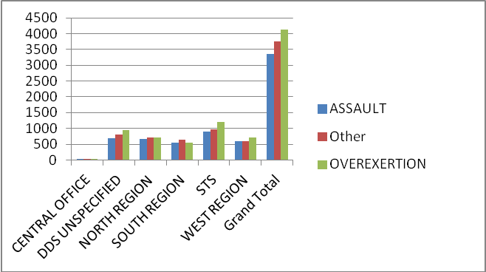

Trends in claims old vs. new:
New claims initially cost our department more in overtime costs due to the loss of the individual at work but the actual claim expense is lower in the beginning. However, as the claim ages the expenses grow exponentially, especially if surgical intervention occurs or if narcotic medication is necessary. Historically aged claims are the most expensive between years two and five and are ripe for settlement. Settlement at this time is beneficial for both the employee and the employer as it allows the employee to move on with their life and the employer to reduce their outstanding liability before the original injury manifests into other areas of the body as it ages. Traditionally injuries that begin in one area of the body affect other areas causing a cascade of related areas to break down. This eventually makes the claim more expensive. For example, December 2012 shows our claims expense for that month is 34.65% of our expense for aged claims two (2) years or less; 31.40% for claims between two (2) and five (5) years and 33.95% for claims older than five (5) years. Therefore, our monthly outstanding liability for claims over two (2) years is 65.35% of our monthly expenditure.

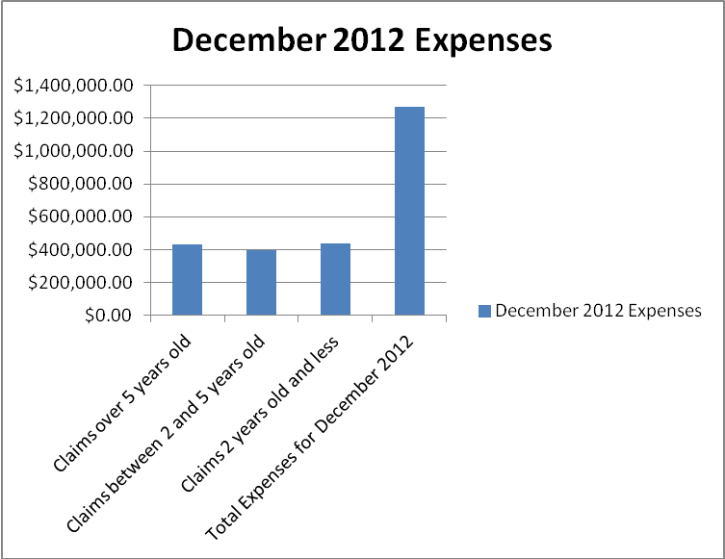

- Overtime: documentation on what you have done to decrease the use of overtime - show longitudinal data.

DDS efforts to reduce overtime in FY 2012 included the closure of six additional residential programs operated by the public sector and the hiring of 42.5 FTEs on a durational/temporary basis, as proposed in the Overtime Reduction Plan submitted to OPM in October 2011. In addition, staffing ratios and schedules were reviewed and revised in many programs.
Despite these efforts, the continued attrition of direct care staff and the 24/7 nature of our operations prevented us from achieving the 10% reduction in overtime that OPM asked us to achieve. For FY 2012 (after adjusting for the 27th pay period that occurred), we experienced a 3.35% increase in overtime hours (total overtime hours were 1.25 million an increase of 40,660 hours) and a 5.54% increase in overtime costs (total overtime costs were $41.2 million an increase of $2.28 million). The percent increase in cost was greater than the increase in hours because less of our total overtime was paid at “straight time” – in FY 11, 52.03% of total overtime was paid at straight time while in FY12, only 50.8% was paid at straight time. More importantly, mandatory overtime which is paid at double time increased 32.55%.

We continued to experience increases in overtime in early FY13. But, we have recently seen marked improvement for the last six pay periods as a result of the continued use of durational/temporary staff and adjustment of staffing ratios and schedules.

It is important to note that overtime is significantly lower than it was in FY 2009 and FY 2010, and due to the dramatic improvements realized in the last six pay periods, total overtime hours are at a historical low.

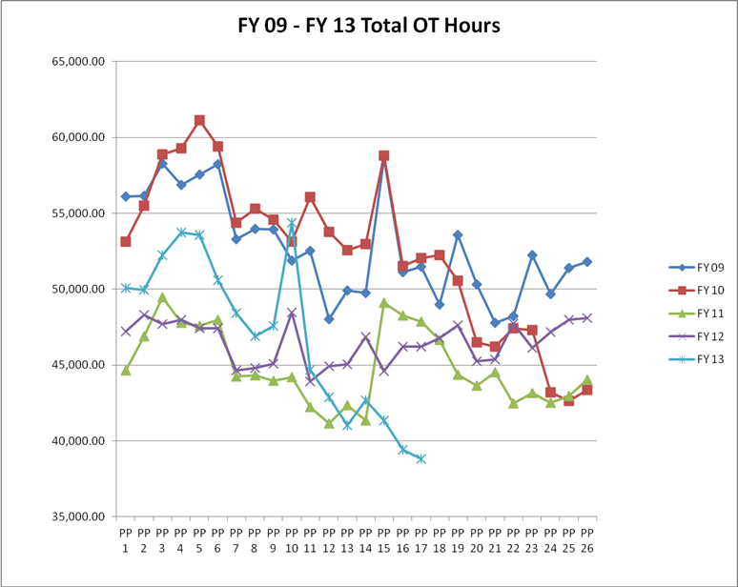

Senator Gerratana
- Concerned about proposed public group home closures.

DDS Community Living Arrangements (CLAs) are chosen for closure based upon consumer census, physical plant considerations and available vacancies (both staff and consumer) within our system. When a home is chosen for closure, the remaining consumers are provided the opportunity to move to other residential programs that meet their identified level of need. Placement opportunities can be in the public or private sector. The consumers’ families and guardians are involved in the selection of new residential services and all phases of the transition to their new homes. DDS works with the employees and their union to reassign staff in accordance with their collective bargaining agreement. DDS employees continue to have public sector jobs and are needed to fill existing staffing assignments in other DDS programs. This allows DDS to meet targeted budget savings by reducing overtime in other programs.

While DDS appreciates the concerns that are raised anytime that there is a change in services and supports, challenging economic times require that we work towards solutions that allow DDS to continue to serve as many individuals as possible within existing resources. As a publicly financed service system, we must provide these services in the most fiscally responsible manner possible. This consolidation of resources allows DDS services to continue, rather than be eliminated, by reducing costs in a planned and beneficial manner. While we are sympathetic to the impact these changes may have on consumers, families and employees, it allows important services to continue while reducing costs and maintaining jobs for our employees.

Rep. LeGeyt
- GAAP Adjustment.

The amounts associated with the GAAP adjustment were determined by the Office of Policy and Management and therefore we would direct any specific questions about methodology to their staff.

Senator Harp
- OPA’s RBA report card raised issues with providers: Describe DDS quality assurance for group homes. What are written procedures and protocols around adverse events?

The reference by the Office of Protection and Advocacy (OPA) in their budget hearing was related to data indicating that multiple substantiated cases of abuse and neglect in the private sector did not appear to trigger the creation of protective services plans. As stated previously, we have not yet had the opportunity to discuss this issue with OPA, however, protective services plans are only a small piece of DDS’s quality assurance process.

Quality Management staff conduct on-site reviews of Community Living Arrangements (CLA), using the Quality Service Review (QSR) process and CLA Licensing Regulations to ensure compliance with state and federal regulations, the department’s policies and procedures and the requirements of the Centers for Medicare and Medicaid Services (CMS) regarding Connecticut’s Home and Community Based and Individual and Family Support Waivers. Information gathered by the DDS Quality Management Services Division is shared with other stakeholders as a basis for quality improvement initiatives, so that agreed-upon best practices can be implemented statewide. When a qualified provider is not complying with statutes, regulations, policies, procedures, directives, provisions of the Purchase of Service Contract or the Provider Assurance Agreement and such non-compliance is negatively impacting supports to consumers, DDS may implement an Enhanced Monitoring Policy. This will assure that a consistent methodology for resolution, termination, non-renewal, or disqualification of provider status is used in all cases. Such matters as issues affecting health and safety, uncorrected licensing citations, abuse and neglect, mortality review, financial or ethical concerns, or failure to comply with the contract, are examples of when this process may be invoked. Refer to attached DDS Procedure I.G.PR.003 Enhanced Monitoring (Effective 8/1/2008).

Other applicable DDS Policies and Procedures include:

- Mortality Reporting and Review Policy
- Incident Reporting Policy
- Abuse and Neglect Policy

We would be happy to provide any of these upon request.

OFA Questions:
- How much has the department distributed in one- time increased needs (residential and day programs) in FY 12?

The total amount in one-time payments for residential and day programs in FY12 was $ 17,601,950.

FY2012 One-Time Breakdown by Category
 | Region
One Time Description | North Region | South Region | West Region | Total
CLA/CRS Transition Payment | $1,321,498 | $1,468,363 | $1,538,077 | $4,327,938
Staff Support -Behavior | $1,087,106 | $682,300 | $2,941,492 | $4,710,899
Staff Support- General | $1,530,921 | $561,002 | $965,223 | $3,057,146
Staff Support- Medical | $853,443 | $379,214 | $243,093 | $1,475,750
Extreme Weather | $574,146 | $359,510 | $414,315 | $1,347,971
Consultant | $30,471 | $27,673 | $12,423 | $70,567
Equipment | $18,721 | $15,463 | $4,259 | $38,443
Transportation not ISE | $3,110 | $10,521 | $677 | $14,308
ISE Job Pursuit | $19,077 | $36,644 | $60,059 | $115,780
ISE Benchmark | $0 | $0 | $6,000 | $6,000
ISE Career Plan Hours | $1,723 | $16,791 | $1,374 | $19,889
ISE Completed Career Plan | $0 | $2,100 | $1,400 | $3,500
ISE Transportation | $1,765 | $434 | $1,786 | $3,985
Working Interview | $5,976 | $2,441 | $140 | $8,557
State Funded Only | $2,945 | $1,707 | $0 | $4,652
Set-Up for new CLA-CRS | $136,669 | $36,662 | $71,593 | $244,924
Other | $668,812 | $391,904 | $1,090,927 | $2,151,643
Grand Total | $6,256,384 | $3,992,728 | $7,352,838 | $17,601,950

- Per capita costs by type of service: similar format to 2009.

See attached FY 12 Cost Comparison Data (the costs included are “draft” because the Department of Social Services (DSS) is currently in the process of reviewing our computations for finalization)

- Update on Early Connections closure.

Month/Year | # of children that will still be enrolled in the Early Connections Program on the 1st of the month*
March 1, 2013 | 36
April 1, 2013 | 34
May 1, 2013 | 33
June 1, 2013 | 27
July 1, 2013 | 24
August 1, 2013 | 22
September 1, 2013 | 17
October 1, 2013 | 16
November 1, 2013 | 13
December 1, 2013 | 9
January 1, 2014 | 8
February 1, 2014 | 7
March 1, 2014 | 6
June 1, 2014 | 3
July 1, 2014 | 0**

*This table shows the numbers of children expected to be enrolled each month if they stay eligible until their third birthday. There is always the chance that a child will exit the system prior to turning three because he no longer needs services or the family chooses to transfer to one of the private Birth to Three programs.

**Two children who turn three in mid-July and mid-September will need to be transferred or exited prior to 7/1/14, when the Birth to Three System is scheduled to move to the Office of Early Childhood.

All of the staff (teachers, therapists, one interpreter and one supervisor) from Early Connections have been offered other work opportunities within DDS in the Individual and Family Support, Public Programs, Autism and Birth to Three divisions of the department. Each of them have assumed or are in the process of assuming these responsibilities as their caseloads end.

- Status report FY 12 and FY13 Group home closures.

North Region:
Parkwood Road, Windsor- Closed October 12, 2011
81 Mountain Road, Newington- scheduled to close in FY13
85 Mountain Road, Newington- scheduled to close in FY13
555 Pomfret Street, Putnam- scheduled to close in FY13
2955 Main Street, Glastonbury- scheduled to close in FY 2013.

West Region:
1 unit/apartment at the Ella Grasso Center- Closed February 1, 2012
1 unit/apartment at Lower Fairfield Center- scheduled to close sometime in FY 13.

South Region:
Fogarty Road, Griswold- Closed August 30, 2011
House 11 at Meriden Regional Center- Closed September 21, 2011
Ellsworth Avenue, New Haven- Closed June 1, 2012
100 Lowe Avenue, Meriden- Closed October 23, 2012 (Re-opened December 17, 2012)
227/229 Camp Street, Norwich- Closed February 22, 2013
251 Rogers Road, Norwich- scheduled to close March 27, 2013

Southbury Training School:
During 2012, six residences closed at STS (3 cottages and 3 Personal Village (PV) residences). As consolidations continue and residents continue to explore community placement options, it is expected that there will be one additional PV closure in 2013.

- What is the number of group homes and the number of consumers residing in them for both public and private settings?

As of February 22, 2013, the total number of DDS Community Living Arrangements was 868, with 803 run by private providers and 65 run by public employees. The total current census as of February 22, 2013 is 3,753.

