Item #0107090A - CTDOT Boundary Marker (survey monument)
Item #0107091A - CTDOT Boundary Marker (survey disk)
Item #0107092A - CTDOT Boundary Marker (capped rebar)

Description: Work done under this item consists of setting survey boundary markers (monuments, disks in ledge or concrete structures, or capped rebar) along new Right–of–Way acquisition lines in the locations indicated on the plans and / or as directed by the Engineer.

Materials: CTDOT concrete boundary monuments, CTDOT boundary disks, and CTDOT capped reinforcing bars (rebars) will be provided by the Department. All other materials shall be the responsibility of the contractor. The contractor is responsible for the delivery of CTDOT supplied materials to the project site from the District Office or other designated location within the District area.

Construction Methods: The Contractor shall be responsible for all computations, location, staking, and setting of highway boundary markers at all P.C.’s , P.T.’s and any other angle points in the State’s Property Acquisition and Defined Highway Easement Lines as shown on the plans and the attached details or as directed by the Engineer.

The standard boundary marker will be the CTDOT concrete boundary monument. Boundary disks set in ledge or other structures and capped rebar will be set at locations as shown in the plans or where the Engineer determines that it is impractical to set a concrete boundary monument.

The setting of boundary markers shall not begin until all excavation, filling operations, grading and drainage has been completed and approval has been granted by the Engineer.

The Contractor shall retain the services of a Land Surveyor licensed in the State of Connecticut to serve as Project Surveyor to directly oversee this work and to ensure that each marker has been set in accordance with CTDOT Standards. The Contractor shall provide the name, place of professional employment, business address, phone number, and license number of the Project Surveyor to the Department.

All boundary and staking computations shall be provided by the Project Surveyor to the Engineer and shall be approved by the District Survey Office prior to staking the locations of the boundary markers.

The Project Surveyor shall stake the location of the boundary markers at the locations shown on the plans or as directed by the Engineer. This work shall meet or exceed a positional accuracy of 1:5000 (0.02’ per 100’) as defined in Section 20-300b-11 of the Regulations of Connecticut State Agencies.

Excavation for the placement of the CTDOT Boundary Monuments shall be by hand or with a power auger. The use of a backhoe or other heavy equipment for excavation purposes will not be allowed. The concrete monument shall be set plumb into the hole to the finished grade and backfilled and compacted in six inch (6”) layers as detailed in the contract or as directed by the Engineer.

In locations where the Engineer determines that concrete monuments cannot be set, the Project Surveyor shall set CTDOT Boundary disks or CTDOT Boundary capped rebars as directed. Rebar driving sleeves shall be used in the setting of capped rebars. All disks set in ledge or concrete shall be secured with ROCKITE®, KWIXSET®, QUIKRETE®, or approved equal fast setting hydraulic anchoring cement compound.

Concrete boundary monuments must be allowed to settle for fourteen days. Once all concrete boundary monuments are completed and allowed to settle and all other boundary markers are in place, the Contractor will notify the Engineer that the boundary marker disks are ready to be drilled. The CTDOT District Survey Office will verify the location of the boundary markers or monuments by drilling the exact location of the highway acquisition or highway easement lines on the boundary monuments or markers within 60 days of notification from the Engineer.

If any boundary marker disks are found to be outside of the boundary point locations and are unable to be drilled, the boundary monuments or boundary markers shall be removed and replaced in accordance with the contract specifications and details. Once the boundary monuments or markers have been drilled and found to meet the contract standards, the Engineer shall notify the contractor of this acceptance.

Method of Measurement: This work will be measured for payment by the number of monuments; disks, capped rebar, of the type specified, complete, and accepted in place.

Basis of Payment: This work will be paid for at the contract unit price each for the survey boundary marker of the type specified complete and accepted in place, which price shall include all computations, equipment, tools, transportation of Department supplied materials, non-Department supplied materials, and labor incidental to the location, staking and setting of boundary markers, and shall include any removal and replacement of non-conforming markers.

CONNECTICUT DEPARTMENT OF TRANSPORTATION
Boundary/Control Monument Setting Procedures
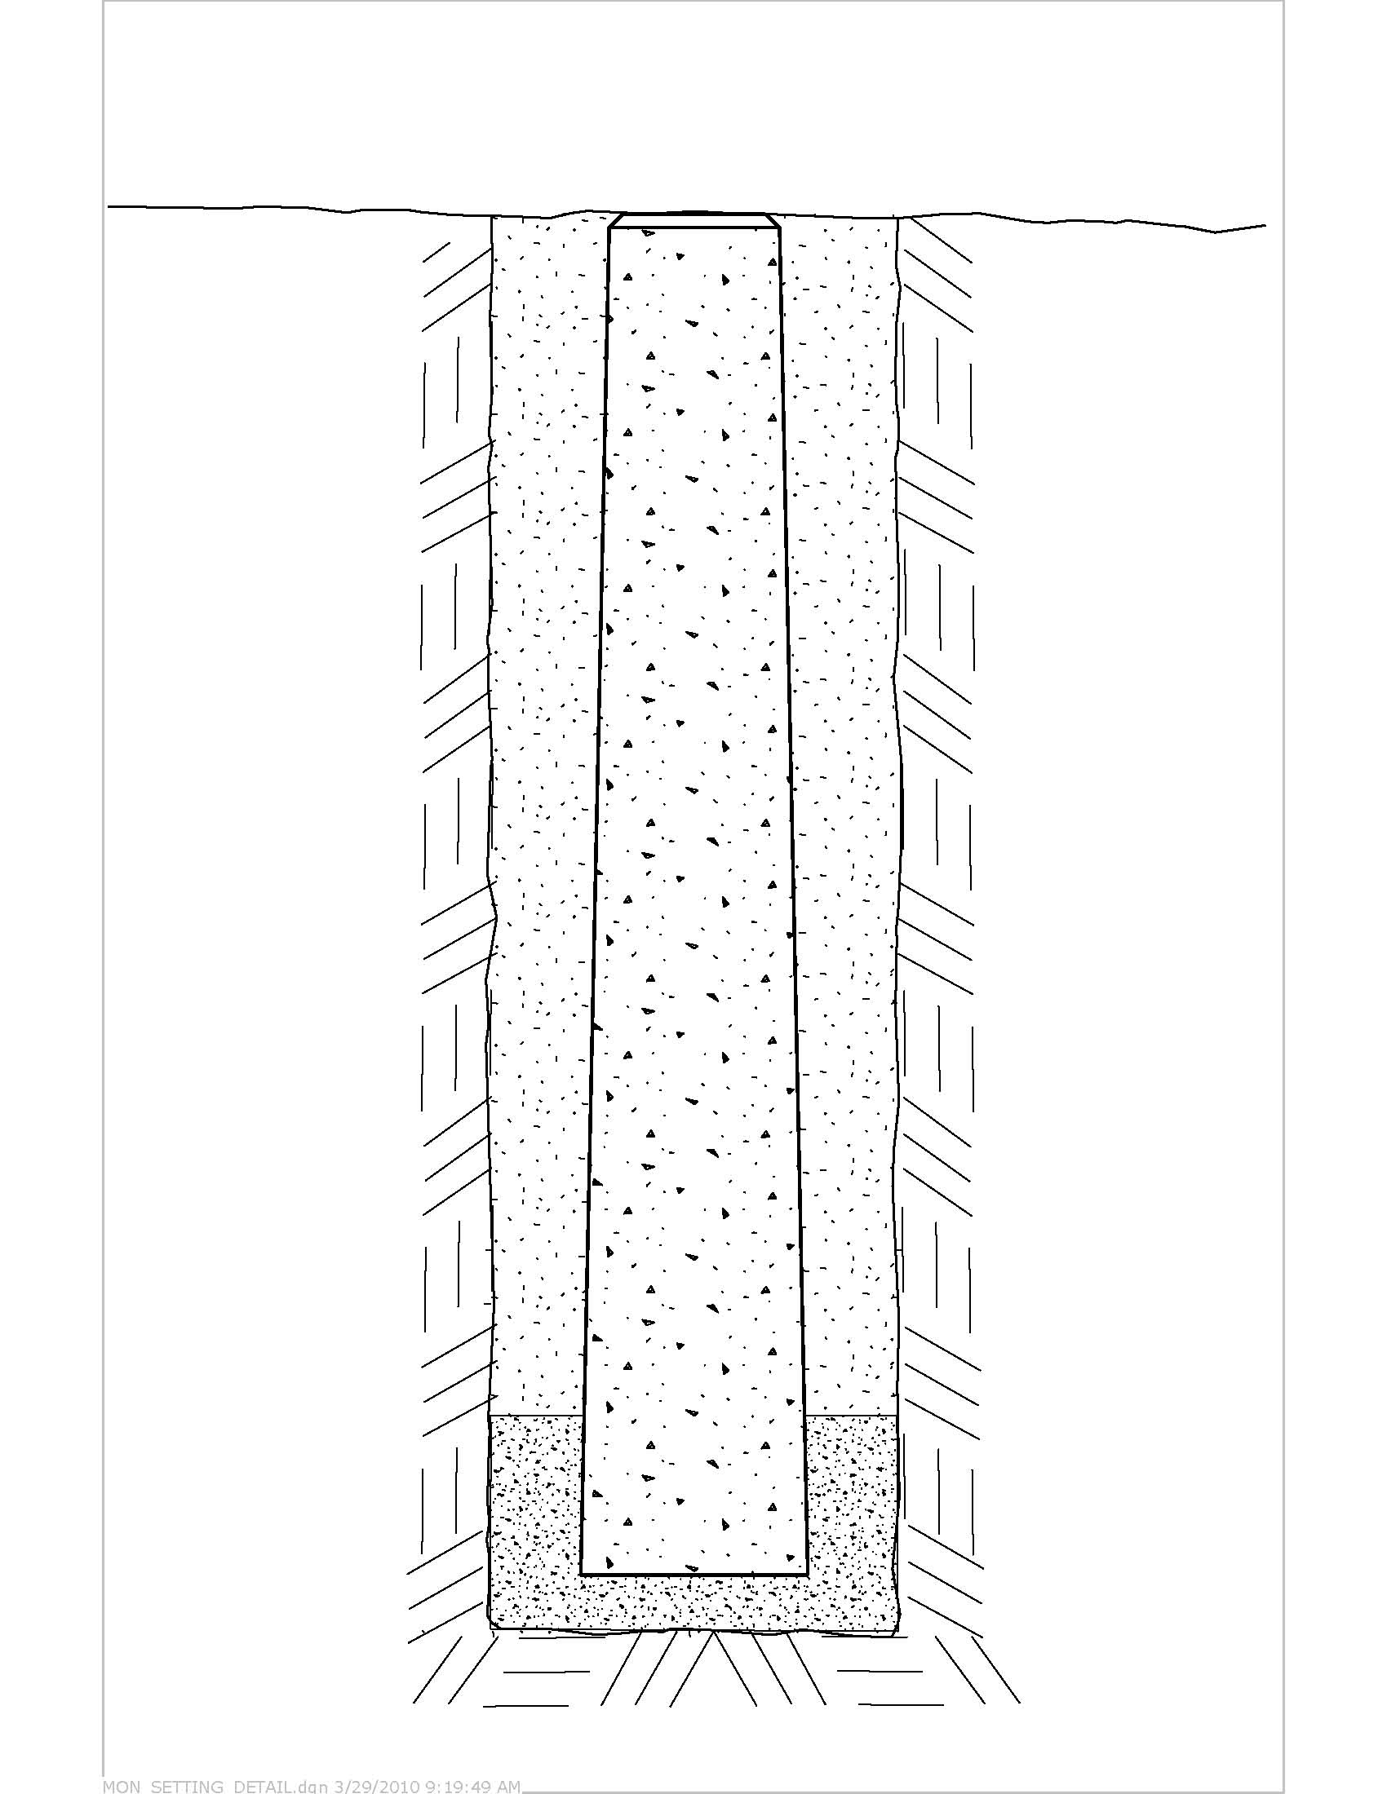
Finished Grade

Limit of excavation

Place backfill of suitable native soil & tamp well in 6” lifts
Fig. 2
Set Approx. Parallel

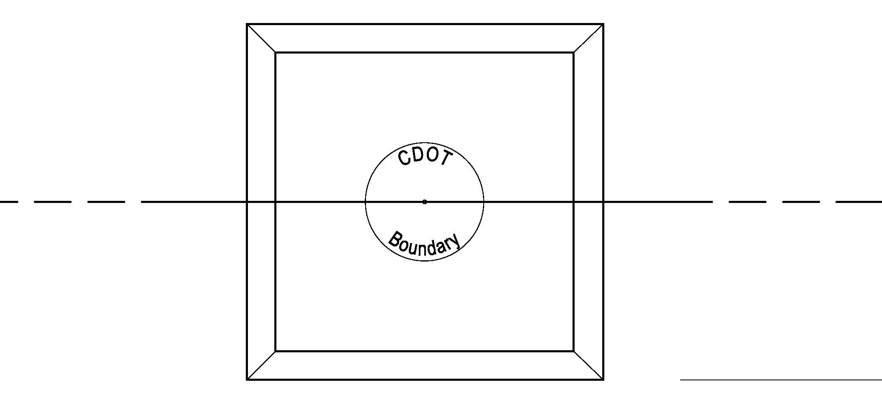

Highway Line
6” granular fill

Fig. 1
Procedure “A”
Setting CT DOT Survey Monuments to a specific point:
The Project Surveyor shall compute and stake the layout of each new CHD monument to be set. The stake shall be a 2” x 2” x 18” (or larger) hardwood stake and tack. The new monument shall be tied in to three points, the hole dug and new monument placed as indicated above. The new monument is to be set plumb in the same horizontal position as the existing staked point to within three, one-hundredths (0.03’) of a foot. It shall be positioned by the contractor, to an exact point, within the specified tolerance. Any monuments not falling within the specified limits shall be reset at the contractor’s expense.
Procedure “B”
Setting CT DOT Survey Disc in ledge:
When a new CHD point falls on ledge which is exposed or within < 2’ of the ground surface, a CT DOT disc may be set. A ¾” diameter hole shall be drilled to a depth of 3” and the surface of the ledge leveled so that the disc sits flush when complete. Discs shall be affixed using ROCKITE®, KWIXSET®, QUIKRETE®, or approved equal fast setting hydraulic anchoring cement compound in accordance with the manufacturer’s recommended procedures.
Procedure “C”
Setting CT DOT “RECHD” (Capped Rebar)
This procedure shall follow the standards of Procedure “A” except a ¾” x 3’ section of rebar is substituted for the traditional concrete monument. The rebar shall be driven with a protective sleeve and is also set to within three one-hundredths (0.03’) of a foot of the staked point, then topped with a two (2”) inch diameter CT DOT aluminum cap, which receives the final precise drill hole. The capped “Re-CHD” shall be set flush to the ground.

