
Updated on
March 8, 2019

OCC FACT SHEET: ELECTRIC SUPPLIER MARKET, MARCH 2018 THROUGH FEBRUARY 2019

The following is an update to the Office of Consumer Counsel’s (OCC’s) Electric Supplier Market Fact Sheet, originally created in 2014. The numbers provided herein are based on data submitted as compliance filings in the Public Utilities Regulatory Authority’s Docket Number 06-10-22.

- Retail suppliers serve 23.7% of Eversource Energy (Eversource) residential customers and 30% of United Illuminating (UI) residential customers, in February 2019.

- In the month of February 2019, over four out of ten residential supplier customers paid more than the Standard Offer in Eversource territory, and four out of ten residential supplier customers paid more than the Standard Offer in UI territory.

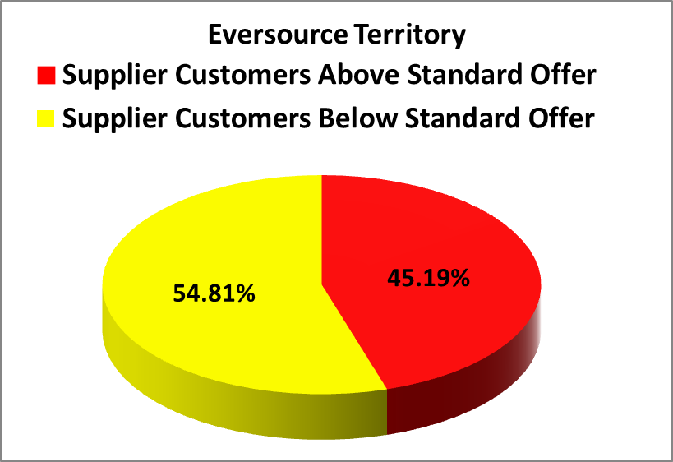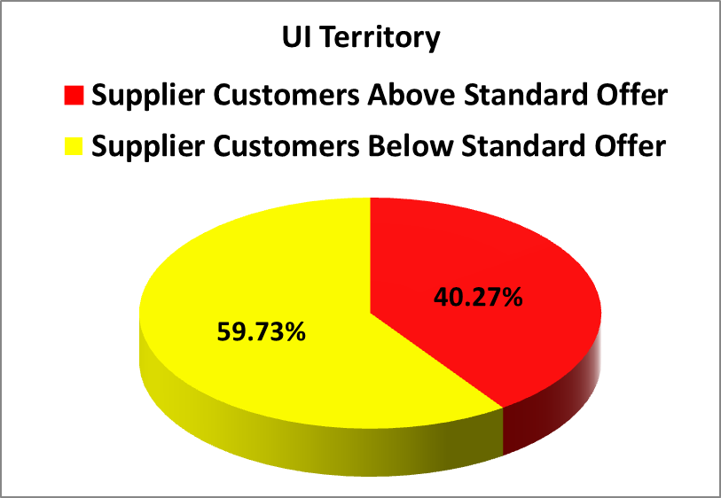
- In the month February 2019, residential Eversource customers who chose suppliers paid in aggregate $987,239 more than the Standard Offer for their electric generation, and residential UI customers who chose suppliers saved in aggregate $84,510 more than the Standard Offer.
- For the rolling year of March 2018 through February 2019, residential consumers who chose a retail supplier paid, in aggregate, $36,553,472 more than the Standard Offer.
- From January 1, 2018 through June 30, 2018, the Standard Offer for Eversource customers was 9.078 cents/kWh. The Standard Offer for Eversource customers from July 1, 2018 through December 31, 2018 is 8.53 cents/kWh. From January 1, 2019 through June 30, 2019, the Standard Offer for Eversource customers is 10.143 cents/kWh.
- From January 1, 2018 through June 30, 2018, the Standard Offer for UI customers was 9.66 cents/kWh. The Standard Offer for UI customers from July 1, 2018 through December 31, 2018 is 9.04 cents/kWh. From January 1, 2019 through June 30, 2019, the Standard Offer for UI customers was 11.2263 cents/kWh.
- The following table lists all electric suppliers who charged at least 20% of their residential customers 12.79 cents/kWh (50% higher than Eversource standard service) or 13.57 cents/kWh (50% higher than UI standard service) or more in the month of February. The phone numbers for each supplier are taken from those listed at energizect.com or the website for that supplier.

Suppliers Charging at Least 20% of their Customers 50% or more than Standard Offer in February
Electric Suppliers | % of Eversource Customers paying over 15.2145 cents | % of UI Customers paying over 16.8395 cents | Supplier Phone Number
Choice Energy | 38.38% | 43.37% | (888) 565-4490
Energy Plus Holdings, LLC | 61.65% | 62.88% | (888) 766-3509
North American Power and Gas LLC | 33.65% | N/A | (877) 572-0442

Please feel free to contact the Office of Consumer Counsel at 860-827-2900 or occ.info@ct.gov if you have any questions about this information.

This Fact Sheet only examines available data regarding pricing by electric suppliers. While some suppliers may offer products or services to customers such as airline miles or a product with additional renewable energy content, there is no data available to quantify the value of such offers. OCC recommends that customers look carefully at the fine print for offers for additional products or services that come with higher prices, to ensure they are getting sufficient value to justify the higher price tag.
These calculations are based on an assumption of 750/month kWh usage.

